Dyslexia Research: See The Difference
Independent researchers at Stanford and Harvard found that brains of struggling readers became more like those of typical readers after they used Fast ForWord. There was increased activation in brain areas critical for reading after struggling readers completed 8 weeks of Fast ForWord.
The averaged fMRI data shown illustrates how the brain activity of children with dyslexia came to resemble the brain activity of proficient readers after Fast ForWord. Likewise, behavioral tests showed improved reading and language performance as well.

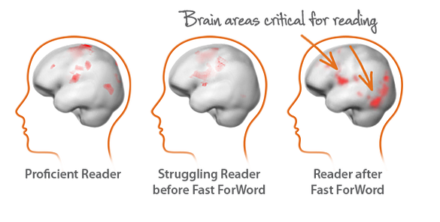

This independent research from Stanford and Harvard shows actual physiological changes in the brain after struggling readers used Fast ForWord. Look at these images of the brains of proficient readers and struggling readers. See the difference? One has more concentrated activity in certain areas of the brain that are critical for reading.

