**Generic Grant Template**

The purpose of this document is to provide you with appropriate and accurate *Fast ForWord®* and *Reading Assistant Plus*™product information which you can use in your grant application. Each grant application is different; the responses below will need to be tailored to meet your specific requirements. In addition, you will need to provide specific information about your schools’/districts’ needs, programs, and project design.

The following Table of Contents gives the headings for each section of Scientific Learning’s Generic Grant Template. We have tried to include the sections found in most grant applications and organize them in the order in which they most often occur. If you would like to jump directly to a specific section, press “Control” on your keyboard and click on the particular section in the Table of Contents that you would like to reach.

**Table of Contents**

[Abstract 3](#_Toc473884493)

[NEED 5](#_Toc473884494)

[Criteria for Identifying Struggling Readers 5](#_Toc473884495)

[Goals 7](#_Toc473884496)

[Strategies 8](#_Toc473884497)

[Introduction to Scientific Learning Corporation 8](#_Toc473884498)

[Three Part Model 9](#_Toc473884499)

[Company History 9](#_Toc473884500)

[MySciLEARN 10](#_Toc473884501)

[Scientific Basis and Proven Results 11](#_Toc473884502)

[The Scientific Background of the *Fast ForWord* Products 14](#_Toc473884503)

[The Research 11](#OLE_LINK33)

[The Intersection of Technology and Neuroscience in the *Fast ForWord* Products 25](#_Toc473884505)

[The Scientific Basis of *Reading Assistant* 26](#_Toc473884506)

[Neuroscience Learning Principles 27](#_Toc473884507)

[Cognitive Skills Development 28](#_Toc473884508)

[Core Skills Improvement **.**](#_Toc473884509)28

[Scientific Learning Alignment to Reading Skills and Grade Levels 34](#OLE_LINK32)

[Language to Reading Connection 34](#_Toc473884511)

[Benefits of *Fast ForWord* and *Reading Assistant* Products 34](#_Toc473884512)

[Descriptions of Scientific Learning’s Products 35](#_Toc473884513)

[Fast ForWord and Reading Assistant Copyright and Upgrade Years 44](#_Toc473884514)

[Implementation 44](#_Toc473884515)

[*Fast ForWord* Best Practices 44](#_Toc473884516)

[Innovative and Flexible Delivery Strategies 45](#_Toc473884517)

[Implementation Models 45](#_Toc473884518)

[Delivery Models 46](#_Toc473884519)

[*Fast ForWord*Schedules 46](#_Toc473884520)

[*Reading Assistant Plus* Schedules 47](#_Toc473884521)

[Scientific Learning’s Products Integration with Core Reading Programs, other Curriculum, and Alignment with State Standards 48](#_Toc473884522)

[Implementation Plans 48](#_Toc473884523)

[Scientific Learning Support and Implementation Services 50](#_Toc473884524)

[Technical Requirements 51](#_Toc473884525)

[Professional SERVICES 52](#_Toc473884526)

[Scientific Learning Support Training Materials 54](#_Toc473884527)

[Additional Professional Development 54](#_Toc473884528)

[Qualifications of Scientific Learning Trainers 55](#_Toc473884529)

[Parental Involvement 55](#_Toc473884530)

[Parent Activities 55](#_Toc473884531)

[Student Progress Reports for Parents 56](#_Toc473884532)

[Activities 57](#_Toc473884533)

[Expected Outcomes and Benchmarks 58](#_Toc473884534)

[Expected Outcomes 58](#_Toc473884535)

[Measurable Benchmarks 59](#_Toc473884536)

[Timelines 60](#_Toc473884537)

[*Fast ForWord* AND READING ASSISTANT Implementation Timeline 60](#_Toc473884538)

[Parental/Community Involvement Timeline 61](#_Toc473884539)

[Evaluation 61](#_Toc473884540)

[MySciLEARN Results Reports 61](#_Toc473884541)

[Other Student Progress Evaluation Options 92](#_Toc473884542)

[Student Assessment 92](#_Toc473884543)

[*Fast ForWord* Project Evaluation 93](#_Toc473884544)

[Documented Fast ForWord Success 94](#_Toc473884545)

[Improvements in Language Comprehension for Academically At-Risk Students 94](#_Toc473884547)

[Improvements in Reading 95](#_Toc473884548)

[Improvements in Language Comprehension for Students Learning English as a Second Language 96](#_Toc473884549)

[Significant Reading Gains for ELL Learners 97](#_Toc473884550)

[Special Education Students 98](#_Toc473884551)

[Language Comprehension in Students of Low Socioeconomic Status (SES) At-Risk for Reading Failure 99](#_Toc473884552)

[Improvements in Comprehensive Language Skills for Adolescents and Adults 100](#_Toc473884553)

[Demonstrated Significant Improvement in Adolescent Literacy Using the *Fast ForWord* Products 101](#_Toc473884554)

[Writing Improvements with Fast ForWord 102](#_Toc473884555)

[Longitudinal Data 106](#_Toc473884556)

[Behavior Improvements with the Fast ForWord Products 104](#_Toc473884557)

[Various School Randomized Comparison Trial Studies 105](#_Toc473884558)

[Budget 106](#_Toc473884559)

Scientific Learning hopes that the information contained in this Generic Grant Template will help you when you are writing your grant application.

**Good Luck!**

# Abstract

*The Abstract is where you will need to write an overview of your project. Here you can briefly lay out the components about which you will go into more detail in the main part of your grant proposal: needs, goals, strategies, objectives, expected results, and evaluation. Applicants need to write their own Project Abstract. The following text could be used in applicants’ Project Abstracts and is aimed at students in Kindergarten through Grade Three. There are many other populations of students that can be helped by the* Fast ForWord *and* Reading Assistant Plus *products; this is only one example of the type of Abstract an applicant can write.*

The primary focus of this project is to utilize the scientifically researched and field proven *Fast ForWord* and *Reading Assistant Plus* language and reading software products in order to ensure that all students in our school will read at or above grade level by the end of the third grade. Scientific Learning’s educational software programs are proven, effective supplemental and intervention materials that will provide our students with the basic skills they need to learn and read. The school will be targeting students in Kindergarten through Grade Three, including those not attaining grade level proficiency in reading/language arts, those at risk for special education, as well as English as a Second Language and Limited English Proficient students. The educational goals of this project will be:

* to use Scientific Learning’s educational software programs to ensure that all children will read at or above grade level by the end of the third grade;
* to enable students to master the skills set down in our state Academic Content Standards and Common Core State Standards for Language Arts and/or Reading through use of the *Fast ForWord* and *Reading Assistant Plus* educational software products;
* to provide Professional Development for our staff in the implementation of the *Fast ForWord* and *Reading Assistant Plus* programs, as well as in the research behind them;
* to effectively integrate the effects of Scientific Learning’s language and reading products throughout our school’s curriculum;
* to track student progress through detailed, regularly generated MySciLEARN reports and project success through pre- and post-testing with Scientific Learning’s *Reading Progress Indicator*.

We expect that each group of students will participate in *Fast ForWord* learning activities for 5 days a week for 30/40/50/90 minutes per day for an average of 12-16/9-13/6-10/4-7weeks or for 3 days a week for 30/50 minutes per day for an average of 12-16/20-27 weeks. After finishing with one of the *Fast ForWord* products, a student will move on to the next appropriate *Fast ForWord* product. We expect that each group will, on average, make gains of 1 to 2 years in our state standards and Common Core State Standards in Reading and/or English Language Arts. Students will also use Scientific Learning’s *Reading Assistant Plus* software for 20/30/45 minutes per day, three days a week. We expect that students using the Reading Assistant Plus program will improve their reading grade level up to 50% more than students receiving classroom instruction alone, in the same time period. Staff will attend one of the Professional Development options provided by Scientific Learning and become proficient in the implementation of the *Fast ForWord* and *Reading Assistant Plus* language and reading products and the scientific research upon which they are based. Teachers will be trained in utilizing student progress reports generated by MySciLEARN*.*

It is our expectation that, with the implementation of Scientific Learning’s language and reading software products, students will be able to read at or above grade level by the end of the third grade and teachers will become proficient in the delivery of the *Fast ForWord* and *Reading Assistant Plus* educational software and integrate them into the curriculum.

# NEED

*A portfolio of assessment tools, including standardized reading/language tests – such as the Woodcock Johnson, CELF, TOLD, etc. – and state tests of academic skills, can be used to determine skill levels of students and their specific language and reading needs.*

*The following checklist can be used to identify participants who may be appropriate for* Fast ForWord *and* Reading Assistant Plus *products and, therefore, can help establish need for applicants’ particular* Scientific Learning *projects.*

## Criteria for Identifying Struggling Readers

*Phonological Awareness*

* + - * Has difficulty recognizing words that begin with the same sound
      * Doesn’t understand rhymes
      * Has difficulty separating the syllables in spoken words
      * Has problems clapping hands or tapping feet in rhythm with songs and/or rhymes

*Word Finding and Retrieval*

* + - * Has difficulty retrieving a specific word
      * Speech is hesitant, filled with pauses or vocalizations
      * Frequently uses words lacking specificity
      * Has low interest in learning words or spelling

*Verbal Memory / Sequencing*

* + - * Relates stories or events in a disorganized or incomplete manner
      * Leaves out important events when reading a story
      * Shows problems learning names of people or places
      * Has difficulty remembering the words to songs or poems

*Fluency Skills*

* + - * Does not garner meaning from the text
      * Does not demonstrate proper inflection or prosody while reading
      * Has difficulty reading smoothly, reads word-by-word, or stumbles frequently when reading aloud
      * Reads quickly but struggles to remember what was read
      * Has good decoding skills but has difficulty understanding text meaning

*Comprehension / Receptive Language*

* + - * Only responds to part of a multiple-element request or instruction
      * Requests multiple repetitions or instructions
      * Relies too much on context to understand what is said
      * Shows a delayed response time to questions
      * Has difficulty making inferences, drawing conclusions
      * Noticeably weaker comprehension in group or classroom setting
      * Has difficulty understanding abstract language, such as idioms or humor

*Expressive Language*

* + - * Talks in short sentences
      * Uses inappropriate rhythm or volume when speaking
      * Has difficulty giving directions or explanations
      * Has difficulty with the rules of conversation, such as turn taking, staying on topic, indicating when he/she does not understand
      * Shows frequent slips of the tongue

*Literacy Skills*

* + - * Disinterested in learning to read or reading
      * Disinterested in being read to
      * Poor reading comprehension
      * Has difficulty / easily frustrated when sounding out words
      * Has difficulty spelling
      * Makes errors in grammar

# Goals

*The following are some possible goals incorporating the* Fast ForWord *and* Reading Assistant Plus *products that you can use in your grant proposal.*

1. Goal:  
   Develop students’ skills in phonemic awareness, phonics, fluency, vocabulary, and comprehension in order to enable them to read by the end of the third grade.
2. Goal:  
   Provide early intervention for those students who are academically at-risk by supplying the cognitive skills that any student needs as a basis for reading, listening, thinking, and participating successfully in the classroom.
3. Goal:  
   Provide teachers with the professional development they need to help students develop phonological awareness, phonics, fluency, vocabulary, and comprehension skills.
4. Goal:  
   Provide parents with the skills and opportunities they need to be their children’s first teachers and to help their children achieve the goal of being able to read by third grade.
5. Goal:  
   Provide teachers with instructional materials based on neuroscience-based reading and language research that has been proven in the field, validated by independent researchers, and accepted by the scientific community.
6. Goal:  
   Provide students with early childhood products that will give them the readiness skills they need to enter school, such as: phonological awareness; color, shape and size identification; letter-sound association; and basic computer skills.
7. Goal:  
   Provide kindergarten to first grade transition products and extended learning opportunities.
8. Goal:  
   Help students develop the motivation to read.
9. Goal:  
   Help middle and high school students stay in school.
10. Goal:  
    Help adult students acquire needed skills in order to be able to read proficiently.
11. Goal:  
    Provide students with guided oral reading practice using research-validated speech verification technology

# Strategies

*The following information will help grant applicants write the Strategies portion of their grant proposals. Strategies can be thought of as the overall means, as opposed to the particular activities, used to achieving an applicant’s goals: in this case, the* Fast ForWord *and* Reading Assistant Plus *products themselves. The following text supplies grant applicants with information about Scientific Learning, the* Fast ForWord *and* Reading Assistant Plus *products, the scientific research upon which the* Fast ForWord *and* Reading Assistant Plus *products are based, and other relevant information that applicants can use in the Strategies section of their grant applications.*

## Introduction to Scientific Learning Corporation

Incorporated in 1997, Scientific Learning Corporation accelerates learning by applying proven research on how the brain learns. Scientific Learning manufactures the *Fast ForWord* and *Reading Assistant Plus* educational software that combine computer technology and the latest advances in scientific research to help students develop the cognitive skills that form a strong foundation for reading and learning.. Once root causes of struggle are addressed through personalized, adaptive exercises, a student’s language, reading and all learning improve quickly.

Fast ForWord K-12 provides a complete evidence-based online intervention solution for struggling learners: 1) tools for building the foundational cognitive capacity so often under-developed in students of poverty and other subgroups through the principles of neuroplasticity – the ability of the brain to rewire and improve; 2) tools for building strong language skills in struggling learners including English Language Learners; and 3) the tools for practicing key literacy skills to build fluency, comprehension, and vocabulary. This family of intervention tools used with fidelity provides the answers to closing the achievement gap for so many of our students who struggle with learning and literacy.

The *Fast ForWord* products are based on over 30 years of scientific research into the way the brain learns, using breakthroughs in brain plasticity as well as patented, computer enabled, digitally enhanced sound. Research-proven techniques are built into each *Fast ForWord* exercise: frequency and intensity of trials; adaptivity of the levels to students’ performance; simultaneous development of multiple skills; and timely motivation. By means of this optimal learning environment, the *Fast ForWord* products develop the basic cognitive skills – memory, attention, processing, and sequencing – which are keys to learning. The *Fast ForWord* products develop these cognitive abilities in the context of oral language and reading skills that students need to succeed academically, such as phonemic awareness, phonics, vocabulary, fluency, comprehension, syntax, grammar, and morphology.

*Reading Assistant Plus* is also based in scientific research and develops students’ reading fluency, vocabulary, and comprehension skills. *Reading Assistant Plus* uses research-validated speech verification technology in order to “listen” to a student as he or she reads aloud. Monitoring for signs of difficulty, the program intervenes with assistance when the student is challenged by a word. Students re-read passages several times to build automaticity. Automatic monitoring of student progress in both *Fast ForWord* and *Reading Assistant Plus* via MySciLEARN reports gives teachers the daily feedback they need to fine tune students’ instruction and improve student achievement.

Many students lack the cognitive skills necessary to take full advantage of the curriculum offered them. Without good working memory or sequencing skills, for example, students cannot follow complicated oral directions and remember them in the right order, or retain all the necessary facts in their proper sequence in a paragraph they are reading. The *Fast ForWord* and *Reading Assistant Plus* products supply students with these necessary cognitive skills so that their brains are ready to learn. The *Fast ForWord* and *Reading Assistant Plus* products don’t replace schools’ curriculum, such as basal readers, but work in conjunction with them, building students’ learning capacity. In this way, the *Fast ForWord* and *Reading Assistant Plus* products enable both students and school curriculum to work better together and, therefore, optimize all available educational resources for improved academic results. And because students need to be able to read in all their subjects, the skills the *Fast ForWord* and *Reading Assistant Plus* products develop are utilized across the curriculum. Standardized tests have demonstrated increased student achievement in reading, math, science, and social studies after students participate in *Fast ForWord* and *Reading Assistant Plus* activity.

## THREE-PART mODEL

Fast ForWord K-12, the Fast ForWord and Reading Assistant Plus combination, provides a complete online intervention solution for struggling learners that includes individualized instruction for students:

1. **Prepare**: Fast ForWord **prepares the foundation for reading** by building the necessary mental systems for learning. Fast ForWord finds and targets hidden culprits for slow reading progress (Memory, Attention, Processing speed – MAPs).
2. **Practice**: Fast ForWord provides a **personalized learning path** to each student. This is how you get far better results. Students engage in intensive, deliberate and personalized practice in increasingly complex language and reading skills.
3. **Reinforce**: As students read aloud, the program **listens and provides corrective reading feedback**. Real-world reading reinforces newly learned skills and rapidly builds fluency and comprehension.

Fast ForWord provides more personalized, intensive practice than other approaches and produces results beyond reading.

## Company History

In March of 1997, Scientific Learning launched its first product, *Fast ForWord Language*, that develops the fundamental language skills that are the building blocks for reading success. *Fast ForWord Language to Reading*, a product designed to rapidly develop the skills that help students make the link between spoken and written language, was released in 1998. In 1999, Scientific Learning introduced *Fast ForWord Middle & High School* which rapidly reinforces and upgrades the foundational skills that lead to fluent reading and communication for older students. Between 2000 and 2005, Scientific Learning introduced Volumes 1-5 of its *Fast ForWord Reading* series which rapidly and systematically develops the skills that will help students become fluent readers. *Fast ForWord Reading Readiness* was newly revised in 2005 and is designed to help younger students acquire the cognitive, oral language, and pre-reading skills they need to move on to the core *Fast ForWord* products. In 2006, Scientific Learning released *Fast ForWord Literacy Advanced*, a companion to *Fast ForWord Middle & High School* that continues building a strong foundation of fundamental cognitive skills in the context of language and reading skills. 2006 also saw the release of *Fast ForWord Literacy*, a revised version of *Fast ForWord Middle & High School*. In Spring, 2008, Scientific Learning announced the release of *Fast ForWord Language, Version 2*,and *Fast ForWord Language to Reading, Version 2*.

At the end of 2007, Scientific Learning acquired *Reading Assistant Plus*, an educational software product that provides students with practice in reading aloud through advanced speech verification technology. *Reading Assistant Plus* helps strengthen students’ reading fluency, vocabulary and comprehension. In 2009, Scientific Learning released *Reading Assistant Plus* Content.

In January, 2011, Scientific Learning launched SciLEARN Enterprise which allows schools to host the *Fast ForWord* products from one central server in the district. With SciLEARN Enterprise, students can access *Fast ForWord* programs from a browser from a computer anywhere within a district. Districts can install once and deploy to more than 3,000 concurrent students. SciLEARN Enterprise works with a wide range of network infrastructures. *Fast ForWord* products are deployed from a central location and scale vertically and horizontally while maintaining performance and eliminating downtime. The web-based administration console allows administrators to manage multiple schools from a centralized location.

In mid-2011, Scientific Learning launched On-Demand hosting. The new On-Demand option is the online version of *Fast ForWord*, accessed via a browser and hosted by Scientific Learning. For this option, Internet bandwidth capacity must be at least 128kbps per concurrently training student.

In mid-2018, Scientific Learning released new versions that replaced *Fast ForWord Language, Version 2*,and *Fast ForWord Language to Reading, Version 2*. The products now are called *Fast ForWord Foundations I* and *Fast ForWord Foundations II*.

(Feb 2019) Today, more than **3.0 million** learners have used Scientific Learning software products; and since the introduction of MySciLEARN in late 2011, over **925,000** learners have used our products online.

Numerous independent studies as well as detailed research and outcomes data consistently confirm the effectiveness of these products. Publications such as *The New York Times*, *The Los Angeles Times*, *Newsweek*, *Time* and others have reported on the powerful science behind the *Fast ForWord* products as well as the success experienced by students across the country.

Scientific Learning has implemented its products for the last 22 years in a wide variety of settings, from small rural to mid-sized suburban to large urban, metropolitan school districts, such as Philadelphia, PA (230 schools), Duval County, FL (95 schools), Polk County, FL (112 schools), and Dallas ISD, TX (70 schools*)*.

## MySciLEARN

In 2012, Scientific Learning launched MySciLEARN which is an on-demand software implementation option hosted by Scientific Learning that is available through internet web browsers and brings together in one place all the tools that schools need, providing anytime, anywhere access to products, training, reports, and more. MySciLEARN allows for fast implementation of the *Fast ForWord* and *Reading Assistant Plus* software and is scalable for any size school or district. The following are some of the main features of MySciLEARN:

* One-stop interface aggregates the most commonly used resources so staff can work more efficiently.
* Implementation Success and Gains reports highlight performance at the district, school, group, and individual student levels.
* Success Forecast Reports give a prediction of what improvement schools will see in the various student populations if the products are properly implemented.
* Audio Recording and Comprehension Reports are also provided for Reading Assistant Plus.
* Report design features graphical depiction of trends, at-a-glance data summaries, and icons highlighting both good and poor performance.
* Fast ForWord auto-assign tool automatically places students in the appropriate Fast ForWord product, freeing up time for teachers and coaches to focus on learners.
* MySciLEARN Resources training portal provides convenient access to self-paced online training programs, a learning community, and easy-to-use instructional resources and tools.
* Expanded roles capability allows customization of roles for district and school staff.

## Scientific Basis and Proven Results

### The Scientific Background of the *Fast ForWord* Products

The *Fast ForWord* products are based on over 30 years of scientific research into the way the brain learns the oral language and reading skills necessary for literacy. The products evolved from the work of noted research scientists Drs. Michael Merzenich and Bill Jenkins at the University of California, San Francisco, and Drs. Paula Tallal and Steven Miller at Rutgers University. Dr. Merzenich, who is a member of the National Academy of Sciences, and Dr. Jenkins are internationally known for their research in the science of brain plasticity, which is the concept that the brain changes as we learn new skills. Understanding brain plasticity has helped the development of improved learning strategies for children with language and reading problems. Drs. Tallal and Miller are experts in research on the neurological basis of language. Dr. Tallal is currently at the faculty at the Salk Institute and is an active participant on many scientific advisory boards and government committees for both developmental language disorders and learning disabilities. She has published over 150 papers on the topic of language and learning and is the recipient of national and international honors. Dr. Miller has extensive experience in organizing clinical research studies and conducting longitudinal studies of children who have language and reading problems. He worked for Scientific Learning for 13 years and was Senior Vice President of Research.

Research has shown that students with reading difficulties frequently have problems discriminating between different sounds. Because these students cannot aurally differentiate between certain English phonemes, they cannot properly make the connection between these phonemes and their print counterparts. The research collaboration of Drs. Merzenich, Jenkins, Tallal, and Miller resulted in a key finding: with the help of computers, phonemes and other speech sounds can be slowed down and digitally enhanced so that students having difficulty distinguishing between similar phonemes (for example, /k/ and /g/) can more accurately make the necessary distinction between them. Using this technology in an intensive, adaptive product, the scientists discovered that students can develop a wide range of critical cognitive, oral language and reading skills such as phonological awareness, phonemic awareness, fluency, vocabulary, comprehension, decoding, working memory, attention, processing, sequencing, syntax, grammar and other skills necessary to learn to read or become a better reader. The optimal learning environment used in the *Fast ForWord* products is based on scientifically-validated methods of learning developed by Drs. Merzenich and Jenkins in their research on brain plasticity, and includes motivation, intensity, frequency, and adaptivity. When combined with precise protocols and the power of computer and internet technology, rapid advances in learning occur.

Dr. Tallal presented many of these research ideas in a "Briefing to the Congressional Biomedical Research Caucus on Advances in Addressing Learning Disabilities" in Washington D.C. on April 21, 1999.

**The Research**

Research on the *Fast ForWord* products falls into three general categories:

* Initial clinical study and original scientific research by the founders of the company conducted in the laboratories and clinics of Rutgers University and the University of California, San Francisco, and published in peer-reviewed publications, such as the *Proceedings of the National Academy of Sciences* and the journals *Science* and *Nature*;
* National Field Trials and School Pilot Study conducted "in the field" with children in private speech and language clinics, schools, institutions, or at home;
* Ongoing research, including longitudinal studies, at schools where Scientific Learning products have been implemented.

A ***Quasi-Experimental Controlled Two-Group Study*** (1994-1995**)** was conducted at Rutgers University in Newark, New Jersey. The clinical results were published in the January 1996 issue of *Science*, one of the world's most prestigious peer-reviewed journals (Tallal, et. al., *Science*. 271: 81-84[[1]](#footnote-1)). The early data showed rapid improvements in language skills with the research prototype of *Fast ForWord Language*, including significant gains in oral language comprehension, speech discrimination, grammar, and syntax.

A ***Multi-Site Field Study*** conducted in 1996 proved the results in a "real world" setting. In collaboration with over 60 independent professionals at 35 sites in the United States and Canada, after *Fast ForWord Language* participation children experienced the same dramatic improvements in language as those who participated in the initialQuasi-Experimental Controlled Two-Group Study. At each site, independent speech and language professionals or educators selected and administered *Fast ForWord Language* to students aged 4 to 14 who exhibited difficulties with either listening or language comprehension skills.

Before *Fast ForWord Language* activity, 77 students demonstrated below-average or low-average performance in most language areas. On average, after *Fast ForWord Language* activity, students in the study demonstrated significant improvements in multiple aspects of overall language development. Their listening, speaking, semantics, syntax, and phonological skills progressed into the average range.

Each of the 35 sites reported positive findings. After *Fast ForWord Language* use:

* 90% of the children experienced significant gains in one or more tested areas;
* Most made significant gains in multiple areas, including listening, speaking, attention, language fundamentals, grammar, and ability to follow directions;
* Gains were, on average, 1 to 2 years in 4 to 8 weeks.

*Results from the Multi-Site Field Study*

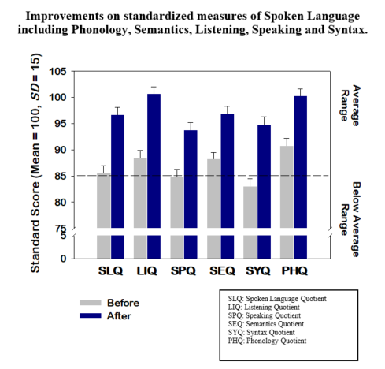

A ***School-Based Randomized Trial*** [[2]](#footnote-2) was conducted in the Fall of 1997, in collaboration with 19 schools in 9 districts, in the states of California, Texas, Illinois, Indiana, and Nebraska. The goal of this controlled study, which included over 400 students in kindergarten through 3rd grade, was to determine the effectiveness of *Fast ForWord Language* for students who were “at-risk” for failure in reading and language skills, when the product was implemented in a school setting.

Classroom teachers selected the students who were at-risk and randomly assigned them to either the experimental group that used *Fast ForWord Language* or to the comparison group (matched to the experimental group by age and gender) that remained in the regular classroom and received non-*Fast ForWord Language* instruction.

Before and after the intervention, students in both groups were assessed with the following standardized tests:

* The Test for Auditory Comprehension of Language-Revised (**TACL-R**),
* The Phonological Awareness Test (**PAT)**
* The Woodcock Johnson Revised Achievement Battery (**WJR**)

Results were consistent with those of the prior, laboratory and clinical trials. Across multiple schools, students gained 1 to 2 years on standardized measures of language comprehension or phonemic awareness following 4 to 6 weeks of *Fast ForWord Language* participation.

## m08eve01xma MCAS subgroupsA *Case Study Using State Assessment Test* data has shown significant improvements across a wide variety of students including students receiving services for special education, students from economically disadvantaged backgrounds, and students who are English language learners. The following graph shows results from students in the Everett Public Schools in Massachusetts who used Fast ForWord products. The measure was the Massachusetts Comprehensive Assessment System (MCAS), the Massachusetts high stakes test for students in 3rd through 8th grade. The district chose to use the products with approximately 20% of their students. Of the 853 students who were assessed on the MCAS before and after Fast ForWord participation, 32% moved up one or more performance levels with overall student performance in all demographic groups analyzed making significant improvements.

The consistent, positive results documented in these and many other studies indicate the enormous potential for language and reading gains across a broad population of students in many different settings.

**Replication study**

Brain Imaging and Academic Testing Before and After *Fast ForWord*

Initial study

A 2003 study done by Temple et al. at Stanford University[[3]](#footnote-3) investigated the effects of *Fast ForWord* participation on children with dyslexia aged 8 to 12 years, who used the *Fast ForWord Language* product for eight weeks. The behavioral and physiological results were compared to those of children with typical reading skills.

Before and after *Fast ForWord Language* participation, the students in the study had their brains scanned using functional magnetic resonance imaging (fMRI), while performing a task related to reading. At both time points, their language and reading skills were measured using the Woodcock Reading Mastery Test - Revised (WRMT-R), the Clinical Evaluation of Language Fundamentals, Third Edition (CELF-3), and the Comprehensive Test of Phonological Processing (CTOPP). A control group of children with normal reading abilities also had their brains scanned, and completed the same test battery at both time points, but did not use the Fast ForWord Language product.

The results showed that the children with dyslexia who used the *Fast ForWord Language product* achieved significant improvements in several measures of reading and language skills including word identification, decoding, comprehension, and receptive and expressive language. Furthermore, the results showed that brain imaging scans of children with dyslexia who used the *Fast ForWord Language* product showed normalization of activity in critical areas of the brain used for reading.

Replication Study

Researchers at Harvard and MIT⁶ assessed reading and language skills in two groups of students: a group of typically developing readers, and a group of students with developmental dyslexia. The dyslexic group went on to use the Fast ForWord Language product, and was then re-assessed.

In addition to behavioral measures of phonological awareness, oral language skills, and reading skills, functional magnetic resonance imaging (fMRI) was used to measure brain activity during an auditory task. Rapid frequency transitions are a critical component of many sounds in human speech. By measuring brain activity as the students listened to different sounds, the researchers could determine whether rapid changes in frequency elicited different responses compared to slow changes in frequency, and whether these changes were consistent for children with dyslexia, and those without.

**Results:** The group of typically developing readers showed a differential response in brain activity when listening to sounds with fast transitions, versus sounds with slow transitions. Prior to remediation, the students with developmental dyslexia did not show this pattern of differential response to fast transitions. They also had substantially lower language and reading scores than typical readers.

After using Fast ForWord Language, the students with developmental dyslexia made significant improvements on all but one of the language and reading measures. In fact, their improvements in phonological awareness and phonological memory were so great that, after remediation there was no longer a significant difference between the abilities of the typical readers and those of the dyslexic students. Likewise, after remediation, students with dyslexia showed increased brain activity for fast transitions relative to slow transitions in several areas of the brain, similar to the pattern seen in typical readers.

**Conclusion:** The results suggest that students with developmental dyslexia process rapidly changing sounds differently than typically developing readers. However, dyslexic students who used Fast ForWord Language started processing rapidly changing sounds differently – in a manner similar to typical readers – while also improving their language and reading performance on standardized tests.

**Evidence of a practical significance in the research data, indicated by an effect size of 0.10 or greater.**

The National Center on Intensive Intervention conducted a review of multiple Fast ForWord research studies and documented positive targeted and broad effect sizes for pre-reading and reading outcomes. The mean effect size (targeted) was .59\* for the Fast ForWord Language series (now Foundations) in the first study (**Miller, Merzenich, Tallal, DeVivo, Linn, et al. (1999)** and .44 for the second (**Scientific Learning Corporation, 2004). The second study also included a mean effect size (broader) of .51.**

## ****Evidence that the participants in the research data provided were at risk (i.e., below the 25th percentile).****

*All of the studies reported above were conducted with at risk populations, including students with diagnosed learning disabilities, and other struggling readers. While Fast ForWord use has been found to benefit average and proficient students, as well, the majority of Fast ForWord studies have been conducted with at risk populations.*

*The four following studies show further results for at-risk students. On average, the students in these studies had initial test scores close to one standard deviation below the mean (i.e., near or below the 15th percentile):*

## Improvements in Language Comprehension for Academically At-Risk Students

The Test of Auditory Comprehension of Language, Revised (TACL-R) is a receptive language test that measures a student’s ability to understand spoken phrases and sentences of increasing complexity. These language skills are particularly important in the elementary school years, when a student’s ability to follow oral instructions and participate in class discussions can be critical to academic achievement.

* Prior to *Fast ForWord* use, the 246 students in the *Fast ForWord* group and the 142 students in the comparison group demonstrated similar skill levels in auditory comprehension, with both groups testing below the average range.
* At the end of the study, the skills of children in both groups had moved into the average range. However, the skills of children in the *Fast ForWord* group improved significantly more than the improvements observed in the comparison group.

f97sch06xgb-nl-ld

**Improvements in Language Comprehension for Students Learning English as a Second Language**

Scientific Learning data has shown that ESL/ELL students who use Fast ForWord make gains comparable native English-speaking students. The graph below shows results from the Test of Auditory Comprehension of Language – Revised (TACL-R) for both ESL and non-ESL students. Both groups improved from below the average range before using *Fast ForWord Language* to well within the average range after *Fast ForWord Language*.

f97sch20xgb

## Language Comprehension in Students of Low Socioeconomic Status (SES) At-Risk for Reading Failure

f97sch05xgbThe graph below shows a comparison of improvements in language comprehension between two groups of at-risk students, ages 7 to 9, of low socioeconomic status (SES) as classified by the Market Data Retrieval Database. A group of students trained on *Fast ForWord Language* software; the comparison group of students did not participate in an intervention program during the same time period (left bar graph). The results are from the Test of Auditory Comprehension of Language, a standardized, nationally normed language test that these students from schools nationwide completed before and after using *Fast ForWord Language* software.

Before using *Fast ForWord Language* software, both groups of at-risk, low SES students performed, on average, below their age-expected performance levels. After the participation period, performance for the group that used *Fast ForWord Language* software moved within the average range. The comparison group showed some improvement but did not move as far into the average range as the *Fast ForWord Language* participation group. The gains made by the *Fast ForWord Language* group were significantly better than the gains made by the comparison group, indicating that the students in the *Fast ForWord Language* group have an improved ability to benefit from the school curriculum.

**Struggling Readers Maintain Improved Reading Skills**

After working with *Fast ForWord Language*, students demonstrate improvements in the foundational skills required for fluent reading; results from up to one year after *Fast ForWord* use show that students maintain and build on their improved reading skills over the long term. The graph below shows improvements in reading skills for more than 100 students in grades K through 6 from schools nationwide. The results are from the Woodcock Johnson Test of Achievement, Revised, a standardized, nationally normed reading test that students completed before and after working with *Fast ForWord Language*, as well as six months to one year following *Fast ForWord* activity.

*m00cmb74xgb-ld-ma*

Before *Fast ForWord Language*, students performed, on average, toward the lower end of their age-expected performance level. After *Fast ForWord Language*, students demonstrated, on average, significant gains in their reading skills. Test results directly after *Fast ForWord Language* showed that students' ability to identify letters and words and to identify missing key words moved higher into the average range. In addition, test results 6 months to 1 year after *Fast ForWord Language* showed that students continued to develop their improved reading skills, indicating that they continue to improve on their ability to benefit from the school curriculum.

**Evidence that the students in the research provided were randomly assigned to the intervention being studied.**

*Numerous schools and school districts have verified the effectiveness of the Fast ForWord products by conducting randomized comparison trials (RCT). The following table summarizes a selection of these research studies:*

|  |  |  |  |
| --- | --- | --- | --- |
| **Study / Reference** | **Research Design** | **Participants** | **Results** |
| Hicksville School District,  Ohio  (2006) | Randomized Controlled Trial | 149 fifth and sixth graders from a rural elementary school (62 Fast ForWord; 87 comparison | On average, the Fast ForWord students at Hicksville Elementary School made gains in reading skills on the Gates-MacGinitie Reading Tests, gaining nearly a year in comprehension skills in just four months. |
| Lakshminarayanan K. and Tallal P.  (2007) | Randomized Controlled Trial | 43 college students age 18-25. 20 control, 23 intervention. | Students who used a Fast ForWord product to develop skills needed to identify FM sweeps showed significant improvements in their speech discrimination thresholds (particularly /ba/-/da/ discrimination) as compared to a control group. |
| Lancaster School District,  South Carolina  (2005), 9(8) | Randomized Controlled Trial | 50 3rd graders at a rural elementary school (25 Fast ForWord; 25 comparison) | Fast ForWord results- average improvement on sight word and decoding portions of TOWRE test were significantly higher than the comparison group. |
| Maryland School District,  (2006) | Randomized Controlled Trial | 48 Kindergarten students attending an elementary school: 25 used Fast ForWord to Reading Readiness and 23 were the comparison group | On average, both the experimental and comparison groups improved significantly in reading ability as measured by the DIBELS, WJ III, CELF-3, and TOOL. A MANOVA of the Letter-Word Identification subtest of the WJ III revealed that students who used Fast ForWord significantly outperformed the comparison group. |
| Miller S, et al.  (1999) | Randomized Controlled Trial | 452 academically at-risk K-3rd graders (288 Fast ForWord; 164 controls) | Fast ForWord students demonstrated a statistically greater gain than comparison group students in auditory comprehension and phonemic awareness (TACL & PAT tests). |
| Rouse, C. and Krueger, A.  (2004) | Randomized Controlled Trial | 485 third through sixth grade students | The study used an intent-to-treat model with a low fidelity implementation. They found no significant differences between the group intended to use Fast ForWord® and control groups. |
| Seminole County School District,  Florida,  (2005) | Randomized Controlled Trial | 38 first and second grade students (15 second grade and 23 third grade students). | The Fast ForWord® group had significantly greater improvements over time than the comparison group. These results were consistent across grade, academic ability, and previous  Fast ForWord® use. |
| Slattery, C.A.,  Widener University  (2003) | Randomized Controlled Trial | 60 3rd-5th graders reading below grade level (30 Fast ForWord; 30 comparison) | Fast ForWord students made significantly greater gains in phonemic awareness and reading ability than the comparison group (Yopp-Singer and QRI-II tests). |
| Sonic Hearing,  Australia  (2007) | Randomized Controlled Trial | 144 students attending four public primary schools between the ages of 5 and 14 (72 Fast ForWord; 72 comparison) | Fast ForWord participants made significantly better gains on a battery of language and literacy tests than the comparison group. They improved from the 12th percentile to the 25th percentile in Literacy skills, from the 12th percentile to the 21st percentile in Receptive Language skills, and from the 10th to the 18th percentile in Expressive Language skills. |
| Springfield City School District,  Ohio  (2005) | Randomized Controlled Trial | 100 first and second grade students. | Students who used Fast ForWord® products made significant improvements in the area of phonemic awareness. First graders who used the Fast ForWord to Reading 1 product had significant improvements in early reading skills, but second graders did not. |
| Washington Local School District,  Ohio  (2007) | Randomized Controlled Trial | 152 seventh graders from an urban junior high school (84 Fast ForWord; 68 comparison) | On average, the Fast ForWord students at Jefferson Junior High School made significant gains in reading skills on the Gates-MacGinitie Reading Tests, gaining over half a year in vocabulary and comprehension skills. |

## Evidence of a large sample size (n>75) and that the sample population was generated from multiple schools.

*Across all of the studies on Scientific Learning’s products, data from more than 100,000 students at 1,000 schools have been analyzed and reported. Many of the studies described above, including six of the RCTs, included large sample sizes.*

## Evidence that the intervention has been approved by a panel of independent experts through a comparably rigorous, objective, and scientific review.

*Scientific Learning’s products and research base have been approved by a number of independent experts, through rigorous, objective, and scientific review. For more information, visit https://www.scilearn.com/evidence/evidence-of-effectiveness:*

What Works Clearinghouse

* There are 21 Fast ForWord studies that meet WWC Evidence Standards across three domains: Adolescent Literacy, Beginning Reading and English Language Development. This is more than any other reading intervention evaluated. Positive effectiveness ratings and improvement indices were found for:
  + Alphabetics
  + Reading Fluency
  + Comprehension
  + English Language Development
    - Largest improvement index of interventions evaluated
* When compared to other interventions evaluated by WWC, Fast ForWord is the only intervention with positive effects for English Learner AND Literacy Outcomes for students grades K-10 in individual, small group, and whole class settings.

National Center on Intensive Intervention

* The National Center on Intensive Intervention conducted a review of multiple Fast ForWord research studies and documented positive targeted and broad effect sizes for pre-reading and reading outcomes.

State Reviews

* Independent reviews by states including Iowa and Nevada concluded that Fast ForWord meets widely accepted criteria for an effective intervention and is a “high-gain” program.

**Evidence of peer reviewed articles and intervention results that were published in a research journal.**

*The following list provides a selection of peer-reviewed, university-based studies on Scientific Learning’s products. Some of these reports were published in research journals; others were unpublished doctoral dissertations or masters theses.*

Auburn University

Krishnamurti, S., Forrester, J., Rutledge, C., Holmes, G.W. (2013). A case study of the changes in the speech-evoked auditory brainstem response associated with auditory training in children with auditory process disorders. *International Journal of Pediatric Otorhinolaryngology, 77(4),* 594-604.

http://www.ijporlonline.com/article/S0165-5876(13)00008-6/fulltext (subscription required)

Capella University

Fischer, S. (2015). Use of the Fast ForWord Language program to improve reading scores of secondary level Special Education students. Doctor of Education dissertation. Capella University.

Full Report: https://search.proquest.com/openview/929c5c4e98e7de9cbd31eb86729279ec/1?pq-origsite=gscholar&cbl=18750&diss=y (paid access)

East Tennessee State University

Marion, G.G. (2004). An Examination of the Relationship Between Students’ Use of the Fast ForWord Reading Program and Their Performance on Standardized Assessments in Elementary Schools. Doctor of Education dissertation, East Tennessee State University.

Summary: http://www.scilearn.com/sites/default/files/imported/alldocs/rsrch/sbr/30156graingerctyedubrief.pdf

Full Report: http://dc.etsu.edu/cgi/viewcontent.cgi?article=2054&context=etd

Harvard Medical School / Massachusetts Institute of Technology

Gaab, N., Gabrieli, J.D.E., Deutsch, G.K., Tallal, P., Temple, E. (2007). Neural correlates of rapid auditory processing are disrupted in children with developmental dyslexia and ameliorated with training: An fMRI study. *Restorative Neurology and Neuroscience, 25:* 295-310.

Abstract: http://www.ncbi.nlm.nih.gov/pubmed/17943007

Full Report: http://content.iospress.com/articles/restorative-neurology-and-neuroscience/rnn253412

Nencki Institute of Experimental Biology/University of Social Sciences and Humanities (Warsaw, Poland)

Szelag, E., Skolimowska, J. (2014). Time perception in aging: Age-related cognitive and temporal decline is reduced by intensive temporal training. *Procedia - Social and Behavioral Sciences 126*: 109-110.

Proceedings: http://www.sciencedirect.com/science/article/pii/S1877042814018801

Northwestern University

Russo, N.M., Hornickel, J., Nicol, T., Zecker, S., & Kraus, N. (2010). Biological changes in auditory function following training in children with autism spectrum disorders. *Behavioral and Brain Functions, 6(60)* 1-8.

Full Report: http://www.behavioralandbrainfunctions.com/content/6/1/60

Rutgers University

Heim, S., Choudhury, N., Benasich, A.A. (2016). Electrocortical dynamics in children with a language-learning impairment before and after audiovisual training. *Brain Topography, 29(3),* 459-476.

Full Report: https://link.springer.com/article/10.1007/s10548-015-0466-y

Heim, S., Keil, A., Choudhury, N., Thomas Friedman, J., Benasich, A.A. (2013). Early gamma oscillations during rapid auditory processing in children with a language-learning impairment: Changes in neural mass activity after training. *Neuropsychologia, 51(5)* 990-1001.

Full Report: http://www.sciencedirect.com/science/article/pii/S0028393213000171?via%3Dihub (subscription required)

Rutgers University / University of California, San Francisco (studies completed before the founding of Scientific Learning)

Merzenich, M. M., Jenkins, W. M., Johnston, P., Schreiner, C., Miller, S. L., & Tallal, P. (1996). Temporal processing deficits of language-learning impaired children ameliorated by training. *Science, 271(5245*), 77-81.

Summary: http://www.scilearn.com/alldocs/rsrch/30315Sciepublish1.pdf

Full Report: http://science.sciencemag.org/content/271/5245/77 (subscription required)

Tallal, P., Miller, S. L., Bedi, G., Byma, G., Wang, X., Nagarajan, S.S., Schreiner, C., Jenkins, W. M., & Merzenich, M. M. (1996). Language comprehension in language-learning impaired children improved with acoustically modified speech. *Science, 271*, 81-84.

Summary: http://www.scilearn.com/alldocs/rsrch/30316Sciepublish2.pdf

Full Report: http://science.sciencemag.org/content/271/5245/81 (subscription required)

Stanford University

Temple, E., Poldrack, R. A., Protopapas, A., Nagarajan, S., Salz, T., Tallal, P., Merzenich., M. M., & Gabrieli, J. D. E. (2000). Distruption of the neural response to rapid acoustic stimuli in dyslexia: Evidence from functional MRI. *Proceedings of the National Academy of Sciences, 97(35),* 13907-13912.

Full Report: (http://www.pnas.org/cgi/content/abstract/240461697

Temple, E., Deutsch, G. K., Poldrack, R. A., Miller, S.L., Tallal, P., Merzenich, M. M., & Gabrieli, J. D. E. (2003). Neural deficits in children with dyslexia ameliorated by behavioral remediation: Evidence from functional MRI. *Proceedings of the National Academy of Sciences, 100(5),* 2860-2865.\*

Full Report: http://www.pnas.org/cgi/content/abstract/0030098100v1

The Johns Hopkins School of Medicine

Schopmeyer, B., Mellon, N., Dobaj, H., Grant, G., & Niparko, J. K. (2000). Use of Fast ForWord to enhance language development in children with cochlear implants. *The Annals of otology, rhinology & laryngology. Supplement, 185*, 95-8.

Full Report: http://www.annals.com/ (subscription required)

University of Jyväskylä (Jyväskylä, Finland)

Björn, P.M., Leppänen, H.T. (2013). Accelerating decoding-related skills in poor readers learning a foreign language: a computer-based intervention. *Educational Psychology: an International Journal of Experimental Educational Psychology, 33(6)*. DOI:10.1080/01443410.2013.797336

Abstract: http://www.tandfonline.com/doi/abs/10.1080/01443410.2013.797336

Full report: http://www.tandfonline.com/doi/abs/10.1080/01443410.2013.797336 (paid access)

University of Oregon

Stevens, C., Fanning, J., Coch, D., Sanders, L., & Neville, H. (2008) Neural mechanisms of selective auditory attention are enhanced by computerized training: Electrophysiological evidence from language-impaired and typically developing children. *Brain Research, 1205*, 55 – 69.

Abstract: http://www.sciencedirect.com/science/article/pii/S0006899308002977

Full report: http://www.sciencedirect.com/science/article/pii/S0006899308002977 (paid access)

Widener University

Slattery, C.A. (2003). The Impact of a Computer-Based Training System on Strengthening Phonemic Awareness and Increasing Reading Ability Level. Doctor of Education dissertation, Widener University.

Summary: http://www.scilearn.com/alldocs/rsrch/sbr/30185bethlehemedubrief.pdf

Wilkes University

Rogowsky, B. (2010). The Impact of Fast ForWord on Sixth Grade Students’ Use of Standard Edited American English. Doctor of Education dissertation, Wilkes University.

Full Report: http://gradworks.umi.com/34/32/3432348.html

### The Intersection of Technology and Neuroscience in the *Fast ForWord* Products

The *Fast ForWord* products combine the advantages of computer technology with recent discoveries in neuroscience in order to offer students a uniquely designed and patented environment in which to learn the cognitive, oral language, and reading skills they need to succeed academically. The *Fast ForWord* software is distinguished from other software in that it provides a minimum of 35,000 learning trials within 40 sessions (50 minutes each) which is the optimal environment for change. *Fast ForWord Foundations I, Fast ForWord Foundations II, Fast ForWord Literacy*, and *Fast ForWord Literacy Advanced* use computer technology to slow down sounds—especially consonants that humans are not able to stretch during speech—to give the brain more time to recognize these sounds. In addition, these products use computer technology to amplify the transitions from sound to sound, which enables the brain to process at faster and faster rates until it has created the neural pathways necessary to process the natural, rapid sounds of speech.

Enabling the brain to process sound at faster rates helps students develop processing speed, a foundational language and reading skill. Good processing speed enables students to recognize and discriminate the phonemes that make up spoken language. (A phoneme is the smallest unit of speech sound that distinguishes one word from another.)

A student with good processing speed will more easily:

* Understand and follow directions and class discussions
* Remember questions, directions, and information
* Learn to read and become a better reader
* Focus during reading
* Develop good coping mechanisms when under time pressure
* Rapidly complete a series of problems

Because students must develop good processing speed before they can hear the rapid sound changes that make up spoken language—and then go on to develop more sophisticated language skills— *Fast ForWord* software products use the resources of computer technology to stretch and emphasize speech sounds in many of its exercises.

Each of the *ForWord Foundations I, Fast ForWord Foundations II, Fast ForWord Literacy*, and *Fast ForWord Literacy Advanced* word exercises contain five speech levels (four levels of modified speech plus natural speech). Each of these *Fast ForWord* products uses a patented process made possible through computer technology of stretching and emphasizing the rapidly changing phonetic elements within natural speech to create the speech levels. The stretching refers to the expansion or increase in duration. The emphasis refers to the increase in amplitude or volume.

As participants advance through the exercises, the degree of speech processing is systematically decreased by the *Fast ForWord* software. Levels one and two contain words that are stretched and emphasized. Levels three and four contain words that are emphasized only. Level five presents natural, unmodified speech. After participants have advanced from one speech level to the next, less modified, speech level, the word exercises will not move them back to the previous level of speech modification.

Table 1-1 lists the percentage of stretching and emphasis in amplitude or decibels (dB) for each of the speech levels.

**Table 1-1** Word Exercise Speech Level, Stretching, and Emphasis

|  |  |  |
| --- | --- | --- |
| **Speech Level** | **Stretching** | **Emphasis** |
| 1 | 50% | 20 dB |
| 2 | 25% | 20 dB |
| 3 | 0% | 20 dB |
| 4 | 0% | 10 dB |
| 5 (Natural Speech) | 0% | 0 dB |

After 8-12 weeks of using the *Fast ForWord* technology solutions, students can discriminate among subtle sound differences and can cognitively process oral language better and faster, therefore, leading to better listening, comprehension, focus, working memory and organizational skills. *Fast ForWord* software provides a strong cognitive and oral language foundation for reading, as well as requisite reading skills, thus leading to better self-esteem in and out of the classroom and more motivation to learn.

### The Scientific Basis of *Reading Assistant Plus*

Research has amply demonstrated that virtually all children are able to make normal or accelerated progress in reading given early and adequate one-on-one support. Of special value is the practice of engaging children, one-on-one, in reading aloud to a helpful listener. Moreover, the benefits of such read-aloud sessions are substantial at least through grade 4 or 5 for virtually all students and well beyond for students who are struggling. As documented by the National Reading Panel, such read-aloud sessions promote not just fluency, but also word recognition and comprehension. Although the benefits are substantial, the cost of such one-to-one reading support with a tutor is extremely high.

Oral reading is important. When a child is reading aloud, it is far easier to be sure that she or he is being accurate. Because listeners can hear difficulties as they happen, help can be offered exactly when it matters most–exactly when the child is attending to the difficult text and exactly where its resolution best supports and is supported by the meaning of the text. Similarly, because listeners know exactly where the child is in the text, they can choose optimal moments to probe understanding, to elicit predictions, or to invite reflection or discussion.

How much guided oral reading do children really need? Research affirms that in the general education classroom one-on-one reading sessions are generally rare and brief. An observational study found that, except for purposes of clarifying information, checking for understanding, or answering specific questions, classroom teachers rarely ask individuals to read to them and, when they do, the readings generally last less than one minute. Further, by all indications, the amount of classroom time spent reading is generally less in poorer schools and with poorer readers.

The National Reading Panel's urging that classroom teachers find ways to increase the time they engage their students in guided oral reading on a regular basis is thus well taken. But how much time is enough? Unfortunately, an accurate answer to this question awaits further research. In the meantime, however, there are reasons to suspect that just a little additional time on reading text, if well-spent, would make a huge difference in students' reading growth. Extrapolating from a study of beginning readers, it appears that even struggling first graders may need only 10 additional minutes a day of active reading time in order to keep up with grade-level expectations.[[4]](#footnote-4)

Scientific Learning’s *Reading Assistant Plus* provides students with an effective one-on-one guided oral reading environment that is cost-effective and bypasses the need for expensive, live tutors providing one-on-one reading support. The student, wearing a headset with a noise-canceling microphone, reads illustrated texts off a computer screen. The program “listens” as the child reads and, using speech verification technology, monitors for signs of difficulty. *Reading Assistant Plus* provides real-time assistance when the student stumbles or gets stuck. In the background, meanwhile, it builds ongoing records of what the student has read and reread, of her or his fluency on each reading, and of the specific words and segments of text with which the student had difficulty. Tied to each text is a Progress Report that summarizes fluency, comprehension, and the amount read. The report also lists problem words. In addition to Progress Reports for the students, the software includes a Review Mode in which miscues are color-coded in the text so that students can selectively focus on difficulties, playing, practicing, perfecting, and replaying their readings to their own satisfaction. A Read to Me mode provides the child with a professional narration of the text.

*Reading Assistant Plus* was reviewed by the Florida Center for Reading Research. *Reading Assistant Plus* received the Center’s highest rating – +++ = “all aspects of this component taught and/or practiced” – for all three of the skills it develops: Fluency, Vocabulary, and Comprehension. *(The FCRR no longer has this report posted to its website; to request a copy of the Reading Assistant Plus FCRR report, please submit a request to* [*carmes@scilearn.com*](mailto:carmes@scilearn.com)*.*

## Neuroscience Learning Principles

Neuroscience research has demonstrated the importance of four key principles for student learning – Frequency and Intensity, Adaptivity, Simultaneous Development, and Timely Motivation – to effect change. The *Fast ForWord* products use these principles to enable student learning. These four principles are an integral part of all *Fast ForWord* products.

Frequency and Intensity

Brain plasticity research demonstrates that completing a set of learning tasks in a frequent, intense timeframe accelerates learning.

Adaptivity

Interactive exercises automatically adapt to individual skill levels and responses, adjusting the learner’s content exposure and targeting correct responses approximately 80% of the time. This both maintains challenge and motivates success.

Simultaneous Development

Each exercise focuses on a specific set of reading or language tasks and simultaneously develops underlying cognitive processes such as memory, attention, and processing.

Timely Motivation

For the brain to learn, students must be active, attentive, and engaged. For example, correct answers are rewarded by points and encouraging animations and sounds. The rate of adaptability also keeps students motivated by providing them with the degree of challenge appropriate to their skill level.

## Cognitive Skills Development

Grounded in scientific research, the *Fast ForWord* and *Reading Assistant Plus* products develop the cognitive skills that support reading.

* Memory: Working memory helps students retain information they have read while they are comprehending a passage.
* Attention: Focused and sustained attention allows students to concentrate on reading without being distracted.
* Processing: Good processing allows students to accurately assimilate information, whether it be the content or sound of words.
* Sequencing: With good sequencing skills, students can maintain the order of what they read, such as the order of letters in a word, or the appropriate order of words in a sentence.

## Core Skills Improvement

Developing students’ cognitive skills in turn allows them to more effectively acquire and develop the basic language and reading skills they need to succeed academically. Without the cognitive skills of memory, attention, processing, and sequencing, many students are not able to acquire basic reading skills like letter-sound correspondence, reading fluency and comprehension, and vocabulary acquisition. This is seen time and again when students in after-school or summer programs repeat the same reading curriculum they had difficulties with during regular class hours. Because the students haven’t developed the basic cognitive skills that will enable them to acquire reading and higher level thinking skills, they still have trouble with the reading curriculum.

The *Fast ForWord* and *Reading Assistant Plus* products improve language and reading skills by an average of one to two years in 8-12 weeks. Among the skills developed by the *Fast ForWord* and *Reading Assistant Plus* products are the five essential components of reading instruction as defined by the national reading panel: phonemic awareness, phonics, vocabulary development, reading fluency, and reading comprehension strategies.

* **Phonemic Awareness**Teaching phonemic awareness is a cornerstone of the *Fast ForWord* products. Many of the exercises in *Fast ForWord Foundations I and II (previously Fast ForWord Language and Fast ForWord Language to Reading), Fast ForWord Literacy,* and *Fast ForWord Literacy Advanced* develop phoneme identification and discrimination in different ways, whether by asking students to match phonemes or hear when a phoneme changes. Students also hear phonemes through the four levels of slowed and digitally enhanced speech used by the above *Fast ForWord* products before they reach the fifth level which is normal speech. This process of slowing and digitally enhancing the sounds of speech through the computer enables students to systematically learn to hear the 44 English phonemes effectively.

f00mhs09xgd PA+PM New template

In addition, all six products of the *Fast ForWord Reading* series also develop phonemic awareness.

* **Phonics**The *Fast ForWord* products are a comprehensive suite of products that not only develop the requisite oral language skills students need before they can read effectively, but also help children learn the relationships between the letters of written language and the sounds of spoken language by supplying systematic and explicit phonics instruction. *Fast ForWord Foundations II, Fast ForWord Literacy,* and the *Fast ForWord Reading* series achieve this through a variety of exercises.

w01img03xld WID WA newest template

* **Vocabulary**All of the *Fast ForWord* products develop students’ vocabulary. Some of the exercises that improve vocabulary include: helping students differentiate between similar sounding words and, therefore, gaining an understanding of word meaning, or sorting words into the correct semantic, phonological, syntactic, or morphological category.

f99shm10txd CELF vocab pre-post

*Reading Assistant Plus* builds a vocabulary base in the context of the story that the student is reading in the software. Reading Assistant Plus helps students learn and retain vocabulary word meanings by providing:

* Audible syllabification
* Dictionary definition
* Contextual sentence
* Picture representation in most instances.
* **Fluency***Fast ForWord Foundations I (previously Fast ForWord Language), Fast ForWord Foundations II, Fast ForWord Literacy,* and *Fast ForWord Literacy Advanced* help students build fluency for oral language. For example, researchers at Stanford University measured naming fluency with the Rapid Automatized Naming (RAN) test and showed significant improvements on this measure of fluency following the use of *Fast ForWord Language*.  
    
  Fluency is also developed by the *Fast ForWord Reading* series. For example, the exercise “Fish Frenzy” in *Fast ForWord Reading Level 1* helps students build skills necessary for fluent reading, such as decoding and word identification. The participant is repeatedly presented with the 200 most frequently used words in written English, and is required to distinguish among them and identify them.

s00wco07xjm newest template

*Reading Assistant Plus* builds fluency by modeling the correct pronunciation, inflection and prosody of the text that the student is reading in the software. After reading, students review problematic words they did not understand and playback their reading. Students listen to their own reading to recognize trouble words and compare their reading to that modeled in the software by a fluent reader. Students are encouraged to re-visit unfamiliar text and re-read selections to build fluency and master each selection.

* **Comprehension**A number of approaches employed by the *Fast ForWord* products help develop students’ listening and reading comprehension. Some exercises develop students’ ability to think logically about a sentence in order to decode its meaning, thereby helping students practice syntax and working memory skills, which are crucial for proficient reading. Other exercises develop an understanding of morphological changes – the smallest change that affects meaning: for example, adding “ed” when changing a verb to past tense – which is crucial for understanding the links between words, the meanings of sentences, and the relationships between sentences, all of which are important for understanding longer passages and developing reading comprehension.

f99hou28xht wjr NEW TEMPLATE

*Reading Assistant Plus* builds comprehension and tests for understanding of the texts at the end of or throughout the passage that the student is reading in the software. With the goal of strengthening students’ understanding and learning, comprehension activities direct students’ attention to critical information and vocabulary. When students finish reading, the text is color-coded to show areas in need of review before re-reading. In the secondary content quiz, questions pop up while students read. In the elementary content, students will find quizzes at the end of the selection. The questions are multiple choice and employ a variety of comprehension strategies, including main idea, inference and vocabulary.

* **Oral Language and Writing**

Fast ForWord products build oral language and cognitive skills to lay the foundation for good reading. They also have been shown to improve speech discrimination and language and listening comprehension skills which are important skills for struggling students. These students make the transition from language to early reading by working on decoding, reading comprehension, sound-letter, left-to-right reading patterns, and story structures within Fast ForWord products. Research shows that students also improve writing abilities as they complete the Fast ForWord products because they are improving the language and cognitive skills that lead to good writing skills.

The *Fast ForWord* products help students develop the skills needed for success in reading and writing activities in the classroom. In order for students to follow directions and function with autonomy, they must be able to sustain focus, retain and process information and also be able to follow a sequence of words, sentences, paragraphs, etc. in reading and writing tasks. *Fast ForWord* builds the cognitive skills necessary for these activities by activating and strengthening the areas of the brains responsible for attention, memory, processing and sequencing. It is different from other reading interventions because it strengthens the key pathways in the brain that help students learn, so they can pay closer attention to their teachers, absorb information faster, and remember what they are taught. The program addresses reading skills and concurrently develops foundational cognitive skills central to all learning, resulting in improved outcomes for reading and other subject areas, too.

There also are specific exercises in the *Fast ForWord Reading* products that help develop skills needed for writing activities. For example, there are exercises that require students to look at a picture and then choose the best response among four sentences that describe that picture. The sentences increase in length and difficulty and require attention to detail. A later level exercise becomes more difficult as students must create a sentence that describes a picture from a list of given phrases. Each set of phrases changes with each selection until the sentence is completed. Other exercises include completing a paragraph by selecting a missing phrase or sentence from multiple options. Additional tasks include ordering sentences to complete a paragraph and paragraphs to complete a reading passage. Researchers and schools have provided documentation demonstrating that these activities improved students’ writing skills even without pen and paper tasks.

Reading Assistant Plus is based on research by the National Reading Panel on the importance of guided oral reading. The combination of the modeled reading and the practice of reading selections orally improve students’ vocabulary, fluency and comprehension. Students also can listen to their own recordings, as well as the modeled readings for each selection, to determine where corrections need to be made to improve pronunciation and reading expression.

Reading Assistant Plus uses speech recognition technology and is the only product that provides feedback to students. As they read orally and come to a word they cannot decode, Reading Assistant Plus will pronounce the word so students can continue reading without losing the fluency needed to comprehend the passage. Words that students stumble over when reading or words that required the corrective feedback are recorded and reported to both students and teachers.

*Reading Assistant Plus* builds fluency by providing fluent audio modeled reading, pronunciation support, oral practice and feedback on words correct per minute. Research over many years has affirmed a more than 85% degree of correlation between fluency and comprehension. Multiple *Reading Assistant Plus* features support the development of reading comprehension such as the guided reading prompts and questions that support students’ larger understanding and appreciation of what they read. They direct students’ attention to meaning, message, and vocabulary in the course of reading with reading strategies such as these: using prior knowledge, identifying a purpose, predicting, making connections, visualizing, monitoring and clarifying, retelling, summarizing, using context clues for meaning, and asking questions. Quizzes after each selection assess mastery of comprehension skills, such as: inferences; sequence; story events; theme; character traits; figurative language; important information; compare and contrast; author’s point of view; fact and opinion; diagrams, charts, graphs; cause and effect; and main idea. The quiz questions also assess four levels of knowledge: literal, inferential, evaluative, and analytical. Again, as with *Fast ForWord,* these components of *Reading Assistant Plus* help students’ writing abilities by providing them with the knowledge about how sentences and paragraphs are constructed, how they work together, and how their organization contributes to clarifying their focus. There also are supplemental materials to support the reading of each selection in *Reading Assistant Plus* provided on the MySciLEARN Toolbox. One of these documents asks students to write a summary of the reading selection in addition to listing vocabulary words and quiz question responses.

Research on the efficacy of *Reading Assistant Plus* has been sponsored through research grants from the National Institute of Health and Child Development and the US Department of Education – Institute for Education Sciences. *Reading Assistant Plus* also provides educators with tools to monitor growth and individualize instruction, focusing on fluency, vocabulary and comprehension growth.

By building these skills in both cognitive and reading foundations, students are prepared for many classroom activities including reading and writing activities. Activities in both products have been proven to help improve reading, writing and other content area tasks.

A report on the Fast ForWord impact on students’ writing skills is available: Rogowsky, B. (2010). [The Impact of Fast ForWord® on Sixth Grade Students’ Use of Standard Edited American English](https://eric.ed.gov/?id=ED523897). Doctor of Education dissertation, Wilkes University.

She later conducted a similar study with college students: Rogowsky, B.A., Papamichalis, P. Villa, L., Heim, S., & Tallal, P. (2013). [Neuroplasticity-based cognitive and linguistic skills training improves reading and writing skills in college students.](http://www.frontiersin.org/Educational_Psychology/10.3389/fpsyg.2013.00137/abstract)Frontiers in Psychology, 4(137)1 – 11.

## Scientific Learning Alignment to Reading Skills and Grade Levels

*The chart below shows the* Fast ForWord *and* Reading Assistant Plus *products’ alignments to grade levels and reading skills. Note: these are ability levels since older students do often use the lower level* Fast ForWord Reading *and* Reading Assistant Plus *products.*

|  |  |  |
| --- | --- | --- |
| ***Product*** | ***Grade Level*** | ***Skill*** |
| ***Fast ForWord Products*** | | |
| *Fast ForWord Foundations I* | *Kindergarten through Fifth* | *Phonemic Awareness, Vocabulary, Fluency, Comprehension* |
| *Fast ForWord Foundations II* | *Kindergarten through Fifth* | *Phonemic Awareness, Phonics, Fluency, Comprehension* |
| *Fast ForWord Literacy* | *Sixth Grade through Twelfth* | *Phonemic Awareness, Phonics, Vocabulary, Fluency, Comprehension* |
| *Fast ForWord Literacy Advanced* | *Sixth Grade through Twelfth* | *Phonemic Awareness, Phonics, Fluency, Comprehension* |
| *Fast ForWord Reading Readiness* | *Pre-Kindergarten through First* | *Phonemic Awareness, Phonics, Fluency, Vocabulary, Comprehension* |
| *Fast ForWord Reading, Level 1* | *First Grade through Third* | *Phonemic Awareness, Phonics, Fluency, Vocabulary, Comprehension* |
| *Fast ForWord Reading, Level 2* | *Second Grade through Fourth* | *Phonemic Awareness, Phonics, Fluency, Vocabulary, Comprehension* |
| *Fast ForWord Reading, Level 3* | *Third Grade through Eighth* | *Phonemic Awareness, Phonics, Fluency, Vocabulary, Comprehension* |
| *Fast ForWord Reading, Level 4* | *Fourth Grade through Twelfth* | *Phonemic Awareness, Phonics, Fluency, Vocabulary, Comprehension* |
| *Fast ForWord Reading, Level 5* | *Fifth Grade through Twelfth* | *Phonemic Awareness, Phonics, Fluency, Vocabulary, Comprehension* |

|  |  |  |
| --- | --- | --- |
| ***Scientific Learning Reading Assistant Plus*** | | |
| ***Levels*** | ***Reading Level*** | ***Skill*** |
| *Kindergarten – Twelfth Grade* | *First – Adult* | *Fluency, Vocabulary, Comprehension* |

## 

## Language to Reading Connection

National reading experts like Catherine Snow have determined that reading is a complex developmental challenge that is highly dependent on oral language skills. According to a study conducted by The National Research Council (NRC) of the National Academy of Sciences:

“For children learning an alphabetic language, like English, there is an important additional ingredient: *phonological awareness* and, in particular, *phonemic awareness*. …in English, the printed symbols (letters or graphemes) systematically represent the component sounds of the language. Understanding the basic alphabetic principle requires an awareness that spoken language can be analyzed into strings of separable words and words, in turn, into sequences of syllables and phonemes within syllables.”[[5]](#footnote-5)

And further:

“The theoretical and practical importance of phonological awareness for the beginning reader relies not only on logic but also on the results of several decades of empirical research. Early studies showed a strong association between a child’s ability to read and the ability to segment words into phonemes (Liberman et al., 1974). Dozens of subsequent studies have confirmed that there is a close relationship between phonemic awareness and reading ability, not just in the early grades (e.g., Ehri and Wilce, 1980, 1985; Perfetti et al., 1987) but throughout the school years (Calfee et al., 1973; Shankweiler et al., 1995). Furthermore…even prior to formal reading instruction, the performance of kindergartners on tests of phonological awareness is a strong predictor of their future reading achievement (Juel, 1991; Scarborough, 1989; Stanovich, 1986; Wagner et al., 1994).”[[6]](#footnote-6)

The *Fast ForWord* products assess and build phonemic awareness, decoding, working memory and other basic thinking and listening skills necessary for early reading success. Many of these skills are included in states’ core curriculum standards and the Common Core State Standards.

## Benefits of *Fast ForWord* and *Reading Assistant Plus* Products

Scientific Learning’s Internet-based *Fast ForWord* and *Reading Assistant Plus* products are designed for students of all ages who are not meeting their potential in reading and oral language, or who want to improve their thinking, listening, and reading skills. The products help reinforce and strengthen basic cognitive, language, and reading skills while challenging participants to develop organizational skills and the critical communication skills necessary for better reading. The intensive, short-term *Fast ForWord* products adapt to individual progress and change the way the brain processes information. *Reading Assistant Plus* builds students’ reading fluency while also developing vocabulary and comprehension. Daily MySciLEARN reports show strengths and identify areas for improvement. The *Fast ForWord* products have been scientifically validated to improve language and reading skills by an average of one to two years. The skills developed by the *Fast ForWord* and *Reading Assistant Plus* products include:

* Phonemic awareness,
* Phonics,
* Fluency,
* Vocabulary,
* Comprehension,
* Sequencing,
* Morphology,
* Syntax and grammar,
* Working memory,
* Sustained and focused attention,
* Listening accuracy,
* Following directions.

Upon completion of the *Fast ForWord* and *Reading Assistant Plus* products, students typically are better able to interact with parents, teachers, and peers; experience higher levels of self-esteem; have fewer behavior problems; and are more engaged in classroom activities.

## 

## Descriptions of Scientific Learning’s Products

**The *Fast ForWord* Family of Products**

The ***Fast ForWord*** educational software are patented, individually adaptive, research-based products that rapidly build the foundational skills needed for learning and reading, such as phonemic awareness, phonics, comprehension, fluency, vocabulary, listening accuracy, working memory, attention, processing, sequencing, morphology, syntax and other critical skills. With over 3 million cumulative product usages since Scientific Learning began doing business, the *Fast ForWord* products have changed the lives of students in schools nationwide by applying significant discoveries in neuroscience that can shorten the learning cycle of students who are struggling or at-risk, and help them back on the track to reading. Among the exclusive components in the *Fast ForWord* products are patented, acoustically modified sound to improve receptive and expressive oral language skills and a neuroscience designed and scientifically-validated optimal learning environment. Using Scientific Learning's prescribed and field-tested protocols, students can achieve a 1 to 2 year gain in reading skills in weeks rather than years. These gains occur in a wide variety of student populations and ages, including English language learner, special education, academically at-risk, performing below potential, general education, and even gifted. Districts have discovered that providing this intervention product dramatically decreases the number of students with language and learning difficulties.

The exercises in the *Fast ForWord* products offer optimal learning conditions that include intense practice of specific skills, a participation protocol, reinforcement or reward for correct performance, and adaptivity to each participant’s individual skill level. The exercises calibrate a 75-80% success rate which builds student motivation; as the student improves, the exercises automatically become more challenging. The product’s ability to evaluate a student’s progress and automatically increase or decrease the task difficulty according to his or her skill level creates a highly motivating learning opportunity.

Students participate in daily, computer-based individualized sessions lasting anywhere from 4 to 16 weeks, depending on the length of the daily sessions (session length varies with different protocols). The students can perform their daily exercises in one continuous session, or the session can be divided throughout the school day. Flexibility of the *Fast ForWord* products allows schools to schedule instruction before, during, or after school, and during weekends, inter-sessions, and the summer.

The ***Fast ForWord Foundations I*** product comprises seven adaptive exercises that use patented technology to clarify sounds and develop oral language and listening skills. This most recent version of the product was completely redesigned in June 2018 and includes new content and design features and new built-in supportive tools that help struggling students achieve success more quickly. Each exercise is designed to develop different skills, including:

* phonemic awareness
* listening accuracy,
* the ability to follow directions,
* sustained and focused attention,
* sequencing skills,
* working memory,
* semantics,
* morphology,
* syntax.

These are the foundational language skills that promote fluent and skillful reading. The exercises are presented in a computer software format designed to enhance a student’s ability to process sounds, words, and sentences.

The ***Fast ForWord Foundations II*** product helps students learn to associate language sounds with the letters of the alphabet and introduces language structures like grammar and syntax. Like Foundations I, this newly redesigned product was released the summer of 2018 and has enhanced features for students and educators. The five exercises of *Fast ForWord Foundations II* offer students engaging practice with reading while specifically instructing them in critical reading skills including:

* phoneme recognition and discrimination,
* phonemic awareness,
* listening comprehension,
* left-to-right visual tracking skills,
* sound-letter correspondence,
* listening accuracy,
* sustained and focused attention,
* sequencing,
* visual word recognition,
* working memory,
* morphology,
* syntax.

The ***Fast ForWord Literacy*** product is a series of computer-delivered exercises for any middle, high school or adult student needing help to reinforce and upgrade the cognitive skills critical for fluent reading and successful learning. This revision of the *Fast ForWord Middle & High School* product includes redesigned, more appealing graphics and themes, significant improvements in the motivational aspects, plus new supportive tools to help struggling students achieve success faster. The product’s compelling framework keeps students engaged while learning:

* listening and reading comprehension,
* fluency,
* working memory,
* morphology,
* syntax,
* critical thinking,
* sustained and focused attention,
* organizational skills,
* vocabulary.

***Fast ForWord Literacy Advanced*** is a neuroscience based literacy product specifically developed for secondary and young adult education. As the companion to *Fast ForWord Literacy*, it continues building a strong foundation of fundamental cognitive skills in the context of language and reading skills including:

* advanced listening accuracy,
* advanced auditory sequencing,
* listening comprehension,
* word analysis,
* English language conventions,
* vocabulary,
* phonological memory, and
* sustained attention.

The ***Fast ForWord Reading Readiness*** product consists of six exercises. The exercises work together to develop four primary skill areas, including: phonemic awareness; working memory; and letter-name and letter-sound correspondence. These critical early learning and pre-reading skills help build the foundation for learning to read.

The products of the ***Fast ForWord Reading***series are designed to assist individuals during various stages of language and reading development. The *Fast ForWord Reading*exercises are designed to help emerging readers build the skills that will lead to reading fluency, providing just the right level of linguistic challenge for each student. The *Fast ForWord Reading* series develops skills that are directly correlated to all states’ current language arts curriculum standards and the Common Core State Standards andhelps students meet and exceed the standards. The following table shows the skills developed by each of the *Fast ForWord Reading* products.

**Skills Trained in the *Fast ForWord Reading* Series**

|  |  |  |  |  |
| --- | --- | --- | --- | --- |
| ***Reading 1*** | ***Reading 2*** | ***Reading 3*** | ***Reading 4*** | ***Reading 5*** |
| * Phonemic awareness | * Phonemic awareness | * Phonemic Awareness Reinforcement | * Phonemic Awareness Reinforcement | * Phonemic Awareness Reinforcement |
| * Phonics | * Phonics | * Phonics | * Phonics | * Phonics |
| * Vocabulary | * Vocabulary | * Vocabulary | * Vocabulary | * Vocabulary |
| * Fluency | * Fluency | * Fluency | * Fluency | * Fluency |
| * Listening Comprehension | * Listening Comprehension | * Reading Comprehension | * Reading Comprehension | * Reading Comprehension |
| * Reading Comprehension | * Reading Comprehension | * Working Memory | * Working Memory | * Working Memory |
| * Working Memory | * Working Memory | * Morphology | * Spelling | * Spelling |
| * Sight/Word Identification | * Sight/Word Identification | * Spelling | * Alphabetizing | * Recognizing, Ordering, and Constructing Sentences |
| * Spelling | * Spelling | * Syntax | * Capitalization | * Paragraph Completion and Ordering |
|  | * Morphology |  | * Punctuation | * Critical Thinking |
|  | * Syntax |  | * Morphology | * Abstract Reasoning |
|  |  |  | * Syntax | * Summarization |
|  |  |  | * Interpreting tables, schedules, and instructions | * Using diagrams, graphic organizers, flowcharts, and concept webs |
|  |  |  | * Figurative Language | * Figurative Language |

Among the works included in *Fast ForWord Reading* series’ classic and diverse reading materials are: *The Adventures of Tom Sawyer* by Mark Twain, *A Child’s Garden of Verses* by Robert Louis Stevenson, *A Christmas Carol* by Charles Dickens, *Little Women* by Louisa May Alcott, *The Tale of Peter Rabbit* by Beatrix Potter, and *Through the Looking Glass* by Lewis Carroll.

*Fast ForWord Reading* Excerpts

*Hog Hat Zone*

The following are two excerpts from the exercise “Hog Hat Zone” found in *Fast ForWord Reading, Level 3*. The first box displays the text used; the second box displays the possible answers that the student must choose from. The authors are given before each excerpt.

*The Adventures of Tom Sawyer* – Mark Twain (1884)

|  |
| --- |
| “Oh, you think {––––––––––––––––} mighty smart, don't you? I could lick you with one hand tied behind me, if I wanted to.” |
| [**you're**, your, you've, yours] |

*Little Women* – Louisa May Alcott (1869)

|  |
| --- |
| “Come in!” and {––––––––––––––––} gruff voice sounded gruffer than ever, as Jo tapped at his door. “{––––––––––––––––} only me, sir, come to return a book,” she said blandly, as she entered. |
| [**Mr. Lawrence's**, Mr. Lawrence, Mr. Lawrences, her] |
| [**It's**, Its, It, I] |

*Lana’s Lanes*

The following is an excerpt from the exercise “Lana’s Lanes” in *Fast ForWord Reading, Level 5*.

“I know it, poor little thing,” crooned Pollyanna, tenderly, looking into the little creature’s frightened eyes.  “And it’s all trembly, too, it’s so scared.  You see it doesn’t know, yet, that we are going to keep it, of course.”

Miss Polly opened her lips and tried to speak; but in vain.  The curious helpless feeling that had been hers so often since Pollyanna’s arrival had her now fast in its grip.

*Question:*

What does the saying “in vain” mean, as it is used in this story?

* **Unsuccessfully**
* In a blood vessel
* With conceit
* In anger

**Fast ForWord Teacher Manuals**

Scientific Learning also provides teachers with reading manuals for all of the *Fast ForWord* products. These Teacher Manuals:

* summarize the *Fast ForWord* product offerings, the science behind the products, and their ability to teach cognitive and reading skills;
* delineate specific foundational reading and academic skills addressed in each *Fast ForWord* product;
* tell how foundational reading and academic skills relate to the cognitive skills critical for learning and reading;
* list the various *Fast ForWord* protocols;
* contain a content overview with a comprehensive chart that lists details about each exercise: task/theme, contents, cognitive skills, and links to classroom learning objectives;
* show what grade of national reading standards the exercises correlate to;
* give exercise details that provide in-depth understanding of curriculum content, exercise progression, motivation, intervention, implementation strategies and assessment;
* contain a suggested *Pacing Chart for Implementation* which outlines recommended steps for each of the first five days of a successful *Fast ForWord* implementation; also included are recommended practices for Weeks 2 and beyond;
* contain content resources that can be used to pre-teach necessary vocabulary and content and intervene when a student is struggling; teachers can also use the content resources to integrate *Fast ForWord* students into class reading activities;

Fast ForWord and Reading Assistant Plus Supplemental Lesson Plans

Also available for the Fast ForWord word exercises and Reading Assistant Plus reading selections are supplemental lesson plans as well as flash cards to help with vocabulary development. These resources were created for ELL students but would be available for any student who needs additional support in using the products. The Fast ForWord lessons are based on the Sheltered Instruction Observation Protocol which has the benefit of being thorough but succinct. It has been thoroughly researched and verified since its inception in the early 2000s.

These lessons also have a distinctive ELD Differentiation piece which means that the lessons provide scaffolds – both up and down – for linguistic complexity and cognitive load. This makes the lessons effective across student populations and helps the lessons teach more explicitly to the skills of each exercise.

The lessons can be completed in 10-30 minutes and, for ELL students, you would want to include native language support when that is appropriate and also could add some of the vocabulary or other ideas from the lessons to vocabulary instruction, word walls, direct instruction and other things you would do to support language development. Many of the lessons include writing activities and provide several writing prompts to help develop students writing skills, as well.

The flash cards are not the images used in the exercises so they are more versatile and are designed to build meaning across visual stimuli. It helps encourage students to understand and apply the meaning of a word in different settings and contexts as opposed to learning only one visual cue.

The Reading Assistant Plus lessons are similar to a whole-group mini-lesson that would be taught in Readers’ Workshop. They deal more directly in sheltered reading instruction and include lessons on activating background knowledge, context clues, stopping and thinking, etc. The lessons are designed to be used by teachers so could be added to the daily classroom routines.

**Scientific Learning’s *Reading Assistant Plus***

Scientific Learning’s***Reading Assistant Plus*** software helps elementary and secondary students strengthen their reading fluency, vocabulary and comprehension by providing one-on-one reading support through the use of proprietary speech verification technology that monitors and assists students through Guided Oral Reading.

*Reading Assistant Plus* acts as a personal, interactive tutor for struggling, self-conscious readers and provides the much needed reading practice that benefits all students. Readers are helped with interactive resources, immediate feedback on errors, and private playback. Teachers receive assessment reports as if they had been sitting next to their students, listening.

* Using research-validated speech verification technology, *Reading Assistant Plus* "listens" to a child as he or she reads aloud.
* Monitoring for signs of difficulty, the program intervenes with assistance when the student is challenged by a word.
* Students re-read passages several times to build automaticity.
* Students are assessed to determine their level of comprehension by skill.
* The software maintains careful performance records and the corresponding audio of each reading session for review by student and teacher.
* The program computes the student’s Words Correct Per Minute automatically.

Students using the Reading Assistant Plus program can improve their reading grade level up to 50% more than students receiving classroom instruction alone, in the same time period.

*Reading Assistant Plus* Content

The *Reading Assistant Plus* reading collection contains highly-illustrated selections, many with a science or social studies theme. Also included are high interest, low reading ability selections for older students who are reading below grade level.

*Reading Assistant Plus* Reading Excerpt

The following is an excerpt from *Reading Assistant Plus* having to do with Brain Science. The excerpt, “The Brain,” is from “A Computer In Your Head?” Odyssey Magazine (March 2001) and is written by Dr. Eric H. Chudler. Following the excerpt are questions for the student to answer about the passage.

Title: *About the Brain*

*The Brain*

Packed inside your skull is a mass of pinkish gray tissue. That pinkish gray tissue is your brain. It's your brain that allows you to ride a bike, read a book, laugh at a joke, and remember your friend's phone number. Your brain controls your emotions, appetite, sleep, heart rate, and breathing. In effect, your brain is who you are and everything you will be. **[GR1]**

Your brain is made up of 100 to 200 billion nerve cells, or "neurons." Each neuron can make up to 10,000 connections with other neurons so that, in all, the brain contains trillions of connections. Your brain works by sending electrochemical impulses through these connections, turning one set of neurons on or off and then another, and another, and another to cause your mind and body to do what they need to do.

On one end of each neuron is a long tail called the axon. The axon's job is to send signals to other neurons. It does this by squirting out special chemicals, called neurotransmitters, when it is excited.

The other end of each neuron is made up of tree-like structures called dendrites. The branches of the dendrites are covered with little receptors. When the receptor on a dendrite is stimulated by a neurotransmitter, it generates an electrical impulse inside its own neuron. If enough of the receptors on a neuron are stimulated at once, the impulse will travel through the body of the neuron and down its own axon so as to release neurotransmitters to the next set of neurons. In this way, countless little neurons chain together to make electrical circuits or pathways for sending information through the brain.  
  
------------------ End of Record My Reading, Part 1 ---------------

*The Systems of the Brain*

The neural circuits of the brain are organized into neighborhoods and systems. The systems of neurons that manage thought, perception, and muscular coordination are located on the outer layer of the brain, called the cortex. Each sensory system is concentrated in its own special region of the cortex. For example, there is one region that specializes in recognizing visual input from the eyes, another that specializes in recognizing speech sounds and still another that specializes in processing other kinds of sounds.

The systems for coordinating your motions are similarly organized into cortical regions. For example, there is one area that is responsible for your hands, one for your legs, and one for the mouth, tongue, and throat motions of speech. The regions in the front of the cortex are in charge of thinking and decision-making. People with damage to this part of the brain have difficulty with planning, problem-solving, and creative thinking.

The systems that manage emotions and bodily functions are located deep inside the brain. One of these, the thalamus, manages the flow of information through the cortex by sending its own signals to each active pathway that say "go ahead" or "not now."

Another important system in the inner brain is the hypothalamus. "Hypo" means below, so the hypothalamus is located just below the thalamus. The hypothalamus is responsible for monitoring the body's physical status, including its metabolism, blood pressure, temperature, fluid and electrolyte balance, body weight, growth, and biological clock. Information gathered by the hypothalamus is, in turn, relayed to the separate systems that can instruct your body to, for example, eat, slow its heartbeat, breathe faster, or dilate the pupils of your eyes. **[GR2]**   
  
------------------ End of Record My Reading, Part 2 ---------------

**Guided Reading Questions:**

* Now that you’ve read the opening paragraph, what is the most likely prediction of what this article will be about?
  + **how the brain works**
  + the color of brain tissue
  + important parts of the body other than the brain
  + bodily functions that the brain does not control
* In what way are the functions of the inner brain different from those of the cortex?
  + **The inner brain controls emotions, while the cortex controls thought and perception.**
  + The inner brain controls bodily functions, while the cortex manages emotions.
  + The inner brain coordinates motions of the body, while the cortex manages thinking and decision-making.
  + The inner brain recognizes visual input, while the cortex recognizes sounds.

**Quiz Questions:**

* A brain might contain as many as 200 billion neurons. True or false?
  + TRUE
* Sending signals to other neurons by squirting out neurotransmitters is the job of the \_\_\_\_\_
  + **axon.**
  + dendrites.
  + receptors.
  + electrical impulses.
* The outer layer of the brain is called the \_\_\_\_\_
  + **cortex.**
  + hypothalamus.
  + thalamus.
  + neural circuit.
* The cortex is the part of the brain that controls your ability to have a conversation. Do you agree or disagree with this statement?
  + **AGREE**
  + DISAGREE
* According to the article, what happens to people with damage to the regions in the front of the cortex?
  + **They have difficulty with planning, problem-solving, and creative thinking.**
  + They have difficulty breathing.
  + They having difficulty seeing and hearing.
  + They have difficulty with the mouth, tongue, and throat motions of speech.

## Fast ForWord and Reading Assistant Plus Copyright and Upgrade Years

|  |  |  |
| --- | --- | --- |
| **Program** | **Year Produced** | **Upgrade (version change)** |
| Fast ForWord Foundations I | 1997 | 2008, Version 2 |
| Fast ForWord Language to Reading | 1998 | 2008, Version 2 |
| Fast ForWord Middle & High School  (discontinued – replaced by Fast ForWord Literacy) | 1999 | 2006, fourth revision |
| Fast ForWord Literacy | 2006 | 2008 |
| Fast ForWord Literacy Advanced | 2006 | 2008 |
| Fast ForWord Reading Readiness | 2005 | Fall 2008 |
| Fast ForWord Reading, Level 1 | 2004 | Fall 2008 |
| Fast ForWord Reading, Level 2 | 2004 | Fall 2008 |
| Fast ForWord Reading, Level 3 | 2000 | 2006, fourth revision,  Fall 2008, fifth revision |
| Fast ForWord Reading, Level 4 | 2003 | 2006, fourth revision,  Fall 2008, fifth revision |
| Fast ForWord Reading, Level 5 | 2005 | Fall 2008 |
| Reading Assistant Plus | 2000 | 2008 |
| Reading Assistant Plus, Content | 2000 | 2009 |
| Reading Assistant Plus (Web) | 2012 |  |
| Reading Assistant Plus | 2017 | 2012 |
| Fast ForWord Foundations I | 2018 | 2008, Language Version 2 |
| Fast ForWord Foundations II | 2018 | 2008, Language to Reading Version 2 |

# Implementation

*The following text describes strategies for the optimal implementation of the* Fast ForWord Solution Set *products. Included are: best practices for implementation of the products, options for the scientifically validated protocols, integration of the products with basal reading programs and curriculum, sample Scientific Learning Implementation Plans, support and implementation services, and technical requirements.*

## *Fast ForWord* Best Practices

Working with schools who have successfully implemented *Fast ForWord* and *Reading Assistant Plus* products, Scientific Learning has developed a set of Best Practices that help all schools who use the products achieve maximum effectiveness. Schools who have followed these strategies have had successful implementations and maximum gain from the *Fast ForWord* products.

1. Set the Plan
   * Assess School and Student Needs
   * Specify Goals
   * Maximize Resources
2. Schedule Professional Development
   * Review Online Professional Development Courses
   * Attend Onsite Professional Development Training
   * Work with School and Community
3. Set the Schedule
   * Schedule Students
   * Conduct Pre-Testing
   * Follow Product Protocol
   * Follow Product Sequence
   * Coordinate Product Timeframe
4. Create the Learning Environment
   * Set Up Lab/Classroom Environment
   * Implement Protocol
   * Supply Motivation/Rewards
   * Provide Supervision/Coaching
   * Contact Support Network
5. See the Gains
   * Review MySciLEARN Student Progress Data
   * Administer Post-Testing
   * Report Results

## Innovative and Flexible Delivery Strategies

The *Fast ForWord* patented software uses scientifically proven, innovative strategies that adapt to each student’s skill level and capture each keystroke the student registers as he/she uses the products. This data is gathered each day and downloaded through the internet to Scientific Learning’s database which then sends it back to the school in the form of graphs or text documenting student progress.

### 

### Implementation Models

For *Fast ForWord* and *Reading Assistant Plus*, there are two different implementation models that are proven to dramatically improve student achievement – an “intervention” model and an “acceleration” model.

The **intervention model** focuses on targeted students or groups of students, such as struggling readers, English language learners, or special education students. With these students, we often see *Fast ForWord* achievement gains of 1-2 years in as little as 8-12 weeks. Students who use *Reading Assistant Plus* have been shown to improve their reading levels 50% beyond the expected gains.

An **acceleration model** ensures all students complete the *Fast ForWord* and *Reading Assistant Plus* programs so that learning outcomes may be maximized throughout the school or district. Since the program can take up to 1-3 years to complete (depending upon initial placement, individual student progress, the weekly usage level selected and the number of products used), we recommend making the program available to all students across two or three elementary grade levels (typically starting in 2nd grade). With the achievement model, we can use data from tens of thousands of prior users to confidently predict how overall results on high stakes tests will improve over the first three years of implementation.

Many districts opt for the acceleration model in their elementary schools and also use an intervention model for targeted middle and high school students who are having difficulty or who may not have had access to *Fast ForWord* and *Reading Assistant Plus* when they were younger.

### Delivery Models

The *Fast ForWord* and *Reading Assistant Plus* products deliver their adaptive and intensive learning activities in weeks rather than years. Because the *Fast ForWord* products can be administered by trained coaches working in conjunction with instructional staff, and because *Reading Assistant Plus* can be monitored by regular classroom teachers, reading specialists, or Special Education instructors, use of the products can occur throughout the day, during or outside of school hours, on weekends, during inter-sessions for year-round schools, and during the summer.

School Day Model (Recommended Option)

* Implemented during the regular school day curriculum
* Ability to focus on a variety of students with regular teacher
* Easier implementation with students
* Higher teacher engagement
* Variety of protocols can be followed
* Ability to serve more students

Intersession

* Longer protocols can be followed
* Ability to focus on kids with greatest needs

Before/After School Model

* Longer protocols can be followed
* Shorter time to achieve results.

Summer School Model

* Customized to fit your summer school program
* Achieve high advancements within a short time frame

### *Fast ForWord*Schedules

Neuroscience research confirms the importance of frequency and intensity of activity to build and strengthen new skills. Each *Fast ForWord* product includes research-based schedules that ensure students receive frequent and intense practice, while providing schools with the scheduling flexibility to meet their instructional programs’ structure and objectives.

Each scheduling option specifies how much time students should spend with the product each day, and for how many weeks students should expect to use the product. The recommended weekly time is 150 minutes per week so there are several options for meeting that goal. Close adherence to an approved protocol correlates highly with good outcomes.

The different *Fast ForWord* protocols that are available show the flexibility of implementations. You can also divide the schedules for all the products into multiple sessions. Students can take breaks between exercises, but not during an exercise. Allow sufficient time in the school schedule for starting up and finishing the exercises and taking breaks.

| ***Fast ForWord* Product** | **Approved Protocols** |
| --- | --- |
| *Fast ForWord Reading Readiness* | 30 minutes per day, 5 days per week, for 8-12 weeks |
| *Fast ForWord* Foundations I  *Fast ForWord* Foundations II  *Fast ForWord Literacy*  *Fast ForWord Literacy Advanced*  *Fast ForWord Reading Level 1*  *Fast ForWord Reading Level 2*  *Fast ForWord Reading Level 3*  *Fast ForWord Reading Level 4*  *Fast ForWord Reading Level 5* | 30 minutes per day, 5 days per week, for 12-16 weeks  OR 3 days per week, for 20-27 weeks (available but does not meet the 150 minutes per week goal)  40 minutes per day, 5 days per week, for 9-13 weeks  OR 3 days per week, for 15-22 weeks (available but does not meet the 150 minutes per week goal)  50 minutes per day, 5 days per week, for 6-10 weeks  OR 3 days per week, for 12-16 weeks  90 minutes per day, 5 days per week, for 4-7 weeks  OR 3 days per week, for 7-12 weeks |

Students proceed individually through the *Fast ForWord* family of products, so teachers and staff can arrange students in whatever size groupings that are the most convenient for scheduling. And, because *Fast ForWord* activity ends after a short, intensive, instructional period, many groups of students can use the *Fast ForWord* products throughout a single school year.

***Reading Assistant Plus*Schedules**

*Reading Assistant Plus* schedules need to that ensure students receive frequent and intense practice, while providing schools with the flexibility to meet their instructional programs’ structure and objectives. Many schools use Reading Assistant two to three times a week from 15-20 minutes for younger students to 30-40 minutes for secondary students.

**Protocol Chart for Joint Product Use of *Fast ForWord* and *Reading Assistant Plus***

The *Fast ForWord* and *Reading Assistant Plus* products can be used jointly. The following are the recommended protocols for joint use of the products. As with the protocols for single product use, close adherence to an approved protocol correlates highly with good outcomes.

|  |  |  |  |  |
| --- | --- | --- | --- | --- |
| **Recommended**  **Protocols** | **Product** | **30 minutes**  **per day** | **30-50 minutes**  **per day** |  |
| Grades K-3 | Fast ForWord | 30min, 3 days/wk | NA | NA |
| Reading Assistant Plus | 20-30 min, 3 days/wk | NA |  |
| Grades 4-5 | Fast ForWord | NA | 30-50 min, 3 days/wk |  |
| Reading Assistant Plus | NA | 30-40 min, 2 days/wk |  |
| Grades 6-12 | Fast ForWord | NA | 40-50 min, 3 days/wk |  |
| Reading Assistant Plus | NA | 30-40 min, 2 days/wk |  |

## 

## Scientific Learning’s Products Integration with Core Reading Programs, other Curriculum, and Alignment with State Standards

*Fast ForWord* software provides a systematic series of intervention products that integrate well with and support other school curriculum. Since the products develop cognitive, oral language, and reading skills students need to succeed, they help effect change across the curriculum.*Fast ForWord Foundations I* and *Fast ForWord Literacy* help build phonological awareness, sequencing, auditory processing, syntax, and grammar as well as other basic language skills essential to reading. *Fast ForWord Foundations I to Reading* and *Fast ForWord Literacy Advanced* develop the same skills as *Fast ForWord Foundations I* and *Fast ForWord Literacy* respectively, but move students toward reading proficiency by also developing decoding, sound-letter recognition, visual word recognition, and reading comprehension strategies, among other language-to-reading skills. The *Fast ForWord Reading* series, including *Fast ForWord Reading Levels 1, 2, 3, 4,* and *5,* directly develops reading skills such as decoding, syntax, grammar, morphology, vocabulary, spelling, phonology, word recognition and fluency, and sentence and passage comprehension. As the student proceeds through each level of *Fast ForWord to Reading,* he or she moves from acquiring more basic skills – such as phonemic awareness and phonics – to more complex skills – such as critical thinking and understanding figurative language.

*Reading Assistant Plus* software combines advanced speech verification technology with scientifically-based interventions to help elementary and secondary students strengthen their reading fluency, vocabulary and comprehension. *Reading Assistant Plus* includes K-12 grade level reading selections so provides students with age-appropriate reading passages, regardless of their reading levels.

Since the *Fast ForWord* and *Reading Assistant Plus* products help build the basic foundation for learning to read, they coordinate well with other literacy components. And because students need to be able to read in all their subjects, the skills the *Fast ForWord* and *Reading Assistant Plus* products develop are utilized across the curriculum. In addition, the *Fast ForWord* products help students gain improved listening skills, which lead to an improved ability to gain oral information in the classroom. Thus, the benefits of the *Fast ForWord* and *Reading Assistant Plus* products generalize into all areas of students’ education.

The *Fast ForWord* and *Reading Assistant Plus* products develop skills required by states’ Language Arts curriculum content standards and the Common Core State Standards. Consequently, basal reading curricula used by states that are aligned to their Language Arts standards and the Common Core State Standards would be coordinated with the *Fast ForWord* and *Reading Assistant Plus* products.

## 

## Implementation Plans

Scientific Learning implementations are not semester bound. The dates for each implementation activity will roll out when the student start dates are determined.

# Our partnership approach to Professional Development services for your team is designed to develop successful implementations for Fast ForWord that will quickly maximize student learning.

|  |  |
| --- | --- |
|  |  |
| **STEP 1**: Determine Plan to Drive Accountability | * Work with District Leaders and Principals on Implementation Planning, Basic District Goals set; then individual Schools develop their School Plan. * Accomplished through Leadership Onsite Meetings or via webinars |
| **STEP 2**: Deploy the Implementation and Assure Instructional Success | * Initial Training for new staff; Additional strategies for initiating and motivating students’ implementation for trained staff * Supplemental materials for teachers use in the classroom |
| **STEP 3**: Mentor Teachers/Coaches | * Consultation and Analysis of Data to Differentiate Instruction * Modeling and Instruction of Successful Intervention Strategies |
| **STEP 4**: Evaluate Success | * Provide Mid-Year and End of Year Reports and Analysis for District and Schools * Plan for next School Year |

# SAMPLE School Year Service Plan

|  |  |  |  |  |  |  |
| --- | --- | --- | --- | --- | --- | --- |
|  | **Service** | | **Length** | **Participants** | **Date** | **Objective** |
| ***STEP 1:***  ***Determine Plan to Drive Accountability*** | | Principal Meetings | 45 minutes per school – or webinar for all | Principals, FFWD School Managers | August | Collaborative development between district administrators, Scientific Learning Professional Development (PD) staff, Principal and his/her leadership team to create a school-wide Implementation Plan designed to meet the specific learning needs of students. |
| Initial Product Training – FFWD/RA | 6-hour session – 15 participants | School Managers, FFWD Teachers | August | Comprehensive product training, hands-on demonstration, student enrollment and assignments in preparation for Fall 2018 launch of *Fast ForWord* *K-12* implementation. All teachers receive 6-hour training. |
| Initial Product Training – FFWD/RA | 6-hour session – 15 participants | School Managers, FFWD Teachers | September | Comprehensive product training, hands-on demonstration, student enrollment and assignments in preparation for Fall 2018 launch of *Fast ForWord K-12* implementation. All teachers receive 6-hour training. |
| ***STEP 2:***  ***Deploy the Implementation and Enhance Instructional Success*** | | Campus Visits: Onsite Assist with Product Launch | All schools to participate | FFWD/RA School Manager, Teachers | September | As schools begin Fast ForWord K-12 implementations, Scientific Learning PD staff will be onsite at each of the schools to assure proper set-up and start. 2-3 schools may come together at one location. User Group Meetings. |
| Campus Visits: Onsite Assist with Students | 3-4 schools per day | FFWD/RA School Manager, Teachers | November/December | On-site consulting visits customized to identify challenges, obstacles or roadblocks. Analysis of MySciLEARN data reports to inform instruction and promote effective use of Fast ForWord K-12. |
| ***STEP 3:***  ***Mentor Teachers & Coaches*** | | Campus Visit: Onsite Assist with Students | 3-4 schools per day | FFWD/RA School Manager, Teachers | November/December | On-site coaching and consulting visits customized to identify challenges, obstacles or roadblocks. In-Classroom/Lab visits to monitor, guide, and consult with Instructors and other faculty in the most efficient implementation of the programs. |
| Campus Visit: Onsite Assist with Students | 3-4 schools per day | FFWD/RA School Manager, Teachers | January/  February | On-site coaching and consulting visits customized to identify challenges, obstacles or roadblocks. User Group Meeting and instruction on Reading Progress Indicator (RPI). |
| ***STEP 4:***  ***Evaluate Success*** | | Mid-Year Data Review | Half-Day | District Leadership | January | Data Analysis Reports to School Administrators ensuring district/school goals and objectives are being met and to make necessary adjustments, if warranted. |
| End of Year Data Review | Half-Day | District Leadership | May | Data Analysis Reports to School Administrators ensuring district/school goals and objectives are being met and to make necessary adjustments, if warranted. |

## Scientific Learning Support and Implementation Services

Scientific Learning offers a package of support services to help schools/districts implement the *Fast ForWord* and *Reading Assistant Plus* products. Additional implementation services are available for an additional cost.

**Scientific Learning Global Support**

Scientific Learning has successfully provided support/facilitation since it was incorporated in 1997 to staff in schools nationwide. Scientific Learninggives educators access to all of the expertise and resources they need to get the best results from using *Fast* *ForWord* and *Reading Assistant Plus* products in their school or district.

Automatic Product Patches and Updatesensure that schools always have the latest teacher tools, online help, and improved launch speed of the operating system, as well as minor product modifications.

Technical Support is provided by trained professionals with decades of experience who assist schools with all types of technical questions regarding the installation and use of *Fast ForWord* and *Reading Assistant Plus* products. Scientific Learning’s average phone response time for getting answers is less than a minute.

Instructional Supportbrings schools answers to all of their questions about using *Fast ForWord* and *Reading Assistant Plus* software, motivating students, recognizing the signs of learning difficulties, and much more. The most successful implementations are the ones where Scientific Learning gets the highest rate of instructional support calls.

Knowledge Baseoffers a wealth of product and resource information available 24/7 for school staff. Its content and answers to Frequently Asked Questions is an easy to use, searchable database of technical and instructional materials, including links for software updates, technical resources, and important announcements for *Fast ForWord* and *Reading Assistant Plus* software customers.

## 

## Technical Requirements

Both the *Fast ForWord* family of products and *Reading Assistant Plus* are computer software. Scientific Learning has two platform options: Enterprise and On-Demand. The following chart shows some of the basic technology requirements for each platform, as well as the number of students schools/districts can expect to serve with each.

|  |  |  |  |
| --- | --- | --- | --- |
| **SciLEARN Platform** | **Number of Learners Served** | **Technology Infrastructure** | **Product** |
| **MySciLEARN** | **1 to unlimited** | 1. **SLC Hosts** 2. **Internet bandwidth needed:**   See charts below. | **Fast ForWord**  **Reading Assistant Plus** |
| **iPad (2 or later)** | **1 to unlimited** | 1. **Network:** Internet access over Wi-Fi or fast cellular data networks (up to LTE). Speeds will vary based on site conditions. | **Fast ForWord** |
| **Chromebook** | **1 to unlimited** | 1. **Network Interface:** 10Mb Ethernet or 802.11g/n wireless connection with Internet access  2. **Other Software:** Adobe Flash Player 10.3+  Reading Assistant Plus Plug-in is not needed for Chrome or Chromebooks.  Requires 32-bit web browser on Windows. | **Fast ForWord** |

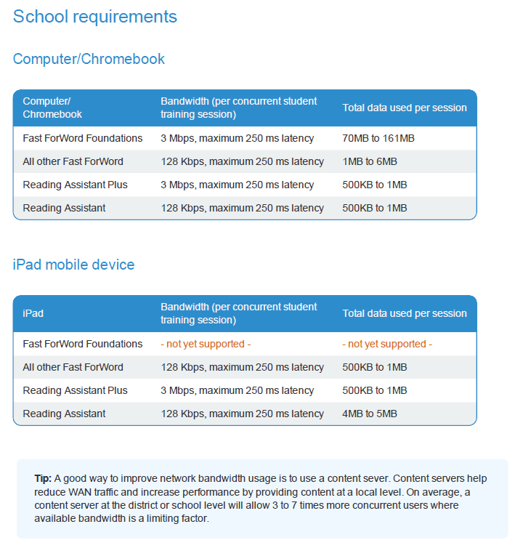

A complete, up-to-date list of Technical Requirements can be obtained from Scientific Learning’s Support Team and the Scientific Learning Support web pages after the *Fast ForWord* and/or *Reading Assistant Plus* products are purchased.

# 

# 

# Professional SERVICES

Scientific Learning has successfully provided training, professional development, consulting services and support for the past 20 years to staff in schools nationwide. Scientific Learning's comprehensive professional development provides school staff with information concerning the science behind the *Fast ForWord* and *Reading Assistant Plus* products and practical guidance for their implementation. The ongoing progress monitoring provided by MySciLEARN Reports enables the classroom teacher to identify student needs and intervene with additional strategies.

Scientific Learning offers the following professional services to ensure smooth implementation of the patented neuroscience based *Fast ForWord* intervention products and *Reading Assistant Plus*. Scientific Learning can build an Implementation Offering tailored to the specific needs of any school district that chooses to implement the *Fast ForWord* and *Reading Assistant Plus* products.

|  |
| --- |
| **Fast ForWord Solution Set MySciLEARN Support Annual Support Package** |
| This package brings together our training and support options to drive implementation success using Fast ForWord. It includes:   * Student Progress Reports – online student/group/school/district reporting * Reading Progress Indicator * Technical and Instructional Support – phone, email, chat and MySciLEARN Resources * Hosting service for MySciLEARN™ * Home Access   **Reading Progress Indicator**  *Reading Progress Indicator* quickly assesses four key skill areas: phonemic awareness, decoding, vocabulary, and comprehension and automatically scores assessments and reports results to parents, teachers, and administrators.  **Product and Implementation Resources**  This site is an on-line learning tool for school personnel to get a more complete understanding of Scientific Learning products and best practices. The 24/7 access also provides valuable start-up information and training for staff who will be dedicated to implementing the Scientific Learning products. These resources are incorporated into MySciLEARN for MySciLEARN customers.  **Hosting**  Scientific Learning will host your SciLEARN™ products in our data center so you can access them over the web anytime anywhere. |

|  |
| --- |
| **Additional Service Options** |
| **Onsite Initial Training/Consulting – Instructional and Technical**  Our SciLEARN implementation specialists will come to the location of your choice to deliver powerful professional development. Onsite service days can be utilized for hands-on initial training, admin training, data reviews, embedded consulting and mentoring in the classroom (no need for subs!), or implementation planning and coaching.  **Web-based Training – Instructional and Technical**  Delivered remotely, 2-hour highly interactive web-based sessions are led by a SciLEARN implementation specialist and will cover a variety of topics to support implementation effectiveness. 15 attendees maximum recommended for each session.  **Remote Consulting**  A consultant is assigned to your account and will assist with your implementation. Your consultant will review your data, monitor progress, and provide guidance on how to achieve lasting student results. |

## Scientific Learning Support Training Materials

**Product Teacher Manuals**

Scientific Learning provides teachers with electronic copies of manuals for each of the *Fast ForWord* productsoffering ideas and content for direct instruction activities andscaffolding instruction for General Education Students, English Language Learners, Special Education Students, and Struggling Readers.

**Initial Training Product Workbooks**

The Initial Training Product Workbooks are comprehensive guides for understanding the best practices in implementation and monitoring student progress, and are the basis for initial training. TheInitial Training Workbook includes detail about how to get your students enrolled, assigned and started along with tips for using each exercise or Reading Assistant Plus selection with ELL or struggling students.

## Additional Professional Development

**The On-Demand Training** section of the MySciLEARN resource site provides on-line, supplemental training support that includes Getting Started videos as well as a variety of videos to help with implementation support. There also are professional development webinars designed to help educators gain a better understanding of different aspects of the programs. The educator training support options prepare school staff to use the *Fast ForWord* and *Reading Assistant Plus* products to their full potential and are a complement to on-site training and web-based training for several reasons:

**Coaches & Instructors**

Coaches and instructors interact directly with the students as they work with the *Fast ForWord* and *Reading Assistant Plus* products. Coaches can be teachers, paraprofessionals, or teaching assistants. They can also be recruited from the community and include parent volunteers, retirees, older adolescents, family members, or other community members. Coaches are trained in the scientific basis and operation of the *Fast ForWord* and *Reading Assistant Plus* products. They may help screen, schedule, and manage the participants who will use the *Fast ForWord* and *Reading Assistant Plus* products. Coaches work with the students and the computers to ensure that the *Fast ForWord* and *Reading Assistant Plus* products are administered correctly and to provide a positive experience. They are an important link to teachers, instructional staff, specialists, and parents because they are present with students continuously during *Fast ForWord* and *Reading Assistant Plus* activities. Coaches perform some or all of the following:

* 1. Ensure student adherence of the *Fast ForWord* and *Reading Assistant Plus* protocol;
  2. Motivate and reward all participants;
  3. Apply creative techniques to help children learn;
  4. Apply technical knowledge to administer the *Fast ForWord* and *Reading Assistant Plus* products and ensure that the computer equipment functions properly;
  5. Communicate with the students’ teachers, parents, or other designated specialists;
  6. Observe student behavior and progress during the various phases of *Fast ForWord* and *Reading Assistant Plus* activity.

Coaches attend Initial Training to learn specific, creative techniques to apply when a child is struggling with a particular *Fast ForWord* exercise or Reading Assistant Plus selection. Scientific Learning also instructs coaches in the technical operation of the devices so they can ensure that each computer, laptop, Chromebook or iPad is ready for student use and to start and run the Scientific Learning products each day. Coaches are instructed in how, immediately after the data are transferred, they can use Scientific Learning’s performance review reports to review each student’s progress for that day or since the beginning of *Fast ForWord* and *Reading Assistant Plus* activity. Coaches who read and interpret the performance reviews can individualize participation for the students, coaching them by providing activities outside the *Fast ForWord* session to help them with areas of particular difficulty. Coaches also have access to a full library of training manuals, videos and MySciLEARN’s online Resource Library to support them in administering the *Fast ForWord* and *Reading Assistant Plus* products.

## Qualifications of Scientific Learning Trainers

Since its incorporation in 1997, Scientific Learning has successfully provided training and support to staff in schools nationwide, from small implementations of 5 to 10 students to implementations in 125 schools in a major metropolitan city.

Scientific Learning has a staff of seasoned and certified implementation professionals that make sure every implementation is successful. Approximately 75% of our trainers and consultants have advanced degrees, and typically 60-80% of our staff at a given time has worked as educators in K-12 schools. Included among them are audiologists, Speech Language Pathologists, Special Education teachers, former administrators (site and district level), former teachers and former *Fast ForWord* lab coaches.

All Scientific Learningtrainers go through a certification process which incorporates content knowledge (products, neuroscience research, best practices for implementation), field observations and practice training situations. During the certification process, trainers are teamed with a more senior consultant for ongoing mentoring in the field. All certified trainers participate in ongoing professional development designed to deepen product knowledge, expand presentation skills, and increase general knowledge about educators and effective consulting.

Scientific Learning online and phone support personnel also go through training on the technical/instructional and procedural aspects of working with *Fast ForWord* and *Reading Assistant Plus* products and implementations in a variety of situations. This training includes a self-paced curriculum, certification test, and ongoing coaching and monitoring.

# 

# Parental Involvement

## Parent Activities

Because parents and families are critical to a child’s success, the *Fast ForWord* and *Reading Assistant Plus* products encourage a variety of parent education activities and are a unique opportunity for parents to become integrally involved along with the schools’ educational staff in their children’s education.

*Fast ForWord* and *Reading Assistant Plus* activities for parents will substantially strengthen the team approach to education at the school and serve as a vehicle to model and redefine the role of parents in children’s schooling. This will assist the maintenance of the project for subsequent years and generally broaden the school’s ability to engage parents in the educational process. Strategies to involve parents, demonstrating how they can assist and participate in literacy activities and help their children through their *Fast ForWord* and *Reading Assistant Plus* sessions, include the following.

* + - Parents may volunteer as coaches and complete *Fast ForWord* and *Reading Assistant Plus* implementation training prior to working with the children.
    - Parents with their own language/reading difficulties, whether due to low reading proficiency or English as a second language, may consider using the *Fast ForWord* and/or *Reading Assistant Plus* products, at the discretion of the district.
    - The district can schedule a parent informational meeting on brain plasticity research and its implication with language learning of students, the proposed intervention with demonstrations of the *Fast ForWord* and *Reading Assistant Plus* products, and the role of parents.
    - The district can offer regular parent/teacher conferences and *Fast ForWord* and *Reading Assistant Plus* implementation training sessions.
    - Districts can email student MySciLEARNreports to their parents.
    - Parents can consult with teachers and/or coaches on the progress of their child by examining his/her *Fast ForWord* and *Reading Assistant Plus* MySciLEARNreports.
    - Parents may complete initial, on-going, and final observational surveys with information on their child's ability to communicate clearly, follow verbal instructions, and recall information.
    - Parents can help students comply with the *Fast ForWord* and *Reading Assistant Plus* protocol by minimizing absences and encouraging students to stay motivated.
    - Parents will be given guidance in how they may directly support their child’s language development skills at home. For example, by reviewing reports created by MySciLEARNspecifying the phoneme pairs that their child finds difficult, parents have the opportunity to practice and reinforce those sounds with their child at home.

## Student Progress Reports for Parents

*Fast ForWord* and Reading Assistant Plus provide an easy to use email feature that can automatically send selected MySciLEARN reports to parents on a daily or weekly basis. These reports can be customized to reflect each recipient’s needs. Each report is formatted as a PDF document and attached to the email. With these automatic notifications, parents stay informed and up to date.

Individual reports available for emailing include:

* Implementation Success,
* Gains,
* Progress History
* Error Reports
* Weekly Achievement Report, and
* Comprehension Report

# 

# Activities

*In this section of a grant application, an applicant needs to describe concrete activities that relevant participants will perform to achieve the project’s goals and set its strategies in motion. Tied to the preceding Goals, the following are some possible Activities incorporating the* Fast ForWord and Reading Assistant Plus *products that you can use in your grant template.*

1. Activity:  
   Students participate in *Fast ForWord* activity for 20-60 sessions 3-5 days per week over the course of a semester.
2. Activity:  
   Students participate in *Reading Assistant Plus* activity for 25-40 sessions 2-3 days per week over the course of a semester.
3. Activity:  
   Have teachers attend Scientific Learning’s professional development seminar for the *Fast ForWord* and *Reading Assistant Plus* products, as well as utilize Scientific Learning’s professional development materials, including product training.
4. Activity:  
   Have parents attend Scientific Learning’s implementation seminar so that they can serve as coaches for students using the *Fast ForWord* and *Reading Assistant Plus* products, instruct parents in ways they can work at home with their children on language and reading skills they find difficult, and, when appropriate and at the discretion of the district, have parents themselves use the *Fast ForWord* and/or *Reading Assistant Plus* products.
5. Activity:  
   Students use the *Fast ForWord* products which are based on 30 years of neuroscience research into the ways the brain learns, have been tested in the field and independently, and have been administered to 4,000,000 students nationwide.
6. Activity:  
   Students use Scientific Learning’s *Fast ForWord Reading Readiness*.
7. Activity:  
   Students who have been identified with language or reading difficulties prior to completion of kindergarten work with *Fast ForWord Foundations I*. Because this is a relatively short, intense product (four to sixteen weeks), participation can happen at the end of the kindergarten year, during the summer, or at the beginning of the first grade year and can take place before, during, or after school hours.
8. Activity:  
   Students work with the *Fast ForWord* and *Reading Assistant Plus* products which calibrate to each student’s skill level and advance according to students’ individual progress.
9. Activity:  
   Middle and high school students in danger of dropping out use the *Fast ForWord* and *Reading Assistant Plus* products which will give them the language, reading, and learning skills they need to bring their abilities to grade level proficiency.
10. Activity:  
    Adult students use the *Fast ForWord* and *Reading Assistant Plus* products in order to gain language and reading skills they never acquired or in order to improve the skills they have.

# 

# Expected Outcomes and Benchmarks

Applicants may also be asked to project what the results of their project will be. The following are some possible Expected Outcomes and Measurable Benchmarks incorporating the Fast ForWord products that you can use in your grant application to show how the preceding goals have been met.

## 

## Expected Outcomes

1. Expected Outcome:  
   Students make gains of 1-2 years, on average, in the foundational skills that are critical for being able to read by third grade.
2. Expected Outcome:  
   At-risk students make gains of 1-2 years, on average, in the foundational skills that are critical for reading and learning, enabling them to stay out of special education and stay in the general student population.
3. Expected Outcome:  
   Teachers will know more about how the development of cognitive, oral language, and reading skills creates good learners and readers and will learn how to effectively implement and sustain good implementation of the *Fast ForWord* and *Reading Assistant Plus* products.
4. Expected Outcome:  
   Parents will become more involved with their children’s reading and education, enabling higher achievement for their children.
5. Expected Outcome:  
   Students make gains of 1-2 years, on average, in the foundational skills that are critical for being able to read by third grade, and students increase their capacity to learn and read.
6. Expected Outcome:  
   Students receive comprehensive development of key skills they need early to be ready to learn to read.
7. Expected Outcome:  
   Students attain quickly the language skills they need for literacy, facilitating a smooth kindergarten to first grade transition.
8. Expected Outcome:  
   Students proceed through the suite of *Fast ForWord* products at their own speed. This adaptability of the *Fast ForWord* products builds students’ confidence and self-esteem in their abilities, which in turn motivates them to read and learn more.
9. Expected Outcome:  
   Middle and high school students acquire language, reading, and learning skills which enable them to become more engaged in their education and stay in school.
10. Expected Outcome:  
    Adult students gain the ability to read or read better.
11. Expected Outcome:  
    Students increase reading fluency with the assistance of guided oral reading practice using research-validated speech verification technology in Reading Assistant Plus.

## Measurable Benchmarks

1. Measurable Benchmark:  
\_\_\_\_\_\_ % of students make gains of 1-2 years, on average, in the foundational skills that are critical for being able to read by the end of third grade

2. Measurable Benchmark:  
\_\_\_\_\_\_ % of at-risk students make gains of 1-2 years, on average, in the foundational skills that are critical for reading and learning, enabling them to stay out of special education and stay in the general student population.

3. Measurable Benchmark:  
\_\_\_\_\_\_ % of teachers know more about the importance of phonological awareness, decoding, fluency, vocabulary, and listening accuracy in students’ reading acquisition, and have more tools at their disposal to help them address their students’ reading needs.

4. Measurable Benchmark:  
\_\_\_\_\_\_ % of parents become more involved with their children’s reading and education, enabling higher achievement for their children.  
\_\_\_\_\_\_ % of parents become *Fast ForWord* and *Reading Assistant Plus* coaches.

5. Measurable Benchmark:  
\_\_\_\_\_\_ % of students make gains of 1-2 years, on average, in the foundational skills that are critical for being able to read, and students increase their capacity to learn and read.

6. Measurable Benchmark:  
\_\_\_\_\_\_ % of students receive comprehensive development of key skills they need early to be ready to learn to read.

7. Measurable Benchmark:  
\_\_\_\_\_\_ % of students attain quickly the language skills they need for literacy, facilitating a smooth kindergarten to first grade transition.

1. Measurable Benchmark:  
   \_\_\_\_\_\_ % of students proceed through the suite of *Fast ForWord* and *Reading Assistant Plus* products at their own speed and show more interest in reading.
2. Measurable Benchmark:  
   \_\_\_\_\_\_ % increase in students staying in school.
3. Measurable Benchmark:  
   \_\_\_\_\_\_ % increase in adults able to read.
4. Measurable Benchmark:  
   \_\_\_\_\_\_ % of students increase reading fluency.

# 

# Timelines

Your grant may ask you for a timeline for your project. The following are two sample timelines for implementation of the Fast ForWord and Reading Assistant Plus products. The first timeline deals with implementation of the Fast ForWord and Reading Assistant Plus products; the second deals with parental/community involvement. Your timeline may include some or all of these components, plus additional ones. Every project will devote different amounts of time to different activities. No amounts of time have been included here so that applicants can insert their own time estimates for each activity.

NOTE: For other timelines, see the more detailed Implementation Timeline on pages 43-45 and the Professional Development Plan on page 54.

## *Fast ForWord* AND READING ASSISTANT PLUS Implementation Timeline

* Set up school/district meeting to disseminate grant information and product components to administrators and educators.
* Set up staff Professional Development training with Scientific Learning.
* Ensure that computers and equipment meet technical requirements.
* Assess students using district-designated instrument.
* Rank assessment scores and select students to participate in *Fast ForWord* and *Reading Assistant Plus*.
* Host a Parent Night to explain grant information and product components and solicit volunteer coaches.
* Recruit high school, senior citizen, and civic community volunteer coaches.
* Provide training for coaches.
* Enroll appropriate students.
* Students begin using the *Fast ForWord* and *Reading Assistant Plus* products;
* Evaluate students’ progress using daily MySciLEARN reports.
* Students finish using the *Fast ForWord* and *Reading Assistant Plus* products;
* Assess students using appropriate test.
* Evaluate the product and its effectiveness.
* Re-align curriculum to new level of students’ reading abilities.
* Hold community meeting to inform parents and community members about the outcomes.
* Disseminate product information and results to other interested educators in the district and state.

## Parental/Community Involvement Timeline

* Parent/Community Information Meeting;
* Parent/Community conferences with teachers bi-weekly during *Fast ForWord* and *Reading Assistant Plus* activity;
* Parent/Community access to library books;
* Parents/Community Members work with the *Fast ForWord* and *Reading Assistant Plus* products (at the discretion of the district) to improve their own reading/literacy skills;
* Parents/Community Members serve as school volunteers;
* Parents/Community Members train as Scientific Learningcoaches;
* Parents/Community Members serve on Advisory Councils;
* Parents review MySciLEARNreports and practice phoneme pairs and sounds with the student at home.

# Evaluation

*Grant applications will generally ask for your plan to monitor the progress of your students and evaluate the success of your project. The following text describes Scientific Learning’s powerful MySciLEARN reports for monitoring student progress, Scientific Learning’s assessment tool –* Reading Progress Indicator *– and other suggestions for evaluating student progress, and information about and suggestions for* Fast ForWord and *Reading Assistant Plus project evaluations.*

## MySciLEARN Results Reports

MySciLEARN reports are online data analysis and reporting tools that enable educators to monitor individual, classroom, school, or district performance of students working with the *Fast ForWord* and *Reading Assistant Plus* programs. Staff get clear, action-oriented information showing student progress over time, in specific reading and cognitive skill areas. The data in these reports are one of the reasons why the *Fast ForWord* and *Reading Assistant Plus* learning acceleration programs have been so successful in helping schools and districts meet state and federal mandates.

On the MySciLEARN Results tab, teachers can see a variety of reports both at the administrative and school levels, according to who is viewing the reports. Four levels of reports are available: district, school, group and individual student.

MySciLEARN Reports for Fast ForWord include: Implementation Success, Gains, Success Forecast, Progress History, Completion, and Error Reports. My SciLEARN Reports for Reading Assistant Plus include: Implementation Success, Audio Recordings, Comprehension, and Reading Selection Success Reports.

The following are examples of progress reports provided by Scientific Learning’s MySciLEARN platform.

***Fast ForWord* MySciLEARN Results Reports**

*Fast ForWord* MySciLEARN Implementation Success Report

The Implementation Success Reports for *Fast ForWord* show product usage information and measures of success at all four levels (district, school, group, and student). With changes in usage over time, staff can make sure students are on track. And staff has easy access to Alerts and Error Reports to help struggling students.

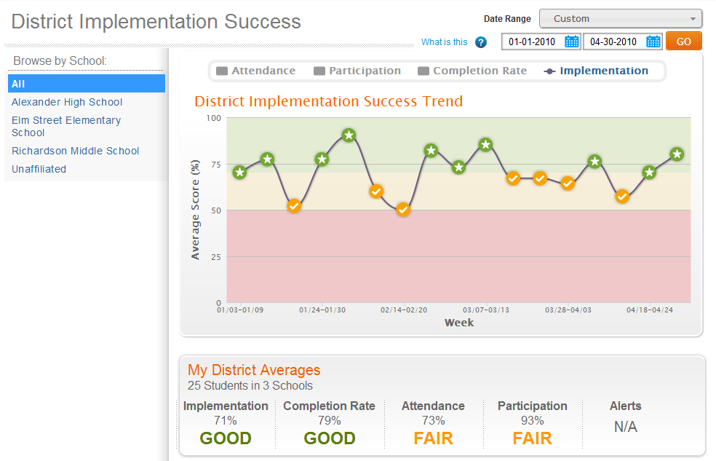

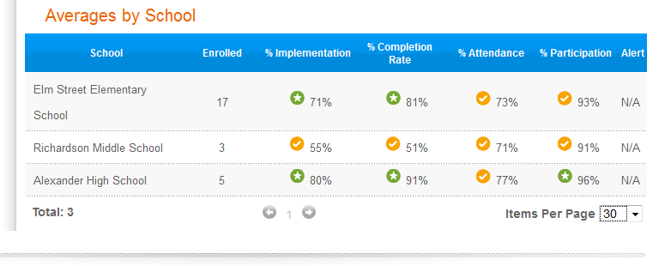

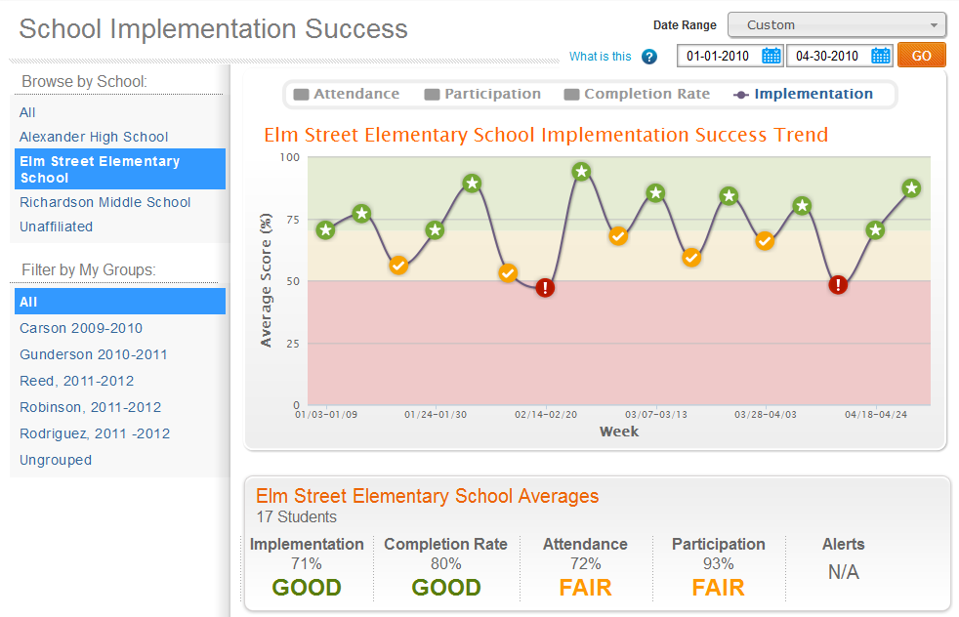

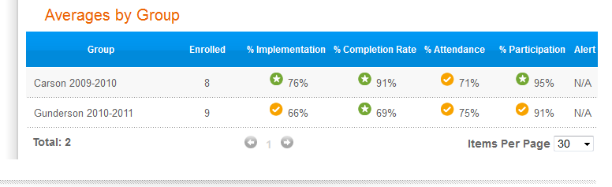

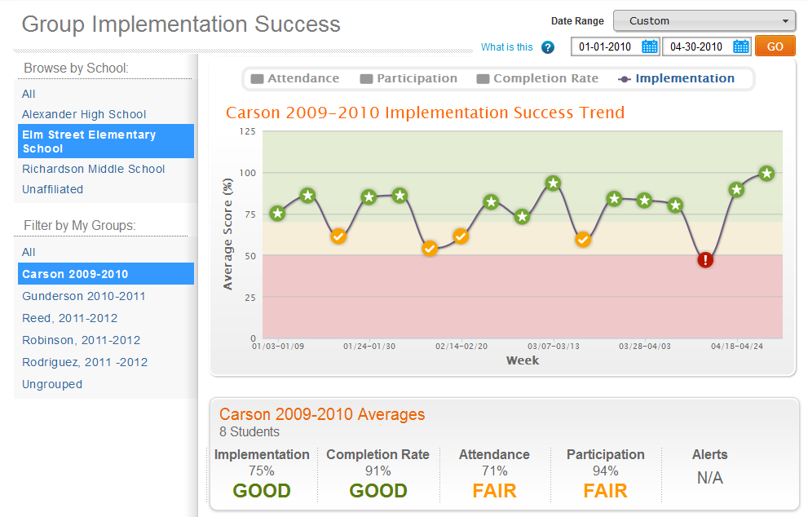

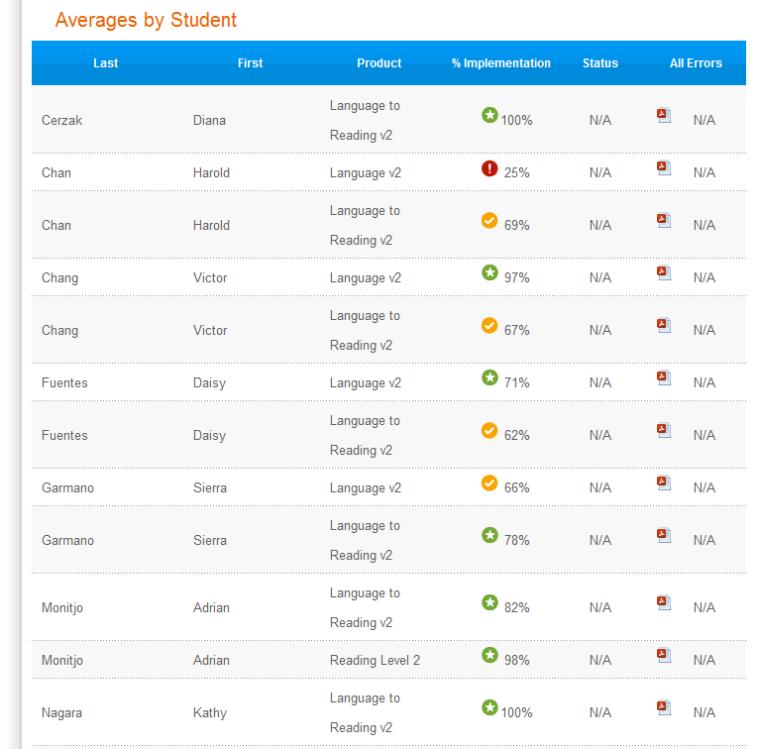

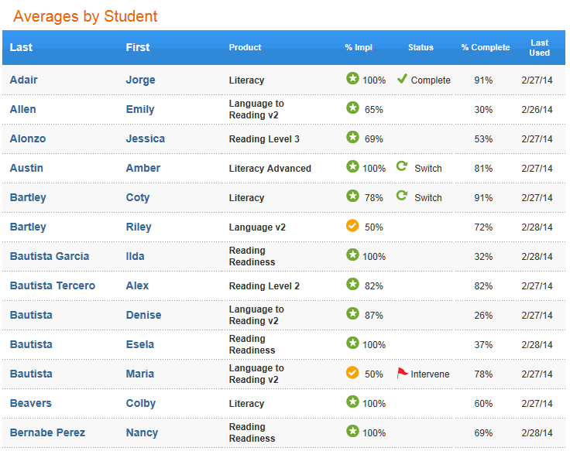

*Fast ForWord* MySciLEARN Gains Report

The Gains Report for *Fast ForWord* displays information about reading level gains at all four of the levels: district, school, group, and individual student. It communicates student growth in terms of percentile scores, proficiency levels, and grade equivalents. The Gains Report also contains a complete Reading Progress Indicator test history for all students.

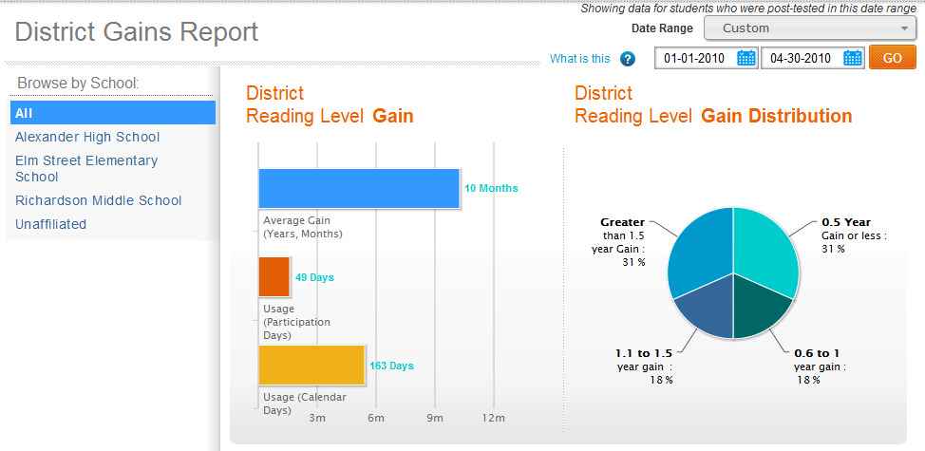

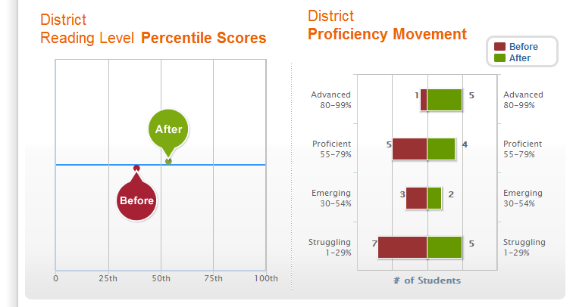

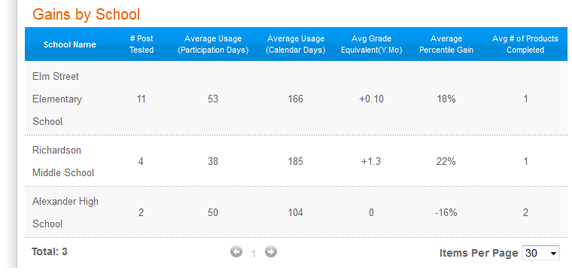

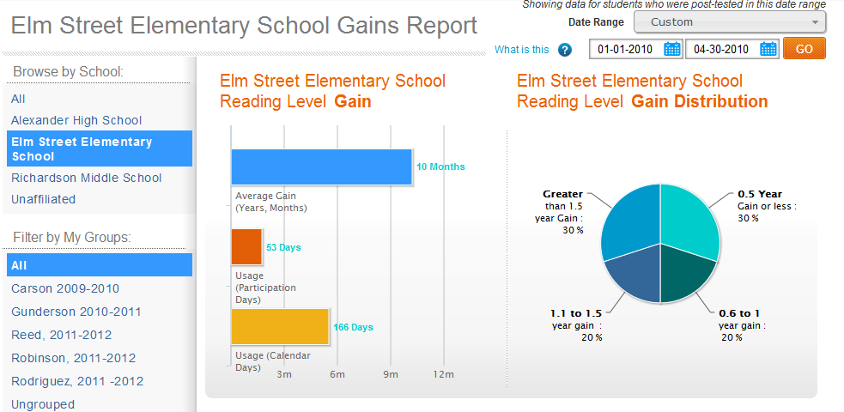

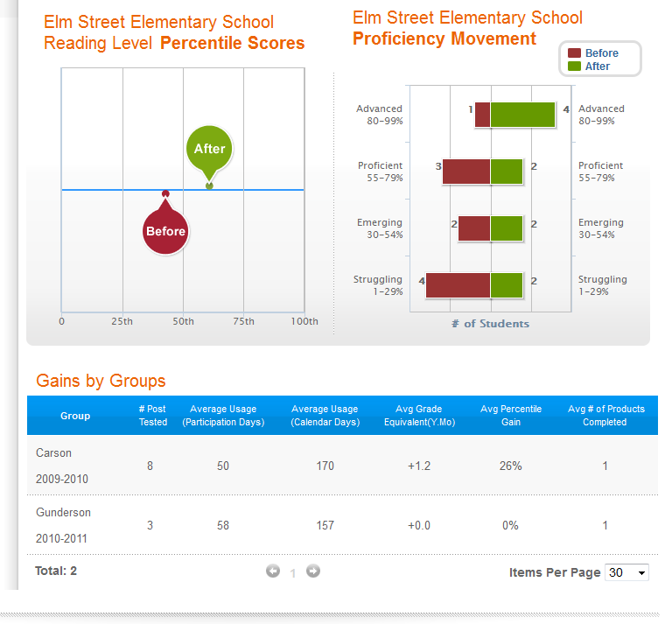

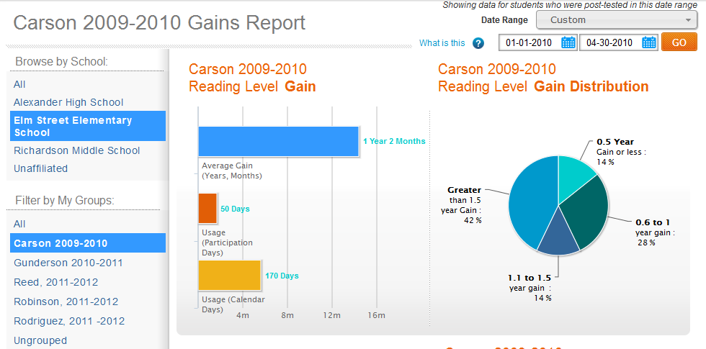

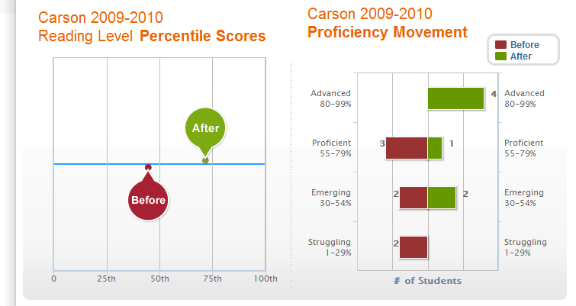

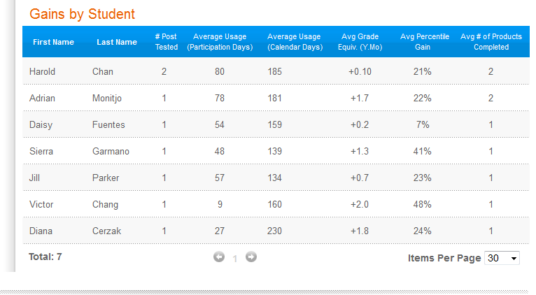

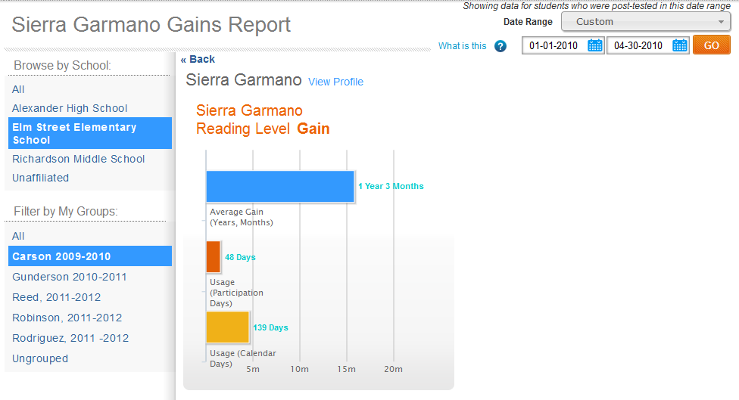

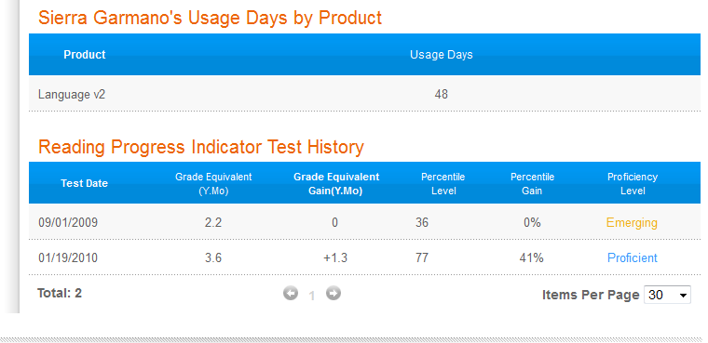

*Fast ForWord* MySciLEARN Success Forecast Reports

Success Forecast Reports for *Fast ForWord* give a prediction of what improvement schools will see in the general student population, students in Special Education, and English language learners if they properly implement the products. Staff can enter the enrollment data for general education students, students in Special Education, and English language learners and their average proficiency percentage for each group to get the graphs.

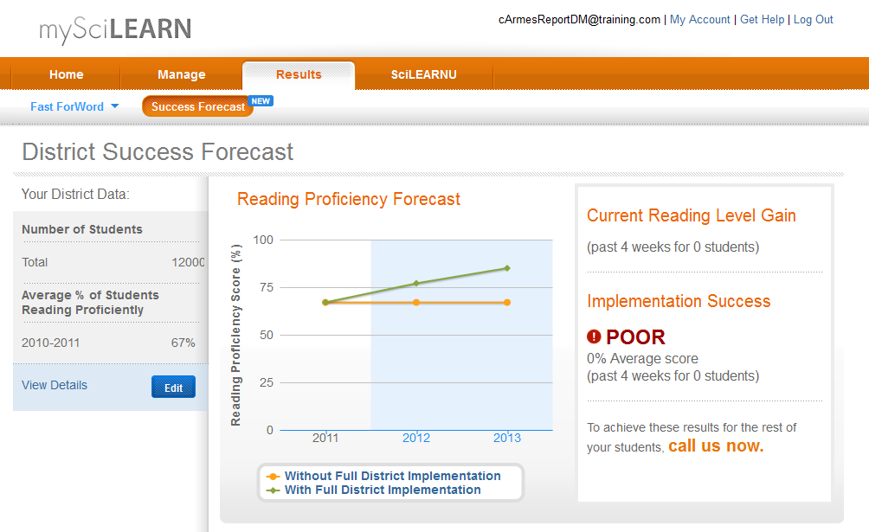

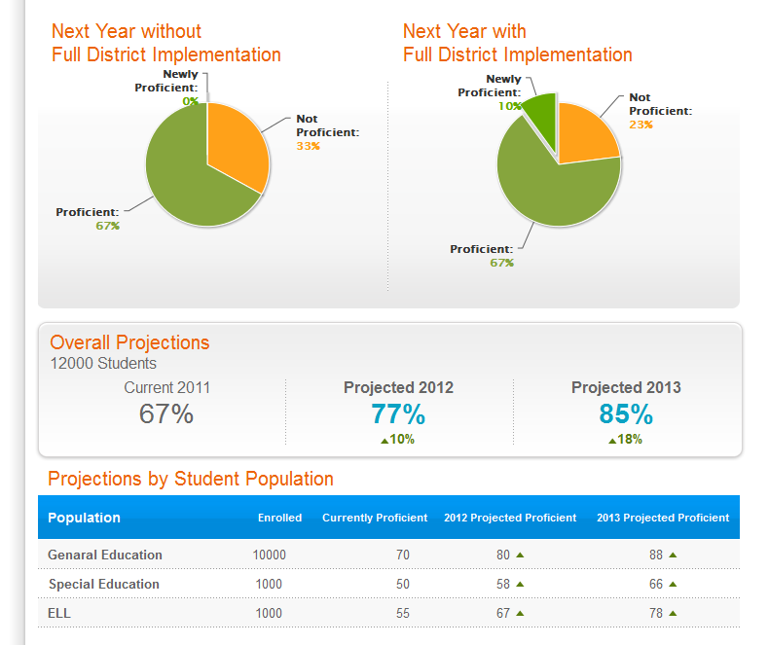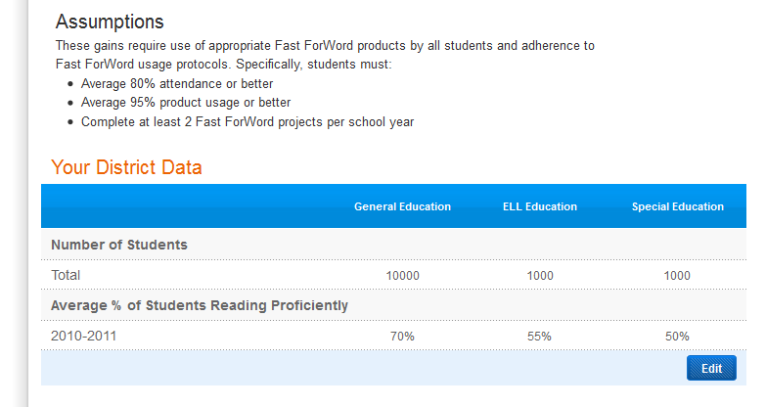

*Fast ForWord* MySciLEARN Progress History Report

The Progress History Report provides a view into a student’s overall implementation success including their completion rate, attendance, participation, and significant alerts, as well as exercise Completion details and Error Reports. This report provides the educator with a choice of date ranges, ‘This Week’, ‘Last Week’, ‘Last 4 Weeks, and a custom date range.

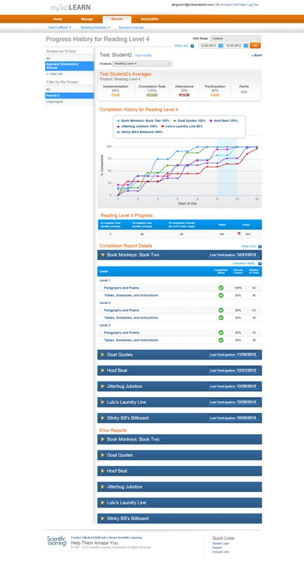

*Fast ForWord* MySciLEARN Completion Report

Staff use the MySciLEARN Completion Report in order to more efficiently and quickly assess the progress within each exercise for each of their students. The completion report tells staff how a student is progressing through each exercise level or exercise set. The completion report shows completion status as complete, or in progress, and also indicates whether the criteria for advancement within the level, group or set has been met. The report will show the educator the number of trials worked on by the student for each level, group or set, up to and including their last participation day.

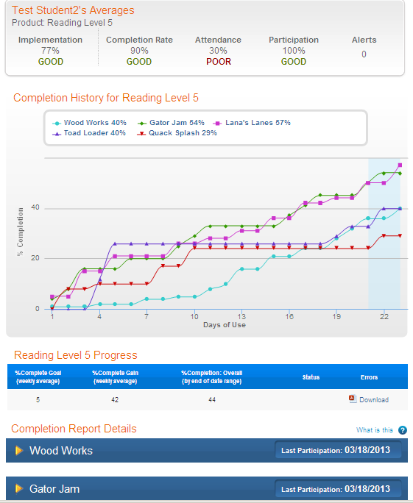

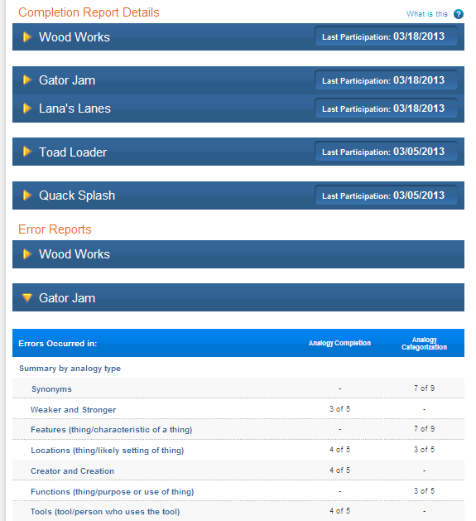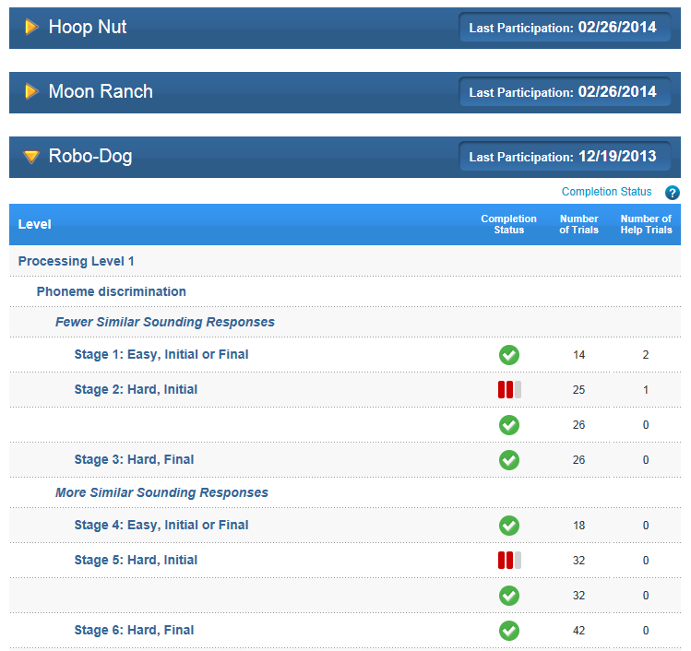

*Fast ForWord* MySciLEARN Error Report

This report displays the errors for each exercise on which the student has worked. Teachers can use this report to gain insight into the areas of difficulty for each student and can determine which skills and objectives need further reinforcement or re-teaching in the classroom. This report displays:

* Errors that occurred within the date range selected
* *Errors Occurred In*: Level or set in which the student made errors. It includes the actual content on which the student was working.
* *Correct Out of Attempts*: Number of correct attempts out of the total number of attempts made in that content.



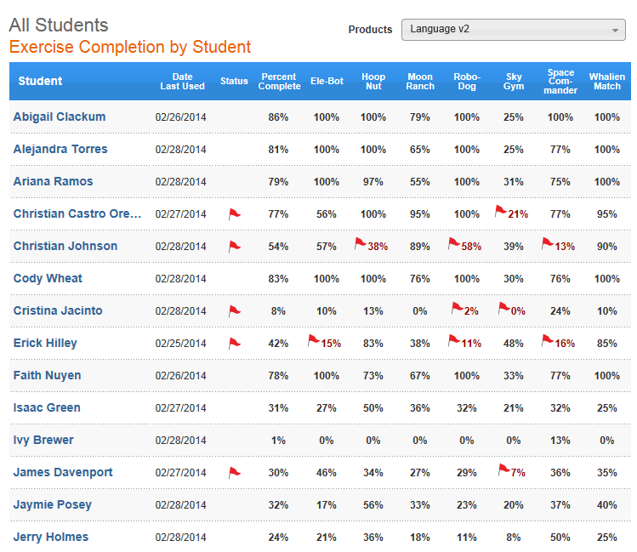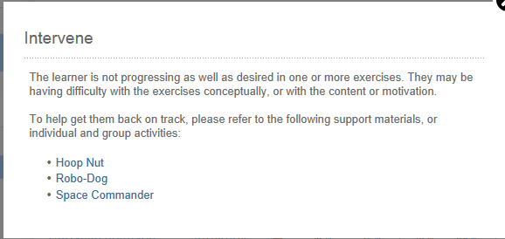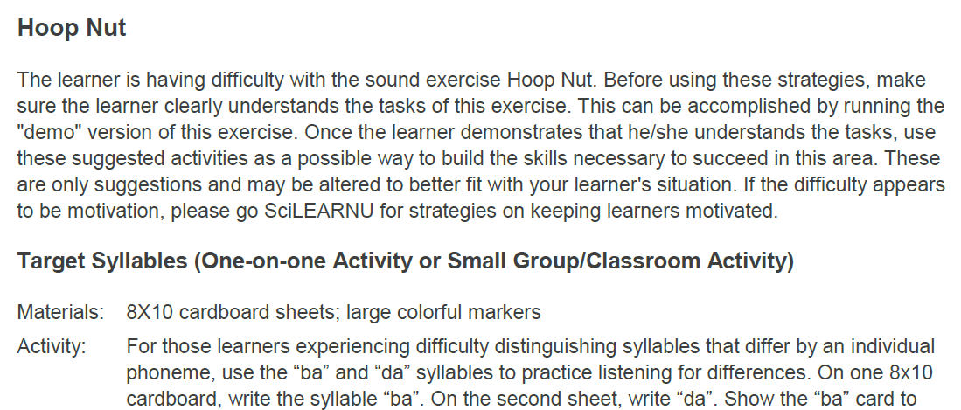

***Reading Assistant Plus* MySciLEARN Results Reports**

*Reading Assistant Plus* MySciLEARN Implementation Success Report

The Implementation Success Reports for *Reading Assistant Plus* show product usage information and measures of success at all four levels (district, school, group, and student). Usage over time and reading level trends are displayed, as well as performance data, all enabling staff to monitor students and help them stay on track. And staff has easy access to Alerts and Error Reports to help struggling students.

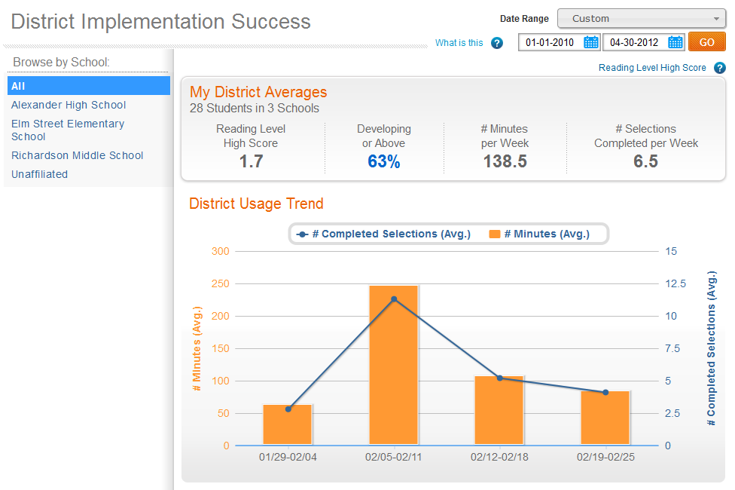

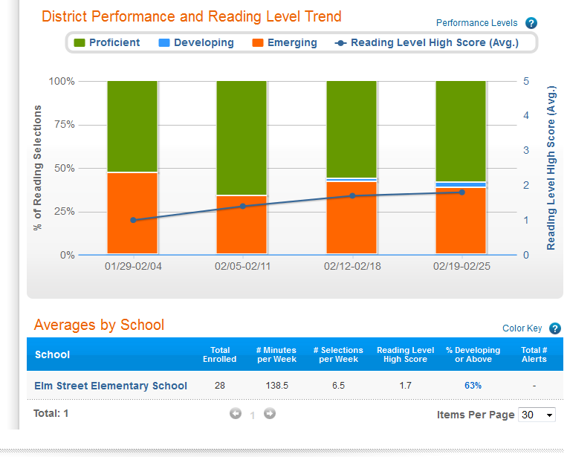

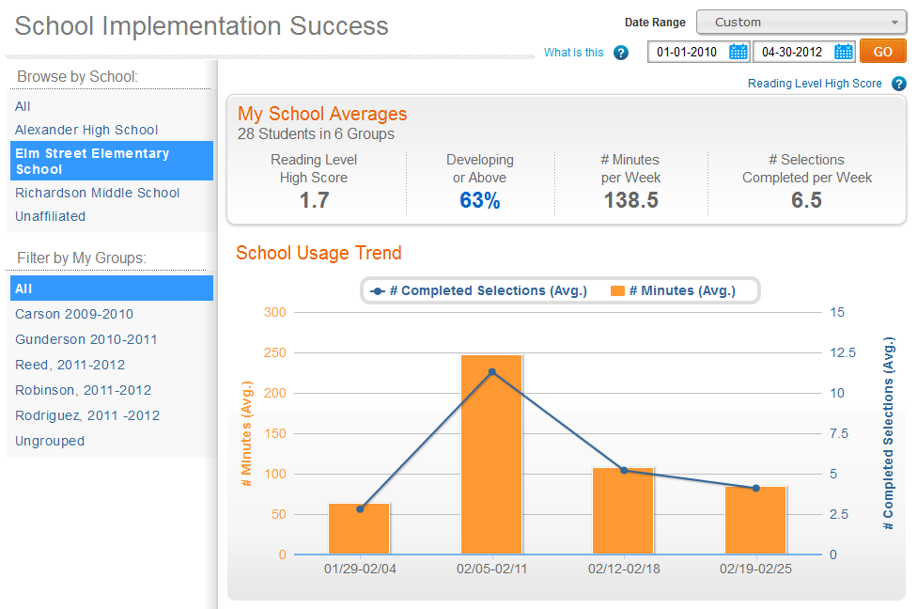

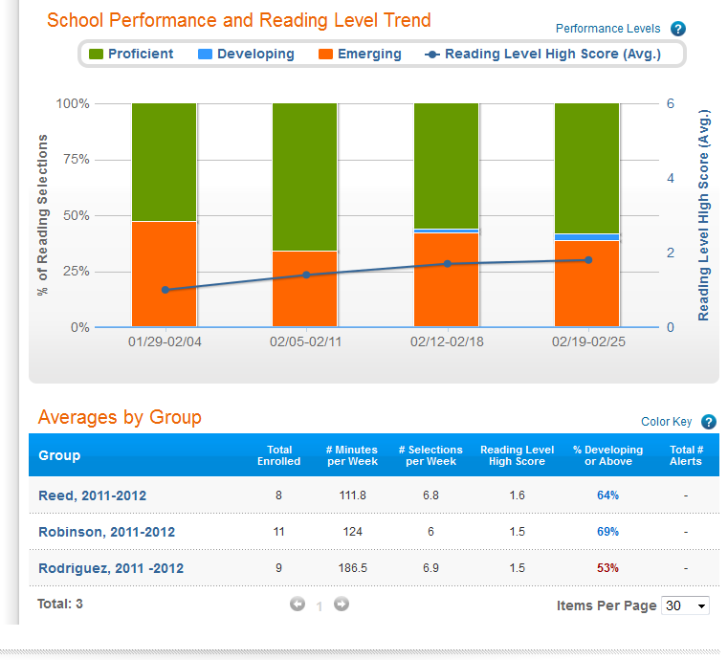

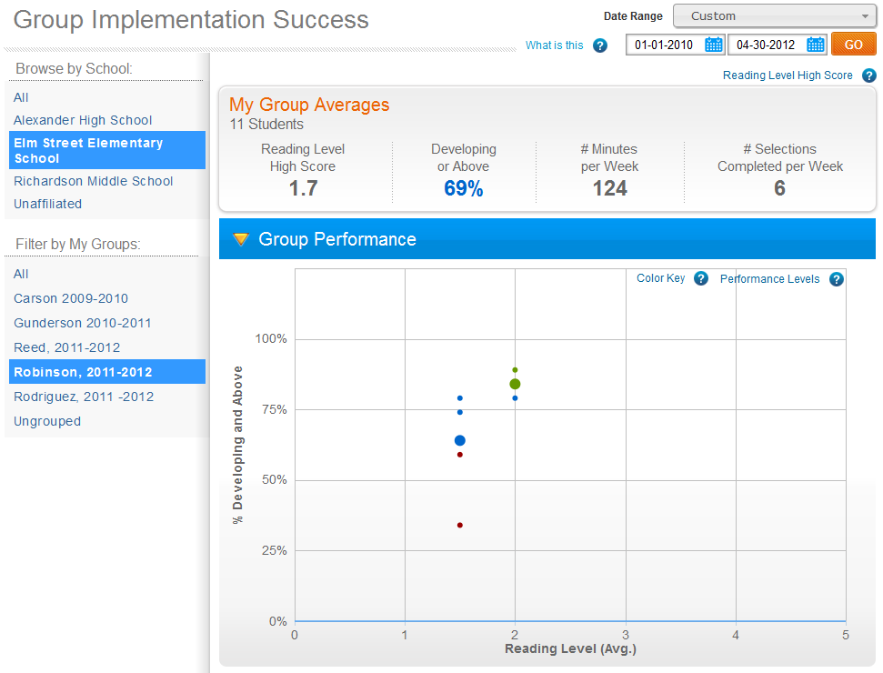

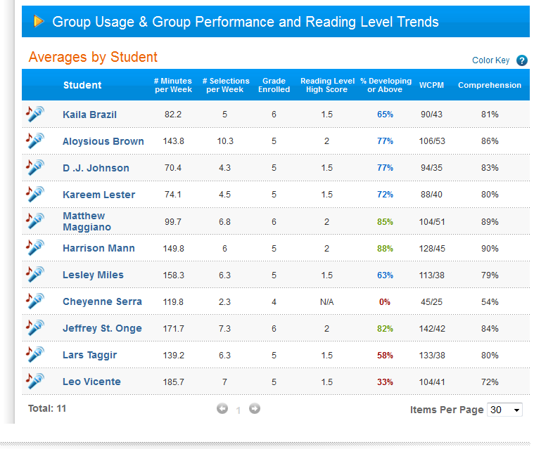

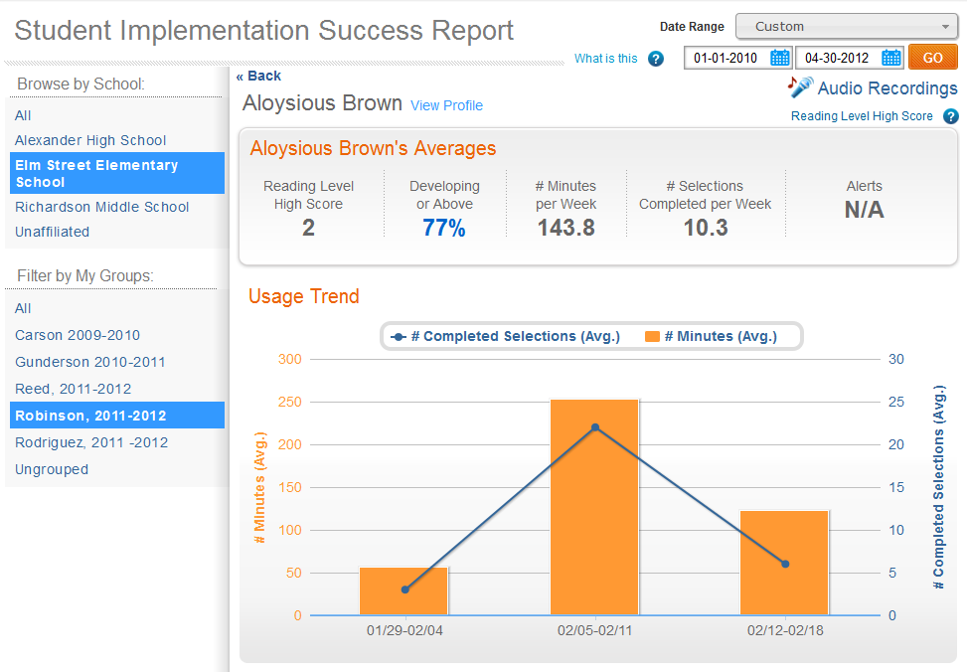

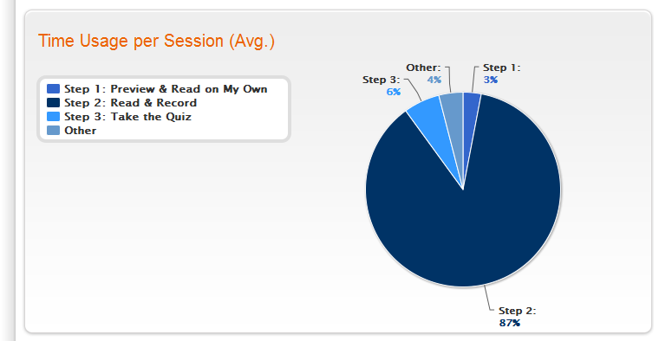

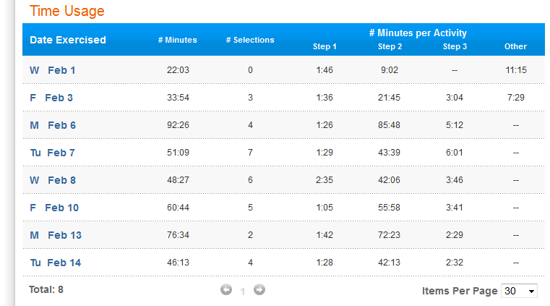

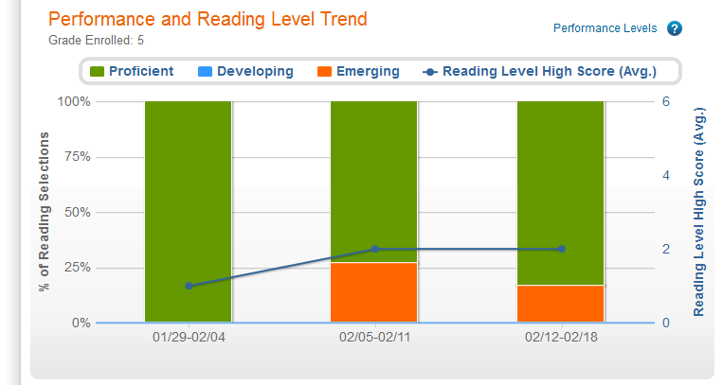

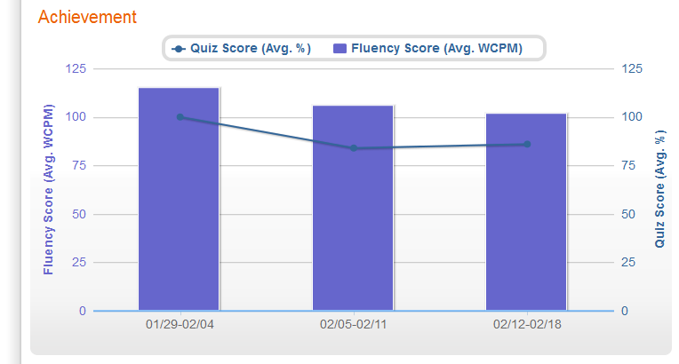

*Reading Assistant Plus* MySciLEARN Audio Recordings Report

Clicking on “Audio Recordings” in the *Reading Assistant Plus* MySciLEARN “Student Implementation Success Report” will provide staff with a list of the selections that the student has read.

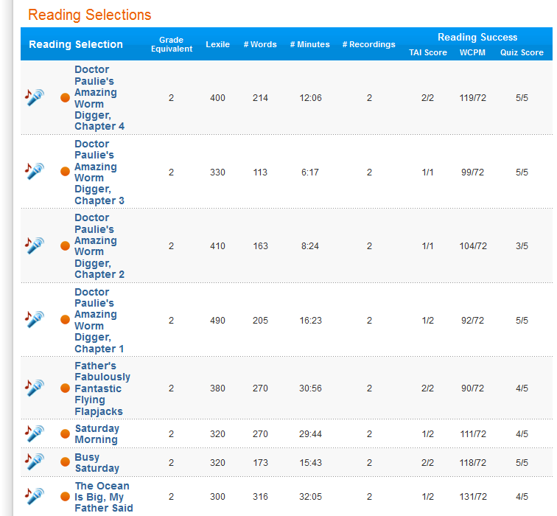

*Recording Details*

Clicking on any of the reading selections will provide staff with details about that particular text and the student’s progress with it. Details are provided in four areas:

* Selection: The text of the reading selection is displayed, and the student’s reading of the selection can be listened to.
* Words to Practice: The words that the student had trouble with and needs to practice are displayed.
* Think About Its: Shows ideas related to the reading selection that the student is asked to think about and the student’s responses.
* Quiz: Shows questions about the text that the student is quizzed on and his/her answers.

*Recording Details: Selection*

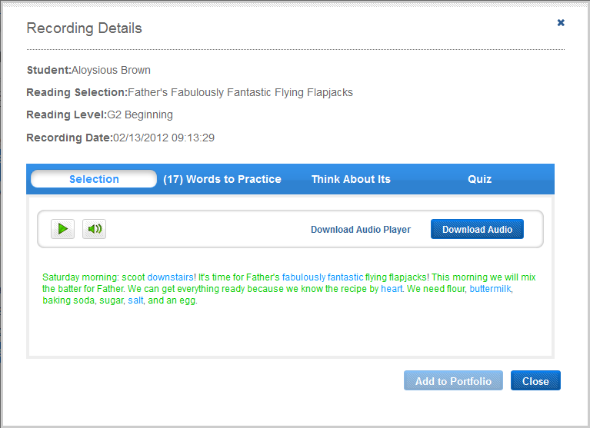

*Recording Details: Words to Practice*

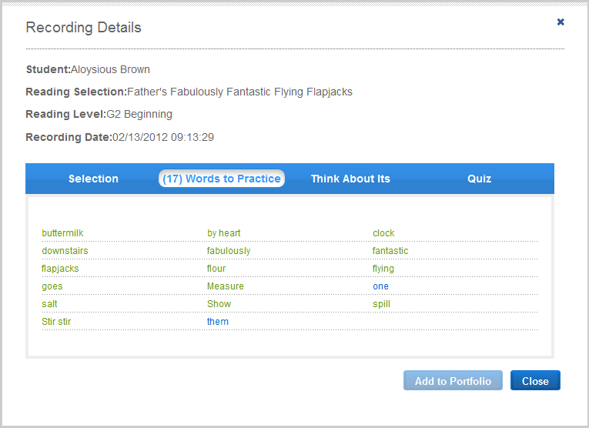

*Recording Details: Think About Its*

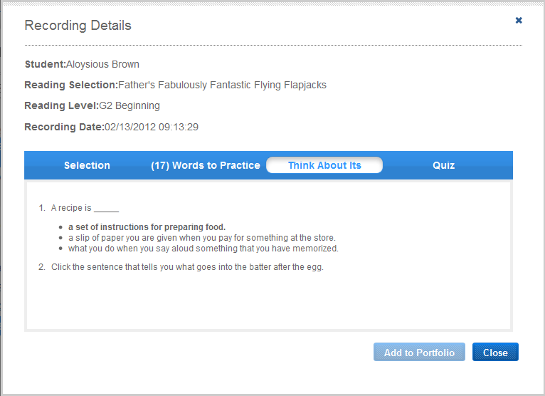

*Recording Details: Quiz*

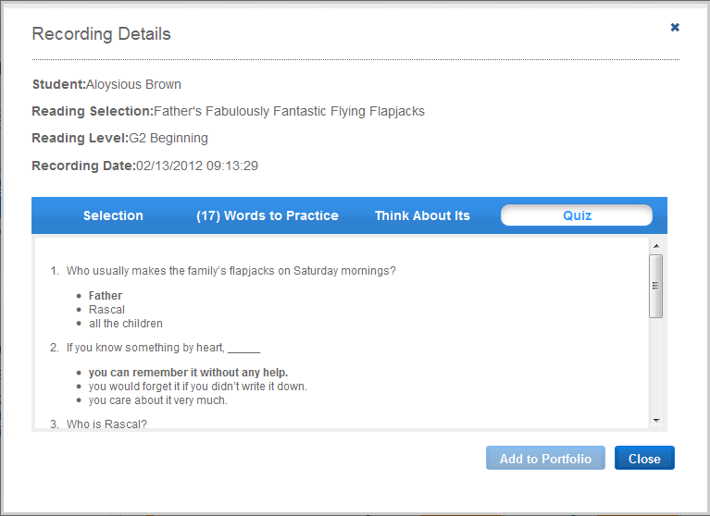

*Reading Assistant Plus* MySciLEARN Comprehension Report

The Comprehension Report provides a graphic summary of students’ performance on the Reading Assistant Plus quiz questions in regard to skills, strategies and levels of thinking.

Comprehension Reports are available at two levels: group and individual student.

*Group Comprehension Reports*

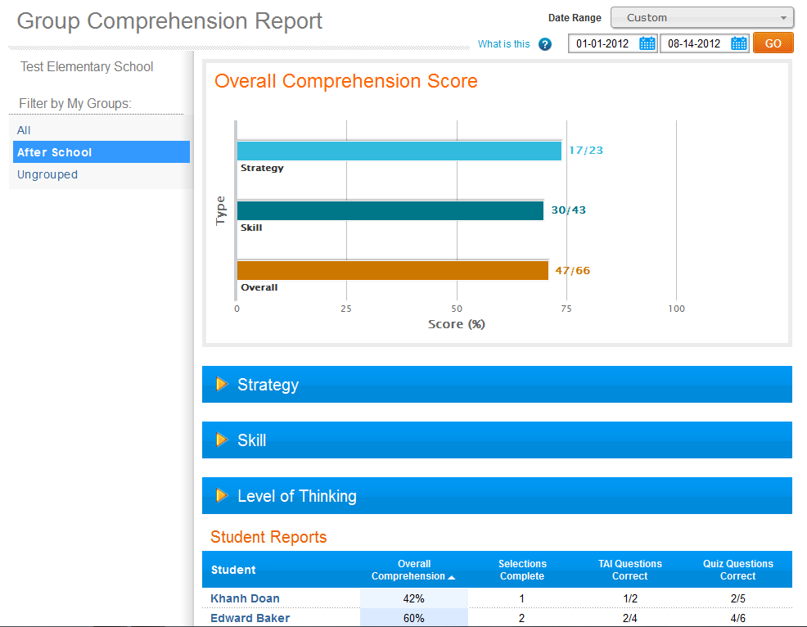

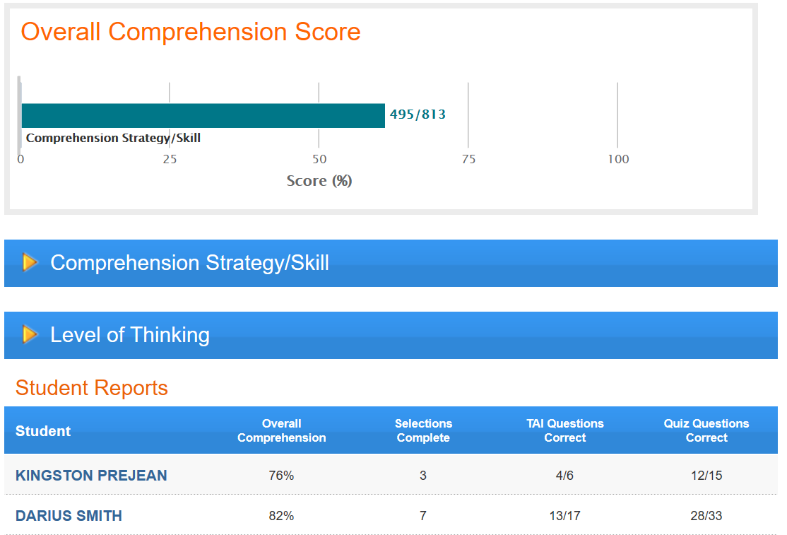

Within the Comprehension Strategy/Skill section, you can see the number correct out of all attempted for such types of questions as prediction, using prior knowledge and identifying a reading purpose.

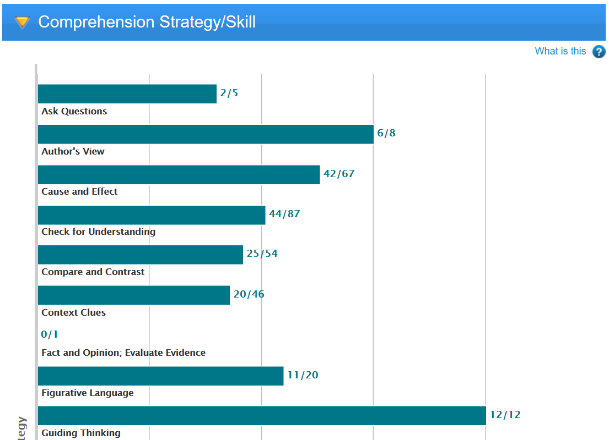

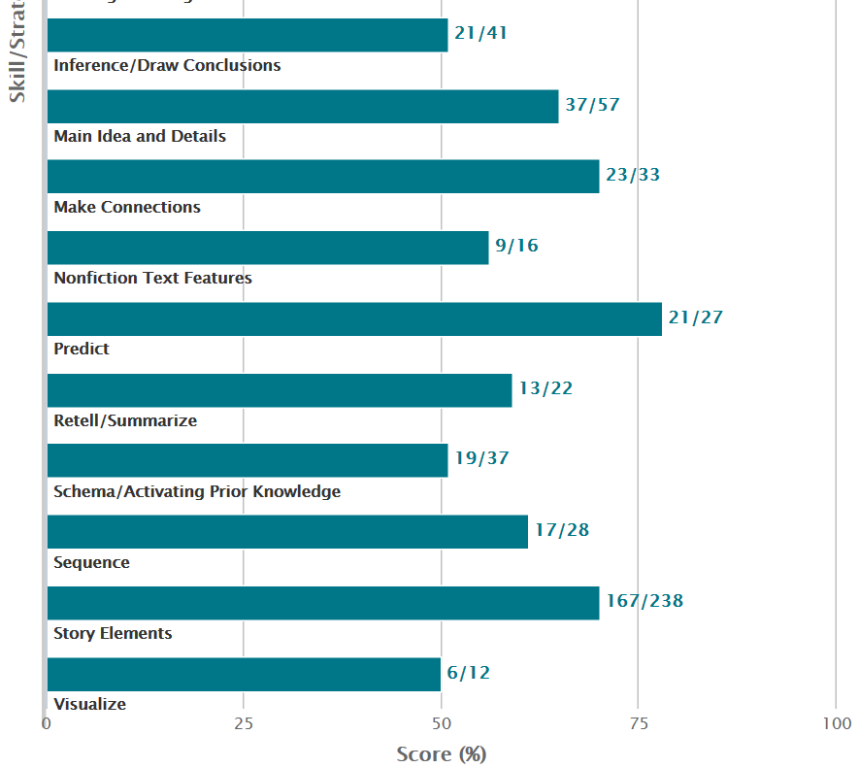

The skill section incudes questions such as compare and contrast, cause and effect and main idea.

The level of thinking portion shows the scoring results for four types of questions: evaluation, inferential thinking, literal thinking and analysis.

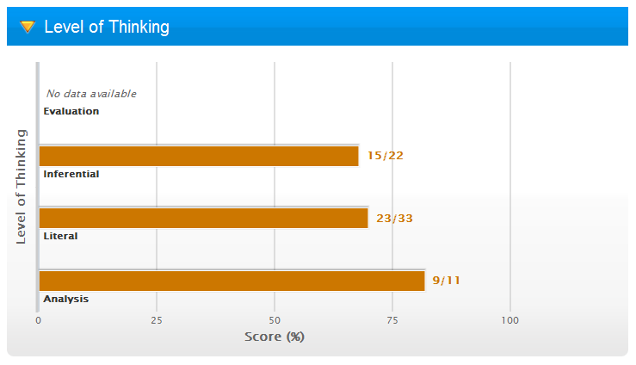

These are the same types of questions included on state assessments and, with this detailed information, you know what areas need re-teaching or additional review.

*Individual Comprehension Reports*

More detailed information is available in the Comprehension Report at the individual student level. By clicking at the top of the report on either the Strategy, Skill, or Overall bar, additional Think About It or Quiz question information is provided.

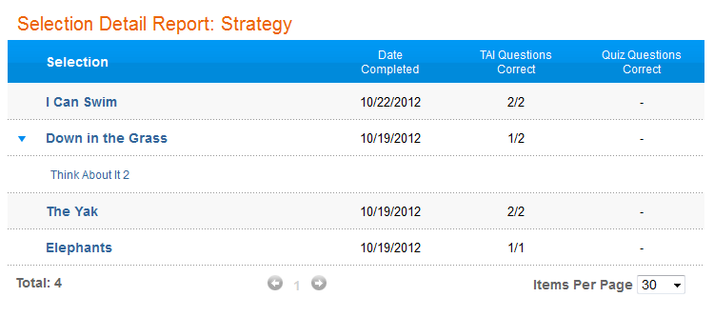

Within the Detail Report, more information can be obtained for individual selections by clicking on the small triangles before the title and then by selecting either the Think About It or Quiz items listed to order a Selection Error Report.

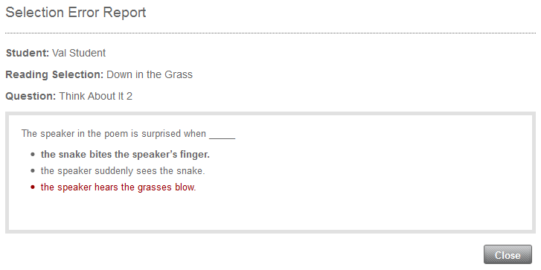

Additional examples are provided below for the Skills and Overall categories.

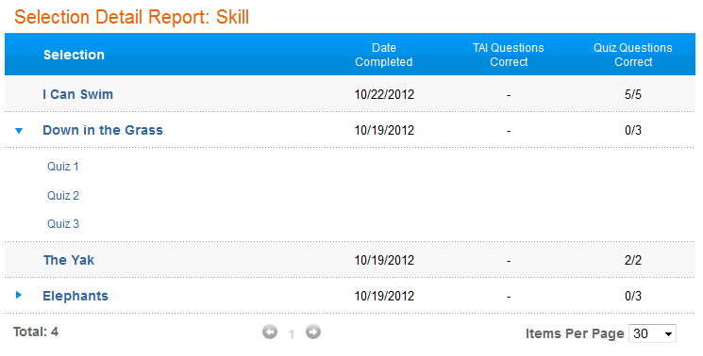

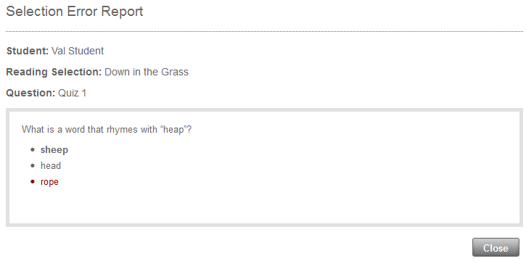

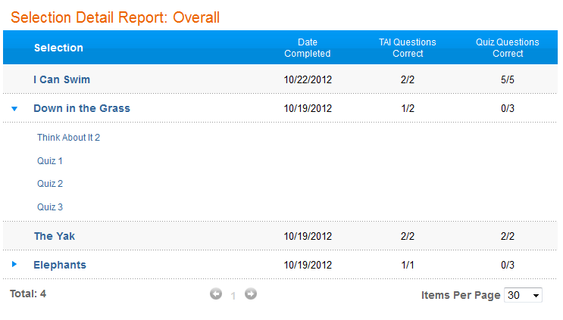

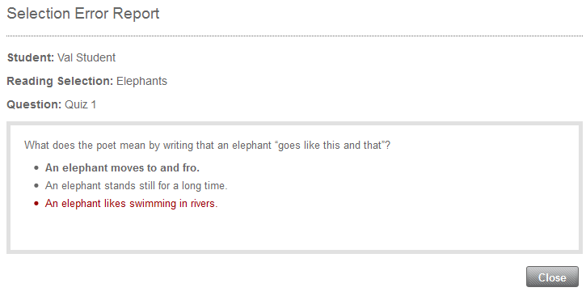

*Reading Assistant Plus* MySciLEARN Reading Selection Success Report

The Selection Report includes specific information on a student’s proficiency level, progress and success within each passage.

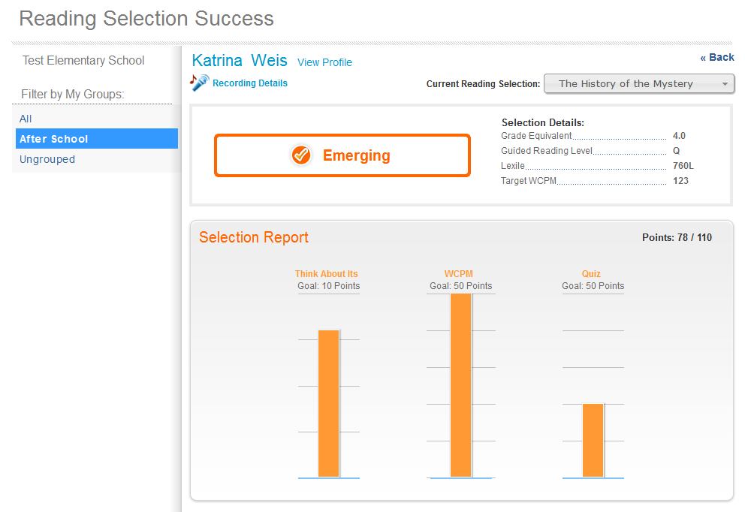

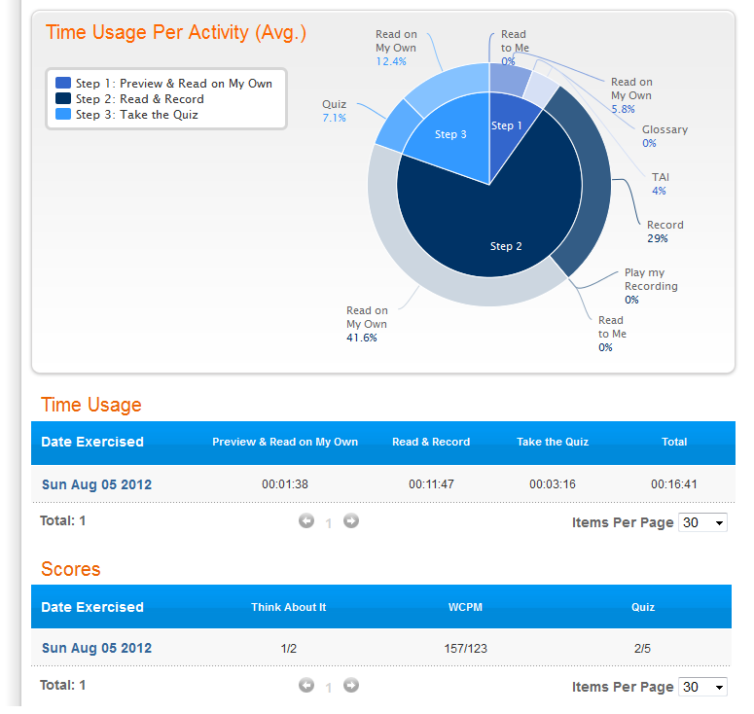

## Other Student Progress Evaluation Options

**Parent/Teacher Conferences**

Regular parent/teacher conferences can be part of implementation of the *Fast ForWord* and *Reading Assistant Plus* products, with parents and teachers sharing information on observed changes in communication and behavior.

**Teacher Surveys**

Teachers may complete a survey to indicate observed changes in students’ classroom behavior, listening comprehension, reading, writing, spelling and speaking.

## 

## Student Assessment

**Reading Progress Indicator**

Within the Fast ForWord K12 program is an assessment called Reading Progress

Indictor. Reading Progress Indicator is a nationally-normed, computerized assessment that rapidly measures Fast ForWord effectiveness, providing a clear picture of reading  skills in terms of grade equivalents and percentile scores.

* Quickly assesses four key skill areas: phonemic awareness, decoding, vocabulary and  comprehension
* Automatically score assessments and report results to parents, teachers and  administrators
* Access accurate progress information that correlates to nationally recognized normed  assessments
* More precisely assess student performance with easy‐to-use, short, frequent assessments

Reading Progress Indicator (RPI) is an assessment administered before and after  Fast ForWord participation to help measure the impact of Fast ForWord intervention.  Skills are measured through online assessments provided at four levels based on the  grade entered within MySciLEARN: K‐1, 2‐3, 4‐6, and 7‐13+.

The assessments aren’t timed, and students may complete them over more than one  session. Students take the assessment individually but it can be administered in groups when students have their own devices such as laptop, Chromebook or iPad.

The scores in Reading Progress Indicator, reported in national percentile scores and  grade equivalent scores, were developed based on the results of a norming study. In  this study, Reading Progress Indicator was administered to a large, nationally representative sample of students. This sample was selected to include students of different ethnicities, and students from all regions of the country. Fast ForWord product use was not considered in the selection process. Normalized scores were then developed based on the performance of the students in the study. Since the norming study, research has  continued and scores from RPI assessments have proved to correlate to many nationally recognized normed assessments such as the Woodcock Johnson III, the Gates‐MacGinitie Reading Tests, and the Scholastic Reading Inventory. Visit the Evidence section of our website to learn more.

Available resources to assist educators with using Reading Progress Indicator and all of the Fast ForWord K‐12 products are available on the MySciLEARN website.

Visit the [Results section of our website](http://www.scilearn.com/scientifically-based-research/correlation-studies/10) to learn more – [www.scilearn.com/evidence](http://www.scilearn.com/evidence)

## *Fast ForWord* Project Evaluation

There are two main criteria that can be used for evaluating the effectiveness of the *Fast ForWord* products: effective product use by the school and student achievement in reading.

*Implementation Fidelity Goals*

Once the Fast ForWordimplementation begins, there are three key ingredients needed for maximum student gains – Completion, Attendance, and Participation (CAPs). When schools follow the recommended Best Practices, students demonstrate significant reading gains. Schools must pay close attention to CAPs on the MySciLEARN reports, and intervene where appropriate.

*Implementing with fidelity* means achieving high scores on each of the CAPs components:

**COMPLETION RATE**– measures the pace at which a student progresses through the content relative to that student’s individualized Completion Goal.

* ***Recommendation***: Progress consistently, meeting (or exceeding) the weekly Completion Goals.
* **Good** = 65%+

**ATTENDANCE** – measures how many days per week a student is using the products.

* ***Recommendation***: Faithfully adhere to either the 3-day or 5-day a week protocol.
* **Good** = 80%+ (100% for the 3-day a week protocol)

**PARTICIPATION** – measures the percentage of the scheduled minutes per day a student is using the software. This indicates the student’s time on task.

* ***Recommendation****:* Participate for the entire length of the Fast ForWord session each day.
* **Good** = 95%+

***Student Achievement***

Scientific Learning works with schools to evaluate the impact of *Fast ForWord* and *Reading Assistant Plus* use on student achievement. The Research Team at Scientific Learning has had extensive training and experience tracking student performance before and after use of *Fast ForWord* and *Reading Assistant Plus* products. The Team will work with schools to set up a case study or randomized control trial to evaluate the effectiveness of the *Fast ForWord* and *Reading Assistant Plus* products by measuring student achievement in reading and/or oral language skills. Testing with state assessment tests or any other mutually-agreeable assessment tool can be used in a *Fast ForWord* and *Reading Assistant Plus* school study.

Through both product use information and student achievement data, a school or district and Scientific Learning will be able to assess the success of their *Fast ForWord* and *Reading Assistant Plus* implementation.

# Documented Fast ForWord Success

*This section contains documented* Fast ForWord *results for various skills and populations. These can be helpful in graphically showing grant evaluators the success of the* Fast ForWord *products and that the* Fast ForWord *products are scientifically validated through rigorous data analyses. For even more school study results, please go to:* [*www.scientificlearning.com/results*](http://www.scientificlearning.com/results)*.*

*Since it was incorporated in 1997, Scientific Learning has successfully provided training and support to staff in schools nationwide who have implemented the* Fast ForWord *products. If you would like to speak with a school that has successfully implemented the* Fast ForWord *products, please fill out a Grant Support Request at:* [*www.scientificlearning.com/grantsupportrequest*](http://www.scientificlearning.com/grantsupportrequest)*, and ask for a National Reference Site in your area.*

## Improvements in Language Comprehension for Academically At-Risk Students

The Test of Auditory Comprehension of Language, Revised (TACL-R) is a receptive language test that measures a student’s ability to understand spoken phrases and sentences of increasing complexity. Performance on this test, which is designed for ages 3 to 9 years 11 months, indicates a student’s ability to comprehend the meanings of word classes and relationships, verb tenses and pronouns, and elaborated sentences.

These language skills are particularly important in the elementary school years, when a student’s ability to follow oral instructions and participate in class discussions can be critical to academic achievement.

Prior to *Fast ForWord* activity, the 246 students in the *Fast ForWord* group and the 142 students in the comparison group demonstrated similar skill levels in auditory comprehension, with both groups testing below the average range.

At the end of the study, the skills of children in both groups had moved into the average range. However, the skills of children in the *Fast ForWord* group improved significantly more than the improvements observed in the comparison group.

f97sch06xgb-nl-ld

## Improvements in Reading

The Woodcock Johnson, Revised (WJ-R) is a wide-range, comprehensive set of individually administered tests for measuring cognitive abilities, scholastic aptitudes, and achievement. The WJ-R consists of various subtests. Commonly used subtests for assessing reading skills are Letter-Word Identification, Word Attack and Passage Comprehension. The Letter-Word Identification subtest measures the subject's reading identification skills for isolated letters and words. Word Attack measures the subject’s skill in applying phonic and structural analysis skills to the pronunciation of unfamiliar printed words. Passage Comprehension measures the subject’s skill in reading a short passage and identifying a missing key word.

Shown here are results for children in schools and private clinics who have participated in *Fast ForWord Foundations I* and *Fast ForWord Foundations II*. Prior to using *Fast ForWord Foundations I*, students performed below average on the Letter-Word Identification subtest and the Word Attack subtest. After using *Fast ForWord Foundations I*, students made significant improvements on all three reading measures (Letter-Word Identification, Word Attack and Passage Comprehension). On average, scores on each measure improved into the average ranges of performance following *Fast ForWord* activity.

*Fast ForWord Language to Reading* builds on the skills developed in *Fast ForWord Language* while adding additional components that develop letter-sound associations, decoding, visual word recognition and reading comprehension. Following work with *Fast ForWord Language to Reading*, students made significant gains on all three reading measures and elevated their reading performance well within the average range. Improvements in the ability to decode single words (Word Attack subtest) as well as their ability to understand a short passage (Passage Comprehension subtest) provided the largest improvements over the period of 20 to 40 instructional sessions.

**Fast ForWord Language Fast ForWord Language to Reading**

m99cmb10xgb

## Improvements in Language Comprehension for Students Learning English as a Second Language

The *Fast ForWord* products have been shown to be effective and scientifically proven tools that help ESL/ELL students become better speakers and readers of English.

* The goal of the *Fast ForWord* products is to have the recognition of the sounds and structures of the second language (English) become as rapid and automatic as in the first language.
* Because the *Fast ForWord* products focus on the 44 phonemes of the English language, they are of prime importance to ESL/ELL students whose native language may use different phonemes than those used in English.
* The *Fast ForWord* products enable ESL/ELL students to truly hear and discriminate between English phonemes, thereby allowing them smooth acquisition of oral language skills.
* An understanding of language sounds and language comprehension is an important indicator of reading readiness, and the *Fast ForWord* products provide ESL/ELL students with this understanding and comprehension.
* While developing and practicing the phonological awareness required for English through the sound exercises, students also practice other important oral and pre-reading skills such as listening accuracy, grammar, syntax, vocabulary, working memory, left-to-right reading patterns, and sequencing.
* ESL/ELL students can then make the transition from language to reading by developing their skills in sound-letter recognition, decoding, morphology, reading comprehension, and story structures with the *Fast ForWord* products.

Scientific Learning data has shown that ESL/ELL students make as significant gains in improved language skills after using the *Fast ForWord* products as native English-speaking students. The graph below shows results for both ESL and non-ESL students. Auditory comprehension skills were measured using the Test of Auditory Comprehension of Language – Revised (TACL-R) for both students who are native speakers of English and students learning English as a second language. Both groups improved from below the average range before using *Fast ForWord Language* to well inside the average range after *Fast ForWord Language*.

After using *Fast ForWord Language*, students learning English showed the same significant gains in language skills as native English speakers.

f97sch20xgb

## Significant Reading Gains for ELL Learners

The following study investigated the effects of the *Fast ForWord* products on the reading skills of 16 high school students at Dallas Independent School District who were English Language Learners and who used the products within the curriculum in a school setting. On average, these students had a Normal Curve Equivalent (NCE) score of 3.63 before Fast ForWord use, over two standard deviations below the mean. After participating in the Fast *ForWord* products, students improved to an average NCE score of 25.8—gaining over one standard deviation in measures of reading ability (Table 1). In terms of grade equivalents, students gained over two years in reading grade level after using *Fast ForWord* products (Figure 1). Student reading ability was assessed with the Gates-MacGinitie Reading Tests (GMRT) before and after *Fast ForWord* product use.

|  |  |  |  |  |  |  |
| --- | --- | --- | --- | --- | --- | --- |
| ELL | n | Before | | After | | t-statistic |
| Mean | SE | Mean | SE |
| Comprehension | 16 | 3.63 | 1.48 | 25.8 | 3.34 | 6.61\* |
| *Table 1. On average, students who had English as a second language made significant improvements and gained over one standard deviation in comprehension skills after Fast ForWord use. \*p<0.05.* | | | | | | |

|  |
| --- |
| f05dls01xgb ESL |
| *Figure 1. Overall, students with English as a second language significantly improved their reading comprehension skills following Fast ForWord participation. Results from 16 students are shown. Not all students had grades available; grade level was calculated from 15 students who had reported grades.* |

## Special Education Students

Learning abilities vary from one child to another. The *Fast ForWord* products are designed to meet a specific student’s needs by adapting to his or her incoming skill level and ongoing progress. By using adaptive algorithms, *Fast ForWord* software maintains each student at a 75-80% success rate; as the student improves, the exercises automatically become more challenging.

Through frequent and intense practice, a Special Education student’s ability to process acoustical signals at a faster rate is developed. Scientific Learning’s *Fast ForWord* computer software offers unique possibilities for enabling Special Education students to hear the phonemes and sounds of language by slowing them down and digitally enhancing them so that they can be differentiated. The implementation of the *Fast ForWord* products will improve reading achievement for Special Education students with language based delays. By improving overall language processing skills, the *Fast ForWord* products ready Special Education students to successfully learn in regular classroom settings by improving listening skills, helping build the basic foundation for learning to read, and developing reading skills.

The following are results for children in Special Education who participated in *Fast ForWord* activity. In addition to language problems, many of the children who participated had other developmental problems or classifications. Examples include Pervasive Developmental Disorder (PDD), Attention Deficit Disorder (ADD), and Central Auditory Processing Disorder (CAPD). On average, children with these disorders, as well as other participants, were able to achieve significant gains in language after *Fast ForWord* activity.

96bet54xgb

## Language Comprehension in Students of Low Socioeconomic Status (SES) At-Risk for Reading Failure

f97sch05xgbThe graph below shows a comparison of improvements in language comprehension between two groups of at-risk students, ages 7 to 9, of low socioeconomic status (SES) as classified by the Market Data Retrieval Database. A group of students trained on *Fast ForWord Language* software; the comparison group of students did not participate in an intervention program during the same time period (left bar graph). The results are from the Test of Auditory Comprehension of Language, a standardized, nationally normed language test that these students from schools nationwide completed before and after using *Fast ForWord Language* software.

Before using *Fast ForWord Language* software, both groups of at-risk, low SES students performed, on average, below their age-expected performance levels. After the participation period, performance for the group that used *Fast ForWord Language* software moved within the average range. The comparison group showed some improvement but did not move as far into the average range as the *Fast ForWord Language* participation group. The gains made by the *Fast ForWord Language* group were significantly better than the gains made by the comparison group, indicating that the students in the *Fast ForWord Language* group have an improved ability to benefit from the school curriculum.

## Improvements in Comprehensive Language Skills for Adolescents and Adults

The Clinical Evaluation of Language Fundamentals, Third Edition (CELF-3) is a comprehensive test that identifies language skill deficits. The CELF-3 measures an individual's ability to understand words and sentences, follow directions, recall and formulate sentences, and understand relationships between words and categories. These are skills that are critical for reading and writing, as well as for understanding classroom instruction and participating in classroom activities.

111 individuals, ages 12-20, took the CELF-3 before and after working with *Fast ForWord Language*. Prior to *Fast ForWord* activity, the adolescent participants performed below the average range on receptive language, expressive language and total language scores with mean scores of 76, 77 and 76 respectively. After an average of 29 days of *Fast ForWord* participation, these individuals demonstrated an average gain of more than 10 points. At post-testing, they performed within the average range with mean scores of 88 on receptive language, 89 on expressive language and 88 on the total language score.

**Combined CELF Scores for Participants Age 12-20**

99com20xgb-bc-ld RecExpTot

## Demonstrated Significant Improvement in Adolescent Literacy Using the *Fast ForWord* Products

Field studies have confirmed that the *Fast ForWord* products improve the literacy skills of struggling adolescent readers by developing their cognitive abilities in the context of the oral language and reading skills that students need to succeed academically.

The following study investigated the effects of the *Fast ForWord* products on the reading achievement skills of middle and high school students who were in the Killeen Independent School District in Texas and who used the products within the curriculum in a school setting. The design of the study was a multiple school case study using the Gates-MacGinitie Reading Test.

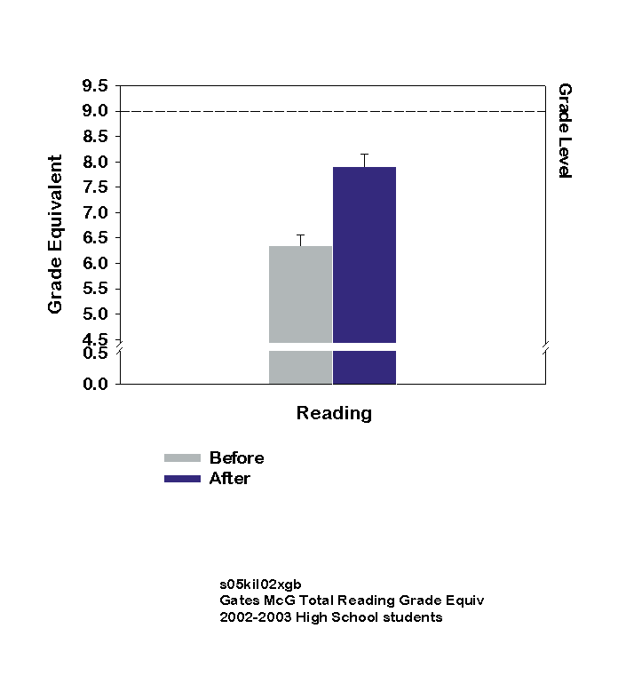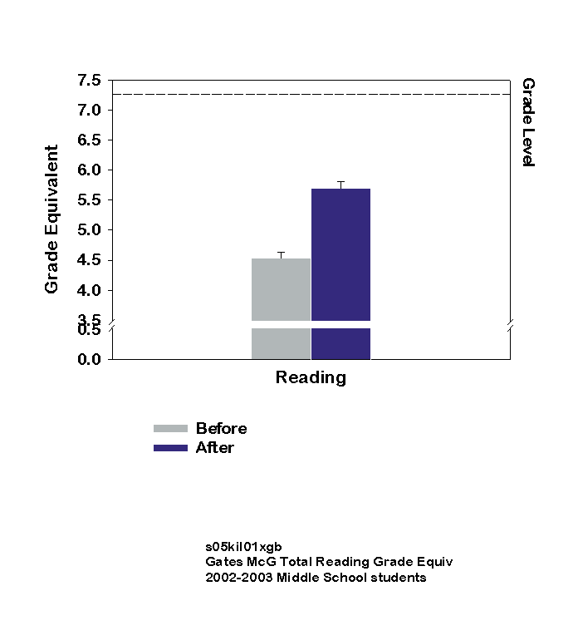 **Middle School Results High School Results**

Middle school students (n=193) included students in grades 7 and 8 (mean grade level of 7.3); all high school students (n=99) were ninth graders. On average, the students in both groups who used *Fast ForWord* products made significant improvements in reading achievement as measured by the Gates-MacGinitie Reading Test. At pre-test, each group of students was performing well below grade level in reading achievement. Post-test results revealed that both the middle school and the high school groups had attained significant improvements. A subset of students assessed two to three months after the post-test indicated that the accelerated learning continued.

## Writing Improvements with Fast ForWord

In a study entitled, “Neuroplasticity-Based Cognitive and Linguistic Skills Training Improves Reading and Writing Skills in College Students,” that was peer-reviewed and published in *Frontiers in Psychology*, Beth Rogowsky, et al, documented the effects that the use of Fast ForWord had on students’ reading and writing skills. The study used a quasi-experimental design.

Study Parameters

The following paragraph quotes directly from the study itself and describes the parameters of the study.

“This study reports an evaluation of the effect of computer-based cognitive and linguistic training on college students’ reading and writing skills. The computer-based training included a series of increasingly challenging software programs that were designed to strengthen students’ foundational cognitive skills (memory, attention span, processing speed, and sequencing) in the context of listening and higher level reading tasks. Twenty-five college students (12 native English language; 13 English Second Language), who demonstrated poor writing skills, participated in the training group. The training group received daily training during the spring semester (11weeks) with the Fast ForWord Literacy (FFW-L) and upper levels of the Fast ForWord Reading series (Levels 3–5).The comparison group (*n*=28) selected from the general college population did not receive training. Both the training and comparison groups attended the same university. All students took the Gates MacGinitie Reading Test (GMRT) and the Oral and Written Language Scales (OWLS) Written Expression Scale at the beginning (Time 1) and end (Time 2) of the spring college semester. Results from this study showed that the training group made a statistically greater improvement from Time 1 to Time 2 in both their reading skills and their writing skills than the comparison group. The group who received training began with statistically lower writing skills before training, but exceeded the writing skills of the comparison group after training.”

Results

The Gates MacGinitie Reading Test (GMRT) median score of the Fast ForWord group went from 109.31 (Time 1) before use of the program to 113.33 (Time 2) after use of the program; for the comparison group, there was no increase in their GMRT median score, which went from 113.19 (Time 1) to 112.05 (Time 2). The scores of the group that used Fast ForWord increased significantly more than the scores of the students in the comparison group.

The Oral and Written Language Scales (OWLS) Written Expression Scale median score for the Fast ForWord group went from 86.20 (Time 1) before program use to 111.04 (Time 2) after program use. For the comparison group, there was no significant change in their OWLS median score, which went from 98.11 (Time 1) to 95.61 (Time 2).  (Note that the Fast ForWord training group’s OWLS Time 1 median test score was considerably lower than the Time 1 median test score of the comparison group.) Again, the scores of the group that used Fast ForWord increased significantly more than those of the comparison group.

C:\Documents and Settings\bcalhoun\Desktop\temp\rutgers\Rutgers OWLS\Rutgers OWLS Graph no numbers added.WMF

Citation: Rogowsky BA, Papamichalis P, Villa L, Heim S and Tallal P (2013) Neuroplasticity-based cognitive and linguistic skills training improves reading and writing skills in college students. *Front. Psychol.* 4:137. doi: 10.3389/fpsyg.2013.00137

## Longitudinal Data

After working with *Fast ForWord Language*, students demonstrate improvements in the foundational skills required for fluent reading; results from up to one year after *Fast ForWord* activity show that students continue to improve their reading skills over the long term. The graph below shows improvements in reading skills for over 100\* students in grades K through 6 from schools nationwide. The results are from the Woodcock Johnson Test of Achievement, Revised, a standardized, nationally normed reading test that students completed before and after working with *Fast ForWord Language*, as well as six months to one year following *Fast ForWord* activity.

*m00cmb74xgb-ld-ma*

Before *Fast ForWord Language*, students performed, on average, toward the lower end of their age-expected performance level. After *Fast ForWord Language*, students demonstrated, on average, significant gains in their reading skills. Test results directly after *Fast ForWord Language* showed that students' ability to identify letters and words and to identify missing key words moved higher into the average range. In addition, test results 6 months to 1 year after *Fast ForWord Language* showed that students continued to develop their improved reading skills, indicating that they continue to improve on their ability to benefit from the school curriculum.

For additional results, visit the Scientific Learning website, [www.scientificlearning.com/results](http://www.scientificlearning.com/results), and click on “Results” in the banner heading.

\* Because results are from nationwide testing, there is variation in the number of students administered each type of nationally normed test.

## Behavior Improvements with the Fast ForWord Products

The graph below shows the percentage of parents who noticed positive changes in various behaviors and skills after their child used *Fast ForWord Language to Reading* software. The parents in this study contributed their feedback 4 months, on average, after their child participated.

Before using *Fast ForWord Language to Reading* software, these children had varying degrees of difficulty in a number of behavioral areas as well as with language and reading skills.

After using *Fast ForWord Language to Reading* software, parents noticed that a significant number of these children demonstrated marked improvement in the following areas:

* Self-esteem, including participation in classroom and group activities as well as enthusiasm about school;
* Talking, including pronunciation, participation in conversation, vocabulary, spontaneity, and ability to stay on topic;
* Reading, including recollection of details and event sequence, ability to understand complex sentences, and confidence when reading aloud;
* Listening and understanding, including response time to questions, ability to follow the flow of conversation, and humor comprehension;
* Academic achievement, including sounding out of new words and spelling as well as attention span, writing, and math;
* Memory, including better retention and recall of phone numbers, event sequences, and details.

w99ff2_15xgb

## 

# Budget

***Fast ForWord* Solution Set Product Packages**

The *Fast ForWord* program is priced at $280 per-student for an annual subscription (five license minimum purchase) or $800 per-student for a perpetual license plus the $83 per perpetual student license each year for MySciLEARN Support package. Site licenses are priced at $21,000 for an annual subscription or $60,000 for a perpetual license plus the $6,225 per perpetual site license each year for MySciLEARN Support services package. All pricing options include access to all software programs. (Prices subject to change.)

A district should choose per-site pricing for any school that plans to enroll more than 75 students in *Fast ForWord* and *Reading Assistant Plus*, and they should choose per-student pricing for any remaining schools that do not.

Subscriptions are all-inclusive prices for one year of using the *Fast ForWord* and *Reading Assistant Plus* products and all annual services – Reading Progress Indicator, MySciLEARN Reports, support, maintenance, plus the option for On-Demand hosting and at-home access.

On-site training or consulting is priced at $2,300 per day. Web-based training or remote consulting, which can be more flexibly scheduled and avoid other costs such as substitute teachers, are available at $500 per 2-hour session or at $1,250 for three sessions.

Contact your local Account Manager for more details at 1-888-665-9707.

1. Tallal, P., Miller, S. L., Bedi, G., Byma, G., Wang, X., Nagarajan, S.S., Schreiner, C., Jenkins, W. M., & Merzenich, M. M. (1996). Language comprehension in language-learning impaired children improved with acoustically modified speech. Science, 271, 81-84. [↑](#footnote-ref-1)
2. Miller, S. L., Merzenich, M. M., Tallal, P., DeVivo, K., Linn, N., Pycha, A., Peterson, B. E., & Jenkins, W. M. (1999). [Fast ForWord training in children with low reading performance](http://www.scilearn.com/alldocs/rsrch/30052FFWLanguageProdRpt.pdf). Nederlandse Vereniging voor Logopedie en Foniatrie: 1999 Jaarcongres Auditieve Vaardigheden en Spraak-taal. (Proceedings of the 1999 Netherlands Speech-Language Association Annual Meeting). [↑](#footnote-ref-2)
3. Temple, E., et al., “Neural deficits in children with dyslexia ameliorated by behavioral remediation: Evidence from fMFI.” *Proceedings of the National Academy of Sciences*, March 4, 2003. 100(5)2860-65. [↑](#footnote-ref-3)
4. Adams, M.J. (2005). The promise of automatic speech recognition for fostering literacy growth in children and adults. In M. McKenna, L. Labbo, R. Kieffer, & D. Reinking (Eds.), Handbook of Literacy and Technology, Volume 2. Hillsdale, NJ: Lawrence Erlbaum Associates. (Abridged Version) [↑](#footnote-ref-4)
5. Snow, Catherine, M. Susan Burns, Peg Griffin, eds. *Preventing Reading Difficulties in Young Children*. Committee on the Prevention of Reading Difficulties in Young Children, Commission on Behavioral and Social Sciences and Education, National Research Council. Washington D.C.: National Academy Press, 1998: 51. [↑](#footnote-ref-5)
6. Ibid. p. 54. [↑](#footnote-ref-6)